

THE NEWS FROM the
VOLUME XLV, NUMBER 3
39

1
KISHWAUKEE KIWANIS CLUB of DeKalb, Illinois

October 23, 2013 Editor: Amy Polzin http://www.kishkiwanis.org

LUNCH: Pulled pork, potato salad, chicken noodle soup (just what my cold needed!), cookies and chips
SONG: God Bless America led by Ralph S. INVOCATION: Jerry Smith

Officers for 2013-2014

President Greg Spears
President Elect Abby Chemers
Vice President Dick Dowen
Treasurer Lisa Small
Asst. Treasurer Sue Doubler
Secretary Ken Doubler
Asst. Secretary Jerry Wahlstrom
Immediate Past President
Melissa Lenczewski
Lt. Governor Bill Cummings
District Governor Pattie Heath

********************
Kishwaukee Kiwanis Meetings

2nd, 3rd, 4th, (and 5th) Wednesday at 11:45 a.m
Hopkins Park Community Room

********************
K-Family Events/Meetings

Circle K Tuesday nights at 9:00 p.m. in DuSable 280.
Hint: To stay young, attend one of their meetings!

AKtion Club – First Wednesday of the month at 2:30 p.m. at Opportunity House (202 Lucas St.) in Sycamore.

********************
Defining Statement

Kiwanis is a global organization of volunteers dedicated to changing the world, one child and one community at a time.

********************
Flag Salute

As our flag signifies purity, valor, and justice, may we as true Kiwanians exemplify these virtues as we serve the children of the world.

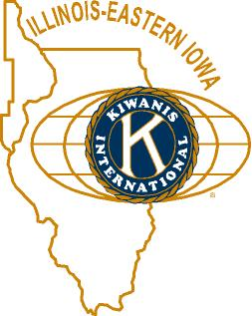

ANNOUNCEMENTS, EVENTS

and OPPORTUNITITES

Pumpkinfest Prayer Breakfast: Thursday, October 24 at 7 a.m., at the Sycamore United Methodist Church. Bill Nicklas will be the speaker. Currently, there are a bunch of us going. Be sure to rise and shine!

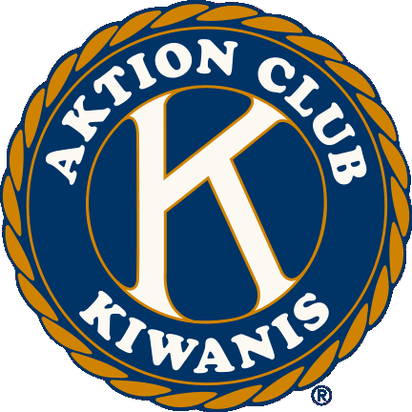
Aktion Club Fundraiser: They’re selling Pumpkinfest sweatshirts for $25. Profits to Eliminate. The design will be by some of the members. Should be pretty good. To place your order by Friday, contact Mike at 815 899 2990 (ext 122), or Michael@ohinc.org.

Mike Mooney has raffle tickets for us to sell, for the Make A Difference DKC raffle to win a new vehicle from DeKalb Sycamore Chevrolet! Please contact Mike to get tickets to sell. For each ticket sold the club will receive an $8.00 donation. The drawing will be November 13.

The next INTERCLUB is Tuesday, November 5 at 9:00 p.m. Tri-County is passing the gavel to Circle K at Pizza Villa. Come be inspired!

ISHA Football Championships at NIU November 29-30. To volunteer, go to
http://ihsadestinationdekalb.com/volunteer. http://ihsadestinationdekalb.com/wp-content/uploads/2012/10/IHSA_sponsor_card.pdf is your site for sponsorship info.
Having its ups and downs, the elevator operator position still has some openings. Here’s the schedule so far:
Friday, Nov. 29, 2013 Saturday, Nov. 30, 2013
8:00 a.m. – 10:00 a.m. Dean Quarnstrom Jack Goodrich
10:00 a.m. – 12:30 p.m. Bill Cummings Jack Goodrich
12:01 p.m. – 2:30 p.m. Need someone Jennie Cummings
2:00 p.m. – 4:30 p.m. Beryl Smith Need someone
4:00 p.m. – 6:30 p.m. Need someone Kendra Chaplin
6:00 p.m. – 8:30 p.m. Need someone Kendra Chaplin (tentative)
8:00 p.m. – 10:30 p.m. Brian Tobin Brian Tobin

Pie Auction fundraiser November 21 6pm – 9pm. Diana King has details. Also, Svetlana is selling pies on behalf of Glidden Homestead.

Eliminate Fundraiser: Sycamore Club is selling BBQ pork drive-up tickets for November 14, at United Methodist Church of Sycamore. $10. Chops from Slo Smoke BBQ in Sycamore.


PROGRAM

*DCCF Open House – November 15, 2013 from 4:00 p.m. – 7:00 p.m. All are invited.

Dan Templin, Executive Director of the DeKalb County Community Foundation (DCCF) gave us some facts about DCCF. Did you know that DCCF is 20 years old? It’s hard to believe that it has been so long. The effects of the DCCF are far-reaching within the county, having awarded over $900,000 to various programs and services county-wide.
The Kishwaukee Kiwanis has contributed and to two funds in the DCCF. We have contributed to the Community Leadership Fund which is used to support the operating fund. This fund was started in September of 2011 and has a current balance of $10,599 and a total of $344.00 in expenditures (this year). We also have supported and contributed to Community Works which has their main emphasis on child care, land use, and workforce development. Community Works started in September of 2007 and currently has a balance of $17,971 with a payout of $573.00 this year. Our club, a couple of years ago decided that we wanted to pledge a minimum of $500.00 per year and will be dedicated to honoring one or more individuals in our club for service and leadership and will go to the DeKalb County Community Foundation in its Community Works program in the name of the recipient(s). Last year we honored Ken Doubler as our first recipient of the Service and Leadership Award. Ken Doubler and Toney Xidis “teased” the club with their hints as to who this year’s recipients were. After several guesses (including Beryl, Beryl, Beryl), Toney and Ken decided to end the suspense and announced that this year we were honoring two of our members with this award. Bill Finucane and Amy Polzin were recognized for their years of service in Kiwanis and in the community. Needless to say, both were surprised and deeply honored. See the next page for more on our recipients.
DeKalbCounty
C o m m u n i t y
F o u n d a t I o n

In case you missed it:
Sue’s collecting dues.

Quote for the day
The true meaning of life is to plant trees under whose shade you do not expect to sit.
- Nelson Henderson (Philanthropist)
(and if you were at today’s meeting, you’ll no doubt notice that I “borrowed” this from one of Dan’s PowerPoint slides)

UPCOMING PROGRAMS: (Why not invite a guest? – that could also mean a prospective member!)

Oct 30, 2013 New NIU President Dr. Doug Baker
Nov 7, 2013 BOARD MEETING @ Lincoln Inn

Today’s Attendance:

31 | Kish Kiwanians (another WAG)
2 | Guest: Marcia Goodrich and Anita Zurbrugg
1 | Speakers: Kim and Heather
0 | Former Big Shots
34 | TOTAL

Ongoing issues – Community Service is still collecting box tops and little toiletries. They will be collecting coats, gloves, and old cell phones.
Serving the Children of the World

Polzin and Finucane honored with Kishwaukee Kiwanis Service and Leadership Award!!

The Awards Committee announced today that Amy Polzin, 18-year member, and Bill Finucane, 27-year member are recipients of the 2013 Service and Leadership Award. Jack Goodrich started the proceedings by giving a bit of background into the committee’s work and criteria. Toney Xidis and Ken Doubler did the honors of presenting the winners. The award includes a $500 donation in the recipient’s name to the DeKalb County Community Foundation Community Works Fund. Dan Templin, Executive Director of the DCCF was on hand to accept the two $500 donations.

Amy was chosen for her overall leadership and behind the scenes commitment to Kiwanis and the local communities. She has chaired practically every committee in the Club, been President twice and was Lt. Governor for Division 14 for one year. A tireless effort to provide service to our Club and the local community is truly her trademark, the 2012 Athena recipient provides quiet, unassuming leadership on bulletins, club directory, and overall communications. As she often says, “I’m proud to be able to help.” Her efforts include years of experience as a City of DeKalb Alderman, member of the Kirkland Lions Club, Boy Scouts “Tribute to Heroes” committee member, recipient of the 2004 NIU Outstanding Service Award for Operating Staff, and a host of others.

Bill has served our Club and community with perfect attendance since he joined in 1986. Probably his best leadership has come in revitalizing the NIU Circle K Club in the mid to late 1990’s and his quiet support for the Biking with Beanzie and Haunted House fundraisers. When a fund raiser happens, Bill is always there to support with time, energy and leadership. As one of his peers said, “Bill gives all he has, and more, and then more again.” Recently retired as Director of the NIU Transportation Department, he enjoys contributing his skills to NIU athletic activities and is currently an Alderman for the City of DeKalb.

We are proud to honor both Amy and Bill and have them join our distinguished Service and Leadership group.



