THE NEWS FROM the
VOLUME XLV, NUMBER 21
39

KISHWAUKEE KIWANIS CLUB of DeKalb, Illinois

June 11, 2014 Editor: Mark Sawyer http://www.kishkiwanis.org

LUNCH: Lunch Meats and Cheese – make your own’s, pasta salad and home made chips!
SONG: America the Beautiful, led by Ralph S. INVOCATION: Beryl Smith, Excellent Job may I say!

Officers for 2013-2014

President Greg Spears
President Elect Abby Chemers
Vice President Dick Dowen
Treasurer Lisa Small
Asst. Treasurer Sue Doubler
Secretary Ken Doubler
Asst. Secretary Jerry Wahlstrom
Immediate Past President
Melissa Lenczewski
Lt. Governor Bill Cummings
District Governor Pattie Heath

********************
Kishwaukee Kiwanis Meetings

2nd, 3rd, 4th, (and 5th) Wednesday at 11:45 a.m
Hopkins Park Community Room

********************
K-Family Events/Meetings

Circle K Tuesday nights at 9:00 p.m. in DuSable 280.
Hint: To stay young, attend one of their meetings!

AKtion Club – Second Tuesday of the month at 2:45 p.m. at Opportunity House (202 Lucas St.) in Sycamore.

********************
Defining Statement

Kiwanis is a global organization of volunteers dedicated to changing the world, one child and one community at a time.

********************
Flag Salute

As our flag signifies purity, valor, and justice, may we as true Kiwanians exemplify these virtues as we serve the children of the world.

ANNOUNCEMENTS, EVENTS

and OPPORTUNITITES

Board Members and all,
Kudos to Abby for accomplishing getting new officers for the coming Kiwanis year! So glad to have Joe G., Kendra, Svetlana, Bill, Steve and Joe J. join the group in October. Looking forward to another great year! (See below for breakdown of positions for coming year.)

Live Healthy DeKalb County – Christel Springmire From Apr 7 – June 7 they will be collecting gym shoes. June 7 to Aug 1, sizing, cleaning, new laces, then distributed at food pantries. Volunteer opportunity for the sizing, and perhaps buying new laces.

Beanzie workday this Saturday 6/14 at 8am at the Storage Unit. Contact Bill F. or Sue for questions. Not sure if electric drills will be needed.

Beanzie setup will be on a Friday 7/11 instead of Saturday. Please mark your calendars and save July 11 & 13. Routes will be marked on the 12th. We are trying to get the majority of the setup done while DHS is already open and we don't have to pay high prices to have the DHS available on a Saturday.

Community Service Committee Meeting 6/25 at 11:45 prior to regular meeting.

The DeKalb County Shoe Share program directed by Cristel Springmire is collecting "all sizes of gently-used gym shoes only" from April 7 through June 7. Please save a few dates. Work day at the County Health Facility.
Multi-Purpose room is 2574 N. Annie Glidden Rd. ​ ​(located between Health Depart and the County Rehab ​&​ Nursing Center. ​ Use ​doors D-20.​)​ Contact Jennie for Work Schedules and sign ups.

PROGRAM

Being the Annual Interclub/Golf meeting at River Heights, we had a very brief program consisting of Amanda Miller of the Somonauk 4H program. She was one of 5 club members this year that won honors in their speaking/presenting competition. She read 3 poems of her own to the club and guests, and let me tell you, they were special! What a talent for composing and speaking for this young woman! Also with her were her mother Florence and her County Advisor Nicole Grossinger

Our 2014 Kishwaukee Kiwanis Scholarship winners this year were: Sara Schafer, Maggie Rapp, and Wasay Ahmad. Greg attended the ceremony at the High School and was in the picture of the recipients. Good Job Greg!

Congratulations to our scholarship recipients and may your future be exceptional!

Quote for the day (For this season’s Graduates)

The larger the island of knowledge, the longer the shoreline of wonder.
Ralph W. Sockman

Your schooling may be over, but remember that your education still continues.

UPCOMING PROGRAMS: (Why not invite a guest? – that could also mean a prospective member!)

6/18 Ed Mathey, Baseball: Our National Pasttime?
6/25 Tom Phillips, NIU Police Chief
July 2 – Board Meeting
July 9 - Biking with Beanzie
July 16 - Barb City Betties
July 23 - Lehan Drugs – Local Business Profile

Today’s Attendance:

31 | Kish Kiwanians
21 | Sycamore Club: 9 DeKalb Club: 5 Aktion Club: 4 Speaker’s guests: 2
0 | VIPs
1 | Guest Speaker: Amanda Miller
53 | TOTAL

Meals on Wheels for the month of July: -- July 3 and July 28 are wide open if anyone would like to claim one of them.

See next page for listing of officers for 2014-2015
Serving the Children of the World
Kiwanis Officers, 2014-15
President | Abby Chemers
President Elect | Dick Dowen
Vice President | Joe Gastiger
Treasurer | Lisa Small
Ass't. Treasurer | Sue Doubler
Secretary | Ken Doubler
Ass't. Secretary | Jerry Wahlstrom
Immediate Past  President | Greg Spears

Board:
2014 Bob Higgerson
2014 Diana King
2014 Mark Sawyer
2014 Beryl Smith
2015 Kendra Chaplin
2015 Steve Cichy
2015 Bill Finucane
2015 Svetlana Henrikson
2015 Joe Jarocki

Thanks to all for your willingness to serve!

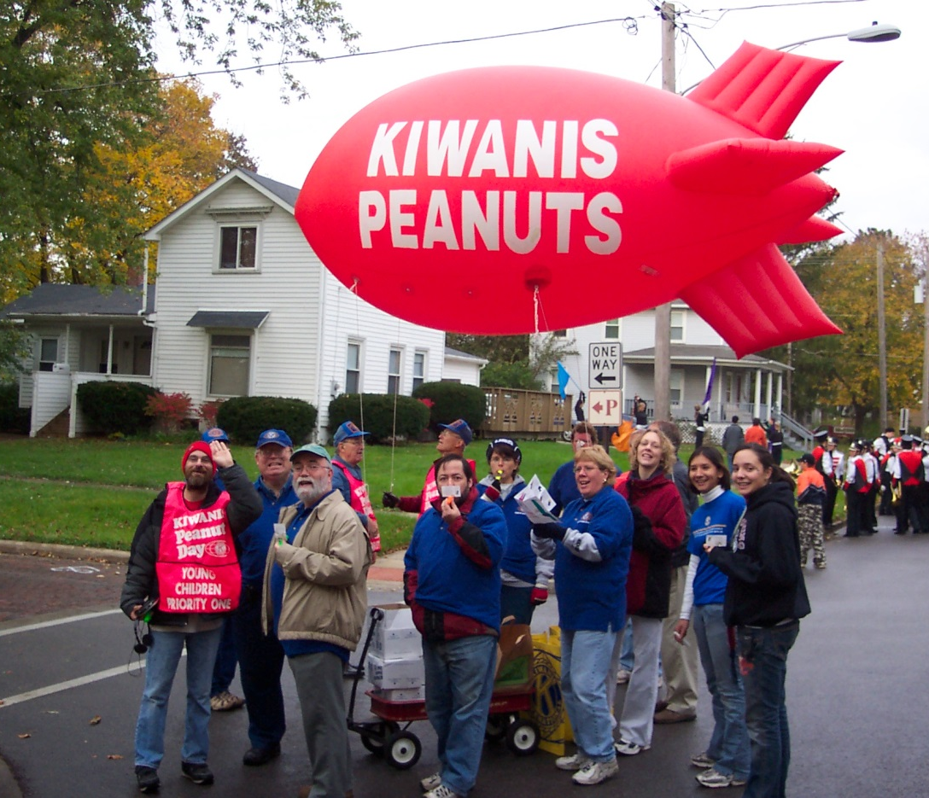
There was a little extra room so I figured I’d throw in this photo of the
premiere performance of the Kishwaukee Kiwanis Marching Kazoo Band.
We rocked this parade!!

