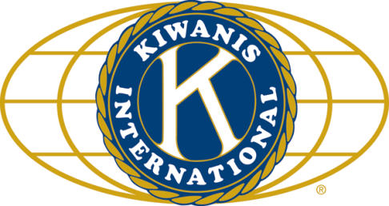

THE NEWS FROM the
VOLUME XLVI, NUMBER 2
39

KISHWAUKEE KIWANIS CLUB of DeKalb, Illinois

October 15, 2014 Editor: Paul Stoddard http://www.kishkiwanis.org

LUNCH: Turkey a la king (but which king??), mashed spuds, stuffing, pasta salad, and cookies.
SONG: God Bless America, led by Bill C. INVOCATION: Peter L.

Officers for 2013-2014

President Abby Chemers
President Elect Dick Dowen
Vice President Joe Gastiger
Treasurer Lisa Small
Asst. Treasurer Sue Doubler
Secretary Ken Doubler
Asst. Secretary Jerry Wahlstrom
Immediate Past President
Greg Spears
Lt. Governor Bill Cummings
District Governor Pattie Heath

********************
Kishwaukee Kiwanis Meetings

2nd, 3rd, 4th, (and 5th) Wednesday at 11:45 a.m
Hopkins Park Community Room

********************
K-Family Events/Meetings

Circle K Every other Tuesday night at 9:00 p.m. in DuSable 268. Hint: To stay young, attend one of their meetings!

AKtion Club – Second Tuesday of the month at 2:45 p.m. at Opportunity House (202 Lucas St.) in Sycamore.

********************
Defining Statement

Kiwanis is a global organization of volunteers dedicated to changing the world, one child and one community at a time.

********************
Flag Salute

As our flag signifies purity, valor, and justice, may we as true Kiwanians exemplify these virtues as we serve the children of the world.

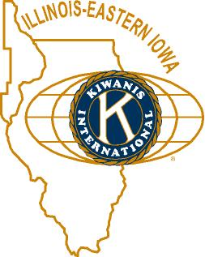

ANNOUNCEMENTS, EVENTS

and OPPORTUNITITES

Peanut Day. No news. Apparently we were working for peanuts.

Tim’s outfit – Northern Rehab is sponsoring a “Walk & Roll for Mobility” fundraiser Saturday morning, to benefit the pathway system. Check it out at http://northernrehabpt.com/news/are-you-ready-to-walk-roll!.aspx

Feed My Starving Children is holding a raffle. $20 tickets, grand prize is $10,000. Our club gets $8 for every ticket we sell. Mike Mooney is selling them. We’ve also requested a slot for packaging. Looks like it will be Thursday November 13, 4-6 pm for the local food packing event. We have 30 spots. Jerry W. showed a short video and started a sign up sheet. Or you can email him. See http://www.makeadifferencedkc.com/ for more information.

AKtion club is putting on a winter coat sale. They’re also selling Pumpkinfest t-shirts ($15) and sweatshirts ($20). Proceeds to Eliminate. (See end of newsletter for more info.)

The next Interclub is October 22. Tri-State is passing the gavel to us. The program that day is Therapy Dogs. Don’t miss it! Dick is causing trouble, changing the sign-up routine. Keep your eyes open for something new (a binder with sign-ups and the complete schedule.

Eliminate raffle was eliminated today.

Sycamore Prayer Breakfast is Thursday, October 23 at 7:00 a.m. at the Sycamore United Methodist Church. Always a GREAT event! See Jerry S for tickets. This year’s speaker: Jim Dambeck from the Sycamore NB&T.

YMCA Halloween Party is October 24 at 4:00 p.m. at the Convo Center. Volunteers are needed all day for stuffing bags, setting up the games, building the haunted house, and more. http://kishymca.org.

Check out the Yearbook info Amy sent you. Let her know if there are any changes to be made.

Oh, and dues are due!

PROGRAM

Today we celebrated our own with the 2014 Kish Awards! After some logistical issues with the microphone (thanks, Ken!), Ken and Toney took on MC duties. Toney reminded us of our role with the DeKalb County Community Foundation. Ken gave a quick history of our Service and Leadership Award, which honors one of the club who exemplifies service and leadership. The awardee has donated, in his or her name, a contribution of $500 to the Kish Kiwanis Club Community Works fund – which focuses on helping young workers, administered by the DCCF. We have over $20,000 in the account. Toney listed the criteria – service to the club in terms of serving/chairing committees and as an officer, participation in events, etc. This year’s recipient has been a president (a long time ago). Ken listed several former members from our recipient’s term as president. They were all before my time. The recipient has been on YCPO for many years, as well as several other committees. He has been our historian (think you know who it is yet?). Finucane joined the club under the recipient’s administration, but the awards committee still decided on…
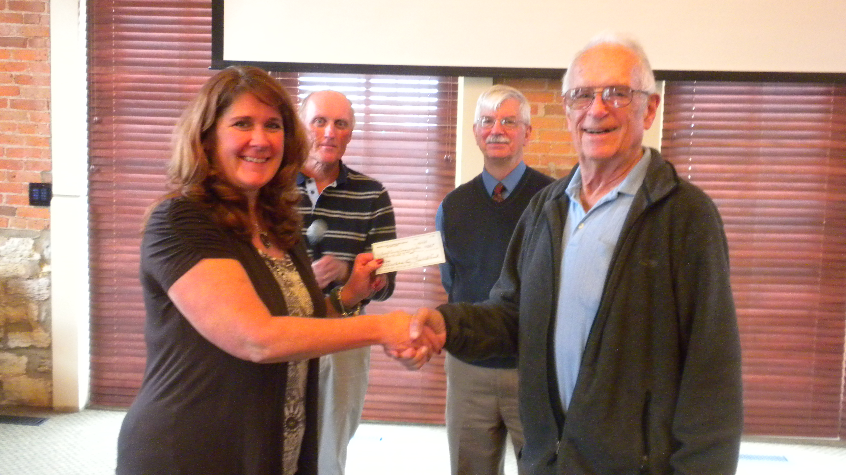
NORM SCHAEFFER!! Congratulations Norm! (No wonder Mary Lou is here.) Norm joined at a time when the pathway project was getting underway, and considers that a great project that we’ve adopted. Norm was pretty humble in his acceptance speech.

Quote for the day
“I don't deserve this award, but I have arthritis and I don't deserve that either.”
- Jack Benny

UPCOMING PROGRAMS: (Why not invite a guest? – that could also mean a prospective member!)

Oct. 22 Therapy Dogs Eileen Balcom (this is also an Interclub)
Oct. 29 T’ai Chi Tim Griffin
Nov. 5 Board Meeting @ the Lincoln Inn

Today’s Attendance:
28 | Kish Kiwanians
1 | Guest: Norm’s wife Mary Lou
0 | Speakers:
29 | TOTAL

(See next page for Aktion Club Pumpkin Fest 2014 Shirts Order Form)

Serving the Children of the World



