THE NEWS FROM the
VOLUME XLVI, NUMBER 39
39

KISHWAUKEE KIWANIS CLUB of DeKalb, Illinois

September 30, 2015 Editor: Paul Stoddard http://www.kishkiwanis.org

LUNCH: Chicken, spuds, rice, rolls, salad,andof course, cookies.
SONG: My Country, ‘tis of Thee, led by Bill C. Invocation:Jack G.

Officers for 2014-2015

President Abby Chemers
President Elect Dick Dowen
Vice President Joe Gastiger
Treasurer Lisa Small
Asst. Treasurer Sue Doubler
Secretary Ken Doubler
Asst. Secretary Jerry Wahlstrom
Immediate Past President
Greg Spears
Lt. Governor George Van Dee
District Governor Jim Dooley

********************
Kishwaukee Kiwanis Meetings

2nd, 3rd, 4th, (and 5th) Wednesday at 11:45 a.m.
Hopkins Park Community Room

********************
K-Family Events/Meetings

Circle K Every Wednesday night at 8:00 p.m. in DuSable 248. Hint: To stay young, attend one of their meetings!

AKtion Club – Second Tuesday of the month at 2:45 p.m. at Opportunity House (202 Lucas St.) in Sycamore.

********************
Defining Statement

Kiwanis is a global organization of volunteers dedicated to changing the world, one child and one community at a time.

********************
Flag Salute

As our flag signifies purity, valor, and justice, may we as true Kiwanians exemplify these virtues as we serve the children of the world.

ANNOUNCEMENTS, EVENTS

and OPPORTUNITITES

The last Interclub wasat 5:30 pm, Monday, Sept 28 at the Elks Club (Aktion club to DeKalb).

PEANUT DAY (Friday Sept 25): It was time to sell peanuts. Donations from streets and stores was about $300 above last year, and pre-sales were comparable to last year’s.

Prayer Breakfast will be on the October 22.

Amy reminded us that Committee sign-ups are happening!!!! Check the list. You may want to volunteer to chair. Still some openings for those.

DeKalb Chamber Halloween 1 – 3 pm. (Saturday). Volunteers needed to help out. Contact Jessica Antonacci (815 756 6306; jessica.antonacci@dekalb.org).

HS Football Championships: 300volunteer opportunities exist, Friday November 27th and Saturday November 28th. Talk to Bill Finucane or Deb Armstrong from the DeKalb County Convention & Visitors’ Bureau.

Feed My Starving Children: November 12 (Thursday) from 7 to 9 pm.

Toiletries- We’re collecting these for Safe Passage. (See below.)

Gov’s visit: (We combine with Divisions 12 and 13) 6:30 – 8 pm, October 16 (a Friday) at River Heights, catered by VAC. Organizational help will be appreciated.

Sue – NEW DUES ARE DUE! (Same as the old dues).

Joan is collecting box tops and Coke lids. Jennie will take your soup labels. AKtion Club is collecting aluminum cans and other recyclable materials.

Archives: If you find any old stuff related to Kiwanis, please give a copy to Norm!

P.o.P. Box

September Birthdays – Bill C., Mark L., Bob S., Herb B, Jerry S, Jennie C, Jerry W (today!). One special birthday today as well.

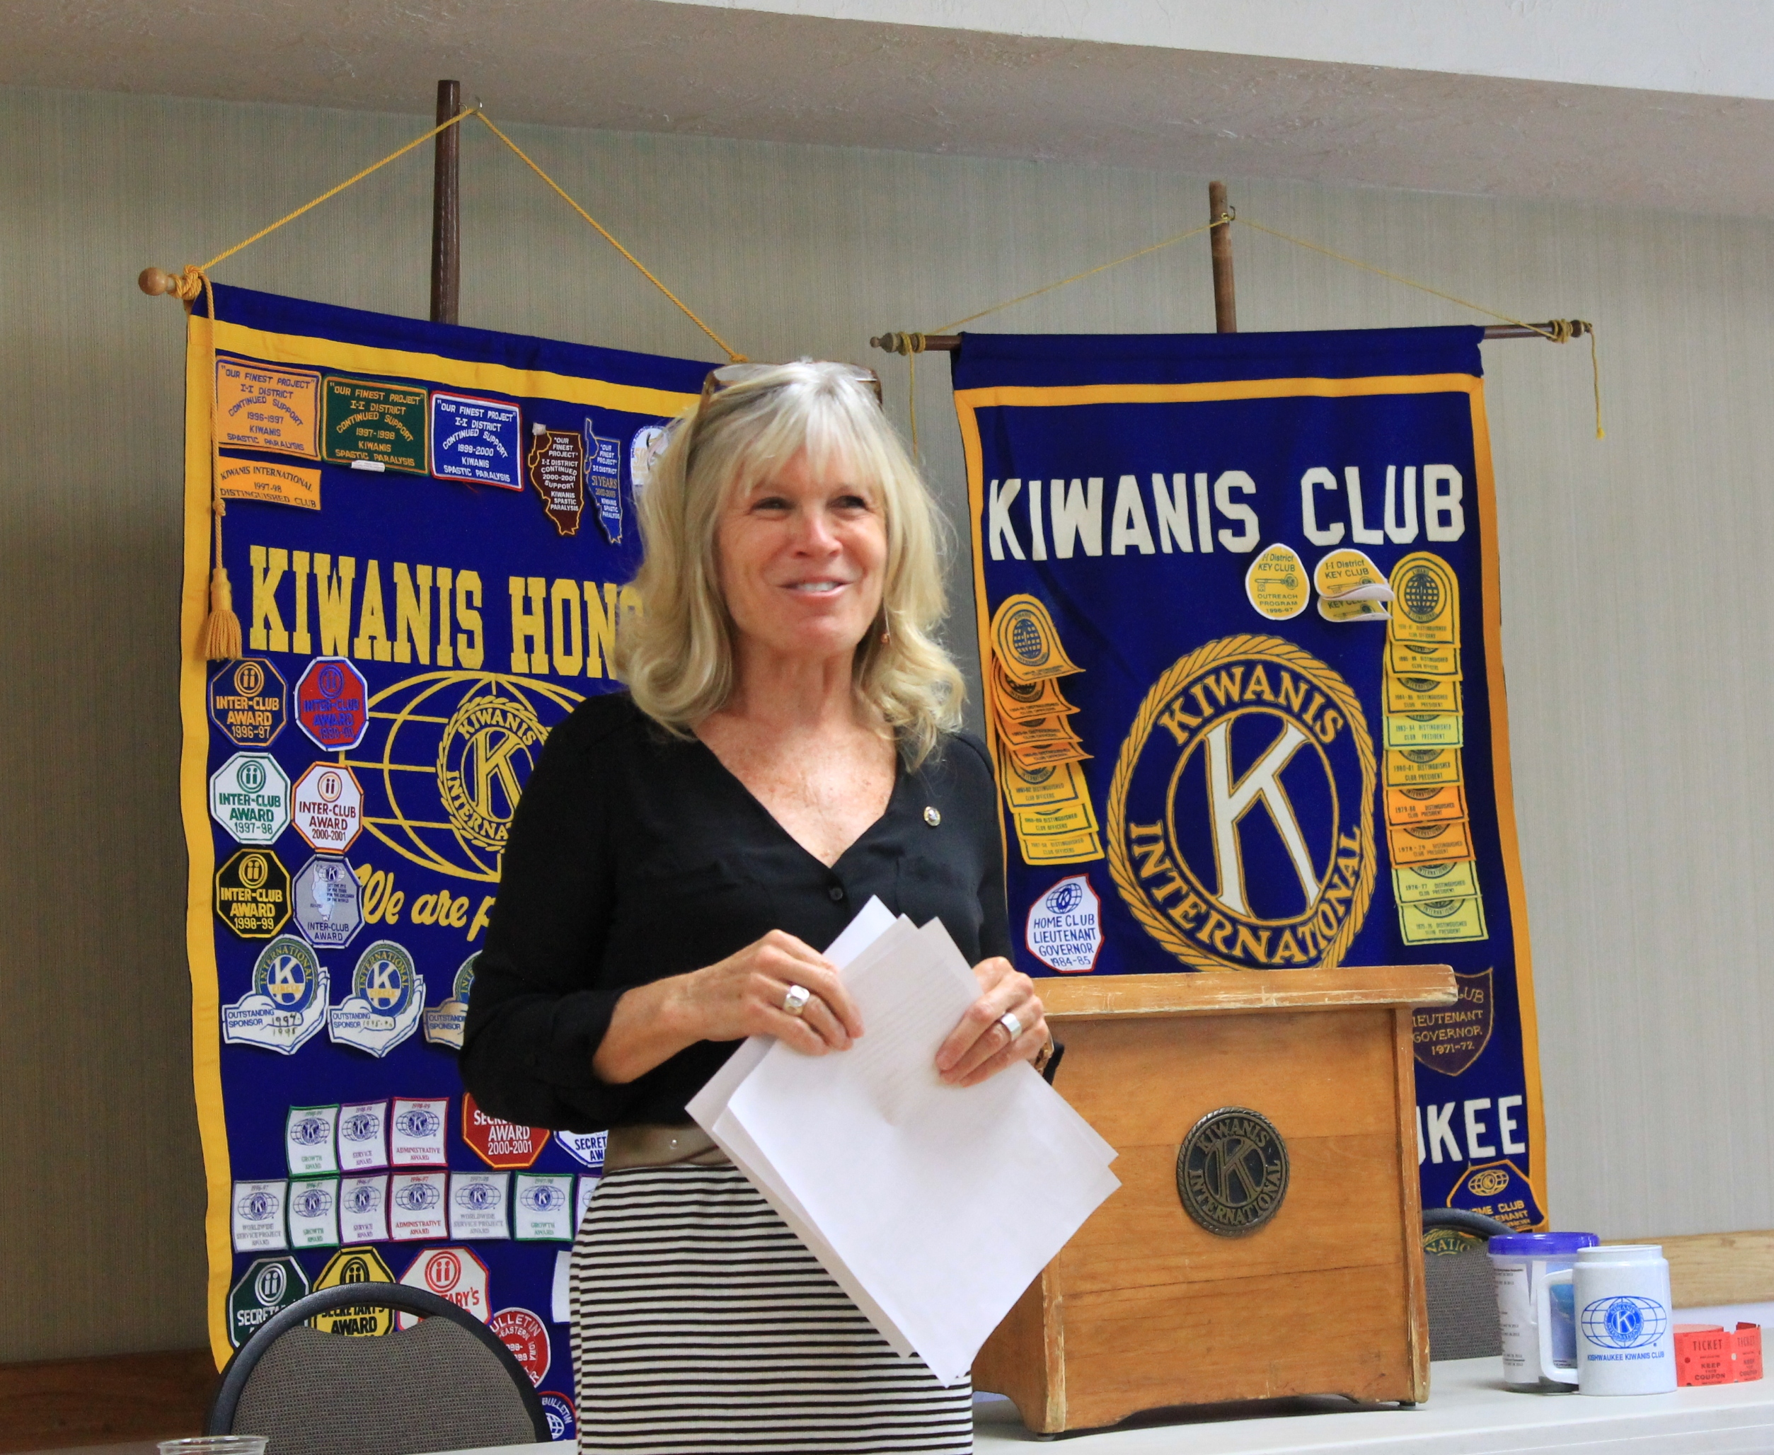
PROGRAM

Today Tarryn Thaden (DeKalb club) humbly and excitedly introduced herself as our new Lt. Gov, and gave us an idea of what the upcoming year might be like. She specifically referred to the Fairdale Park rebuilding project. She then sentenced, er, installed our new officers. For those of you keeping score at home, that’s Dick Dowen as President, Joe Gastiger as President-elect, Bob Higgerson as Vice-President, Lisa Small as Treasurer, Ken Doubler as Secretary, Sue Doubler as Asst. Treasurer, Jerry Wahlstrom as Asst. Secretary, and Abby Chemers as Immediate Past President. The new board members are: Norm Schaeffer, Bill Minor, Mike Mooney, and Dean Quarnstrom. (Continuing board members are: Al Mueller, Svetlana Henrikson, Steve Cichy, Bill Finucane, and Betty (Joe) Hampa.

Many thanks to outgoing officers Greg Spears (Immediate Past President) and board members Bob Higgerson, Diana King, Mark Sawyer, and Beryl Beryl Beryl Smith.

Heard around the tables: You want to avoid the Merit Parkway on Friday afternoons.

Quotes for the day
“The fire of God
Fills him. I never saw his like; there lives
No Greater leader.”
Alfred Lord Tennyson – Idylls of the King: Lancelot and Elaine, Line 314.

“The leader, mingling with the vulgar host
Is in the common mass of matter lost”
- Alexander Pope The Odyssey of Homer. Book iv. Line 397.

UPCOMING PROGRAMS: (Why not invite a guest? – that could also mean a prospective member!)
October 7 BOARD MEETING @ Lincoln Inn
October 14 John Laskowski Engineers Without Borders
October 21 Anita Zurbrugg Awards Day
October 28 TBA
November 4 BOARD MEETING @ Lincoln Inn

Today’s Attendance:
36 | Kish Kiwanians
0 | Guests:Bill’s daughter Shannon, Deb Armstrong, Jessica Antonacci
2 | VIPs, etc.Lt. Gov. Tarryn, Circle-K Prez Lica
0 | Speakers:
38 | TOTAL

See more of the newsletter on the following pages:

OCTOBER BIRTHDAYS!
1 Ken Doubler 17 Kevin Breuer
3 Dick Dowen 21 Bill Finucane
4 Michelle Graham 28 Mike Mooney
10 Bob Higgerson

YOUTH SERVICE BUREAU WISH LIST:
TAG (Therapeutic Art-Making Group):
Permanent markers, canvases, paint brushes, glue, watercolors, drawing paper, tracing paper, oil pastels, colored pencils, markers….any and all art supplies could help.
VolunTEEN:
Gardening gloves, small handheld shovels, cleaning supplies.
Thank you so much again for the opportunity to share about the Youth Service Bureau, and thank you for your dedication to the community.
Diana L. Hulst, Executive Director of DeKalb County Youth Service Bureau

The following are items we (Safe Passage) regularly need. If you are looking to donate please consider these items!

1. Gas station & Wal-Mart gift cards
2. Non-perishable food
3. Linens for twin beds
4. Towels & washcloths
5. Diapers & Pull-ups (especially larger sizes)
6. Baby wipes
7. Paper towels, toilet paper, & tissues
8. Sweatpants & sweatshirts
9. Women’s underwear (bras and panties)
10. Cleaning supplies (dish soap, spray cleaners, laundry detergent, etc.)
11. Harder hair brushes
12. Hair conditioner
13. Olive Oils for hair (not cooking oil)
14. Pantine shampoo/conditioner (Brown Bottle)
15. Motions haircare products
Serving the Children of the World

