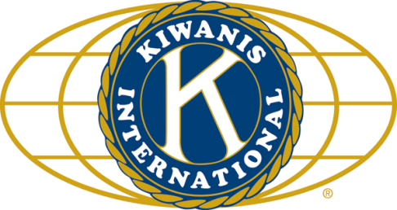

THE NEWS FROM the
VOLUME XLVII, NUMBER 1
39

KISHWAUKEE KIWANIS CLUB of DeKalb, Illinois

October 14, 2015 Editor: Paul Stoddard http://www.kishkiwanis.org

LUNCH:Turkey ‘n fixins, spuds, rolls, salad,andof course, cookies.
SONG: America the Beautiful,led by Bill C. Invocation:Dick D.

Officers for 2014-2015

President Dick Dowen
President Elect Joe Gastiger
Vice President Bob Higgerson
Treasurer Lisa Small
Asst. Treasurer Sue Doubler
Secretary Ken Doubler
Asst. Secretary Jerry Wahlstrom
Immediate Past President
Abby Chemers
Lt. Governor Tarryn Thaden
District Governor Penny Linneweh

********************
Kishwaukee Kiwanis Meetings

2nd, 3rd, 4th, (and 5th) Wednesday at 11:45 a.m.
Hopkins Park Community Room

********************
K-Family Events/Meetings

Circle K Every Wednesday night at 8:00 p.m. in DuSable 254. Hint: To stay young, attend one of their meetings!

AKtion Club – Second Tuesday of the month at 2:00 p.m. at Opportunity House (357 N. California St.) in Sycamore.

********************
Defining Statement

Kiwanis is a global organization of volunteers dedicated to changing the world, one child and one community at a time.

********************
Flag Salute

As our flag signifies purity, valor, and justice, may we as true Kiwanians exemplify these virtues as we serve the children of the world.

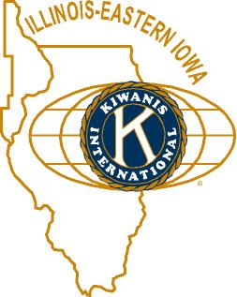

ANNOUNCEMENTS, EVENTS

and OPPORTUNITITES

Dick’s first meeting as Prez. He established that he was in charge pretty quickly.

The next Interclub is at 6:30 pm, this Friday at River Heights. It’s the Governor’s visit. Cost is $13.

Mike Mooney reminded us it’s Feed My Starving Children time. Two ways to participate – come to the meal packing at Suter’s on Thursday, November 12 (7-9 pm). See Jerry W about that. We’re also selling (or buying) raffle tickets (the club gets $8 for each ticket we sell). The grand prize is $10,000.Mike is the raffle man.

PEANUT DAY (Friday Sept 25): It was time to sell peanuts. Donations from streets and stores was about $300 above last year, and pre-sales were comparable to last year’s.

Prayer Breakfast will be on Thursday, October 22, at 7 am, at the Syc United Methodist Church. NIU Prez Doug Baker will be the speaker. Members will be covered by the club. Other guests – the cost is $7. Talk to Jerry Smith.

DeKalb Chamber Halloween 1 – 3 pm. (Saturday). Volunteers needed to help out. Contact Jessica Antonacci (815 756 6306; jessica.antonacci@dekalb.org).

HS Football Championships: 300volunteer opportunities exist, Friday November 27th and Saturday November 28th. Talk to Bill Finucane or Deb Armstrong from the DeKalb County Convention & Visitors’ Bureau.

Toiletries- We’re collecting these for Safe Passage. (See below.)

Sue – NEW DUES ARE DUE! (Same as the old dues).

Joan is collecting box tops and Coke lids. Jennie will take your soup labels. AKtion Club is collecting aluminum cans and other recyclable materials.

Archives: If you find any old stuff related to Kiwanis, please give a copy to Norm!

Pie Auction: November 19
from 6:00-8:30 p.m. at Hopkins Park
(refer to later pages of newsletter for more information and registration form (if you would like to show off your baking talents).

PROGRAM

John Laskowski stopped by to talk about his organization, Engineers without Borders (EWB). He brought his techie, Jarod. John is the interim director of Public Works for the city of DeKalb. Jarod is his intern. EWB is like Doctors without Borders, but with different members – mostly students in EWB. EWB is international, humanitarian, and non-profit. There mission is to help people meet there basic infrastructure needs, and also to help the student members appreciate the higher goals of engineering (that’s not what John said, but the best I can remember). In 2000, Dr. Bernard Amadei, from UC Boulder, saw a situation in Belize that needed to be addressed, and thought it would be a great opportunity for Boulder students to get involved. EWB was born! Infrastructure, agriculture, energy are all areas that EWB helps out with. An interesting project – using a soccer ball as a small generator. Kids play soccer, ball powers a light bulb that allows the teacher to grade papers. NIU’s first project was in 2009/2010 in Tanzania. Dr. Otieno has family connections there. They needed a cook stove, water heater, and a light source. NIU students from all sorts of different majors help – they don’t have to be engineers, or even like math. Current project is with Geology’s hydrogeologic students (think MEL). The project is in central Mexico. Finding clean water is problematic there. John and Jerod had a practical demonstration for us. They use silica nitrate, and clay filters which are hand-made by the locals, to purify the water. Ground up charred bones (charcoal) are also used in the filtering process.
Check them out on the web, where there are no borders:http://www.ewb-usa.org John requested the honorarium go to EWB.

Heard around the tables: Not sure, I wasn’t paying attention. Too busy concentrating on lunch.

Quotes for the day
“To the optimist, the glass is half full. To the pessimist, the glass is half empty. To the engineer, the glass is twice as big as it needs to be.”
- Anonymous.

UPCOMING PROGRAMS: (Why not invite a guest? – that could also mean a prospective member!)
October 21 Anita Zurbrugg Awards Day
October 28 TBA
November 4 BOARD MEETING @ Lincoln Inn

Today’s Attendance:
37 | Kish Kiwanians
0 | Guests:
0 | VIPs, etc.
2 | Speakers: John, Jerod
39 | TOTAL

See more of the newsletter on the following pages:

Pie Auction Registration Form
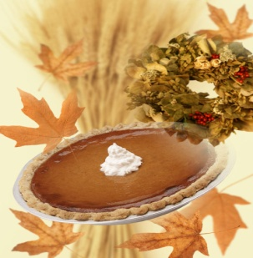

Show off your baking skills or lack of and donate a pie for the event.

The auction will be limited to 20 pies however we will also have pies available for purchase on our Holiday Pie table. Pies can be purchased for $25.
Pies eligible for auction will be judged based on appearance, ingredients, and the most unique basket.

Rules for pies
- Pies must be homemade. This is great time to show-off your talents.
- Pies must be baked in a non-returnable container. Be creative and include a lavish basket with your pie.
Please let us know in advance if you will be registering a pie.
Registration deadline is November 9^{h}.
Pies can be dropped off at FSA 14 Health Services Drive on November 18th from 2-6:30pm.

Please call 815-758-8616 for more information.

Thank you for your support of Senior Services!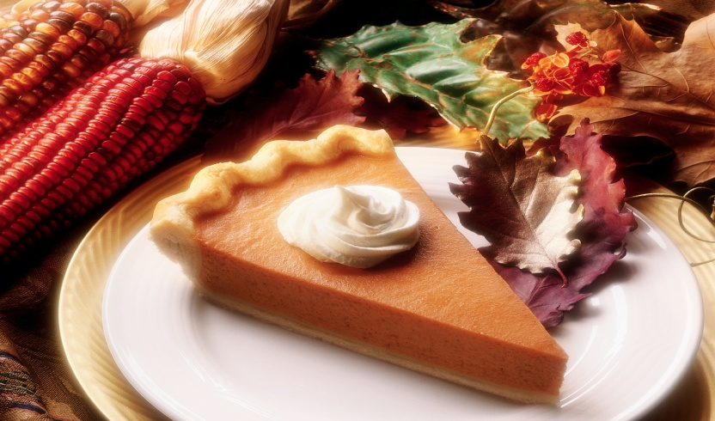
Pie Auction Registration Form

Registration Deadline November 9th 2015
Please Print and Complete in Full

Name:
Agency Name:
Address:
City:
Phone:
E-Mail:

Please indicate what type of pie you will be representing

Apple
Citrus
Berry
Fruit
Nut
Pumpkin
Peanut Butter
Sweet Potato
Holiday Pie
Other

Please call Diana 815-758-8616 for questions or more information

YOUTH SERVICE BUREAU WISH LIST:
TAG (Therapeutic Art-Making Group):
Permanent markers, canvases, paint brushes, glue, watercolors, drawing paper, tracing paper, oil pastels, colored pencils, markers….any and all art supplies could help.
VolunTEEN:
Gardening gloves, small handheld shovels, cleaning supplies.
Thank you so much again for the opportunity to share about the Youth Service Bureau, and thank you for your dedication to the community.
Diana L. Hulst, Executive Director of DeKalb County Youth Service Bureau

The following are items we (Safe Passage) regularly need. If you are looking to donate please consider these items!

1. Gas station & Wal-Mart gift cards
2. Non-perishable food
3. Linens for twin beds
4. Towels & washcloths
5. Diapers & Pull-ups (especially larger sizes)
6. Baby wipes
7. Paper towels, toilet paper, & tissues
8. Sweatpants & sweatshirts
9. Women’s underwear (bras and panties)
10. Cleaning supplies (dish soap, spray cleaners, laundry detergent, etc.)
11. Harder hair brushes
12. Hair conditioner
13. Olive Oils for hair (not cooking oil)
14. Pantine shampoo/conditioner (Brown Bottle)
15. Motions haircare products
Serving the Children of the World

