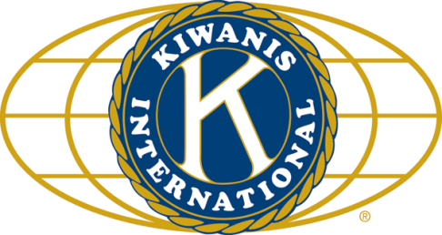

THE NEWS FROM the
VOLUME XLVII, NUMBER 2
39

KISHWAUKEE KIWANIS CLUB of DeKalb, Illinois

October 21, 2015 Editor: Paul Stoddard http://www.kishkiwanis.org

LUNCH: Garfield’s favorite: Lasagna!!, rolls, salad,and of course, cookies.
SONG: God Bless America, led by Bill Cummings Invocation: Al Mueller

Officers for 2015-2016

President Dick Dowen
President Elect Joe Gastiger
Vice President Bob Higgerson
Treasurer Lisa Small
Asst. Treasurer Sue Doubler
Secretary Ken Doubler
Asst. Secretary Jerry Wahlstrom
Immediate Past President
Abby Chemers
Lt. Governor TarrynThaden
District Governor Penny Linneweh

********************
Kishwaukee Kiwanis Meetings

2nd, 3rd, 4th, (and 5th) Wednesday at 11:45 a.m.
Hopkins Park Community Room

********************
K-Family Events/Meetings

Circle K Every Wednesday night at 8:00 p.m. in DuSable 254. Hint: To stay young, attend one of their meetings!

AKtion Club – Second Tuesday of the month at 2:00 p.m. at Opportunity House (357 N. California St.) in Sycamore.

********************
Defining Statement

Kiwanis is a global organization of volunteers dedicated to changing the world, one child and one community at a time.

********************
Flag Salute

As our flag signifies purity, valor, and justice, may we as true Kiwanians exemplify these virtues as we serve the children of the world.

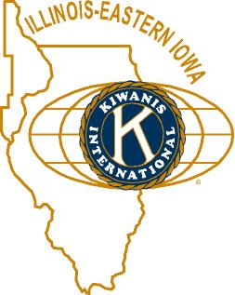

ANNOUNCEMENTS, EVENTS

and OPPORTUNITITES

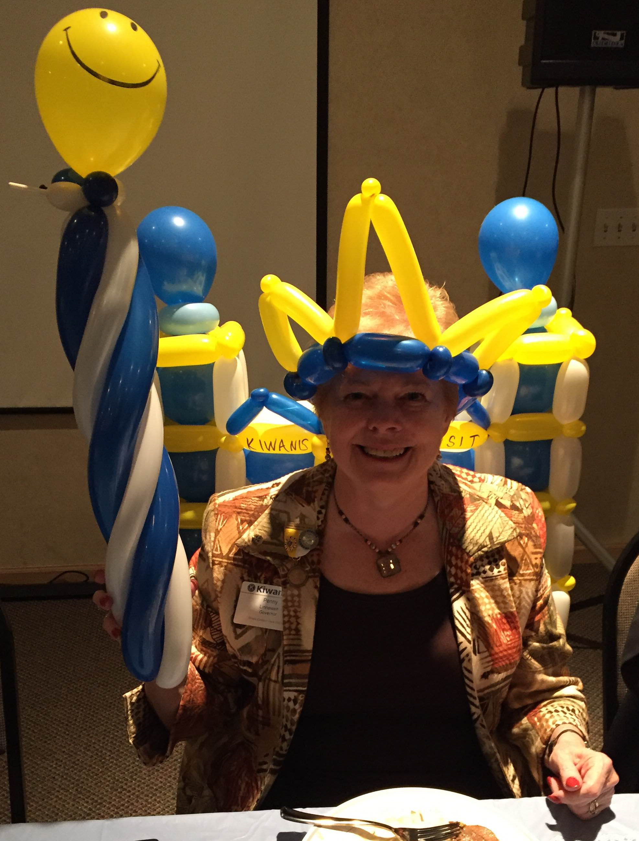
The last Interclub wasat 6:30 pm, Friday at River Heights. It was the Governor’s visit. Governor Penny Linneweh made the mistake at District Convention of mentioning that she used to feel like a princess. After having children, she became the queen. With grandchildren, she is now the Queen Mother. In keeping with the Queen Mother status, she was presented her thrown, scepter, and tiara thanks to the amazing talents of Circle Ker Lica Sato-Keane. We were well represented with 7 members. “Do it for the Children.”

Mike Mooney reminded us it’s Feed My Starving Children time. Two ways to participate – come to the meal packing at Suter’s on Thursday, November 12 (7-9 pm). See Jerry W (the protocol breaker) about that. We’re also selling (or buying) raffle tickets (the club gets $8 for each ticket we sell). The grand prize is $10,000.Mike is the raffle man.

Prayer Breakfast will be tomorrow Thursday, October 22, at 7 am, at the Syc United Methodist Church. NIU Prez Doug Baker will be the speaker. Talk to Jerry Smith. Nine Kish Kiwanians are going (including protocol-breaking Jerry W.).

For Future Consideration: Ralph Sherman has come up with an idea that Dick is really keen on, but it needs 100% participation. Talk to Ralph, or come to the next board meeting for details. Dick’s being tight-lipped and mysterious.

We need more members for the Membership committee. This is important, so please consider helping out in this area. Amy will also send out the Committee Listing for you to consider becoming a member of other committees whose membership is a little low.

DeKalb Chamber Halloween 1 – 3 pm. (Saturday). Volunteers needed to help out. Contact Jessica Antonacci (815 756 6306; jessica.antonacci@dekalb.org).

HS Football Championships: 300volunteer opportunities exist, Friday November 27th and Saturday November 28th. Talk to Bill Finucane or Deb Armstrong from the DeKalb County Convention & Visitors’ Bureau.

Bell Ringing Friday November 13 at Schnuck’s.

Toiletries- We’re collecting these for Safe Passage. (See below.)

Sue – NEW DUES ARE DUE!(Same as the old dues).

Joan is collecting box tops and Coke lids. Jennie will take your soup labels. AKtion Club is collecting aluminum cans and other recyclable materials.

Archives: If you find any old stuff related to Kiwanis, please give a copy to Norm!

Almost a PoP Box
Dick got his Presidential pin (and a hug).
Abby got her Past President’s pin, and her plaque.
And in case you missed it at the Gov’s Dinner,
Abby received a Zeller award.
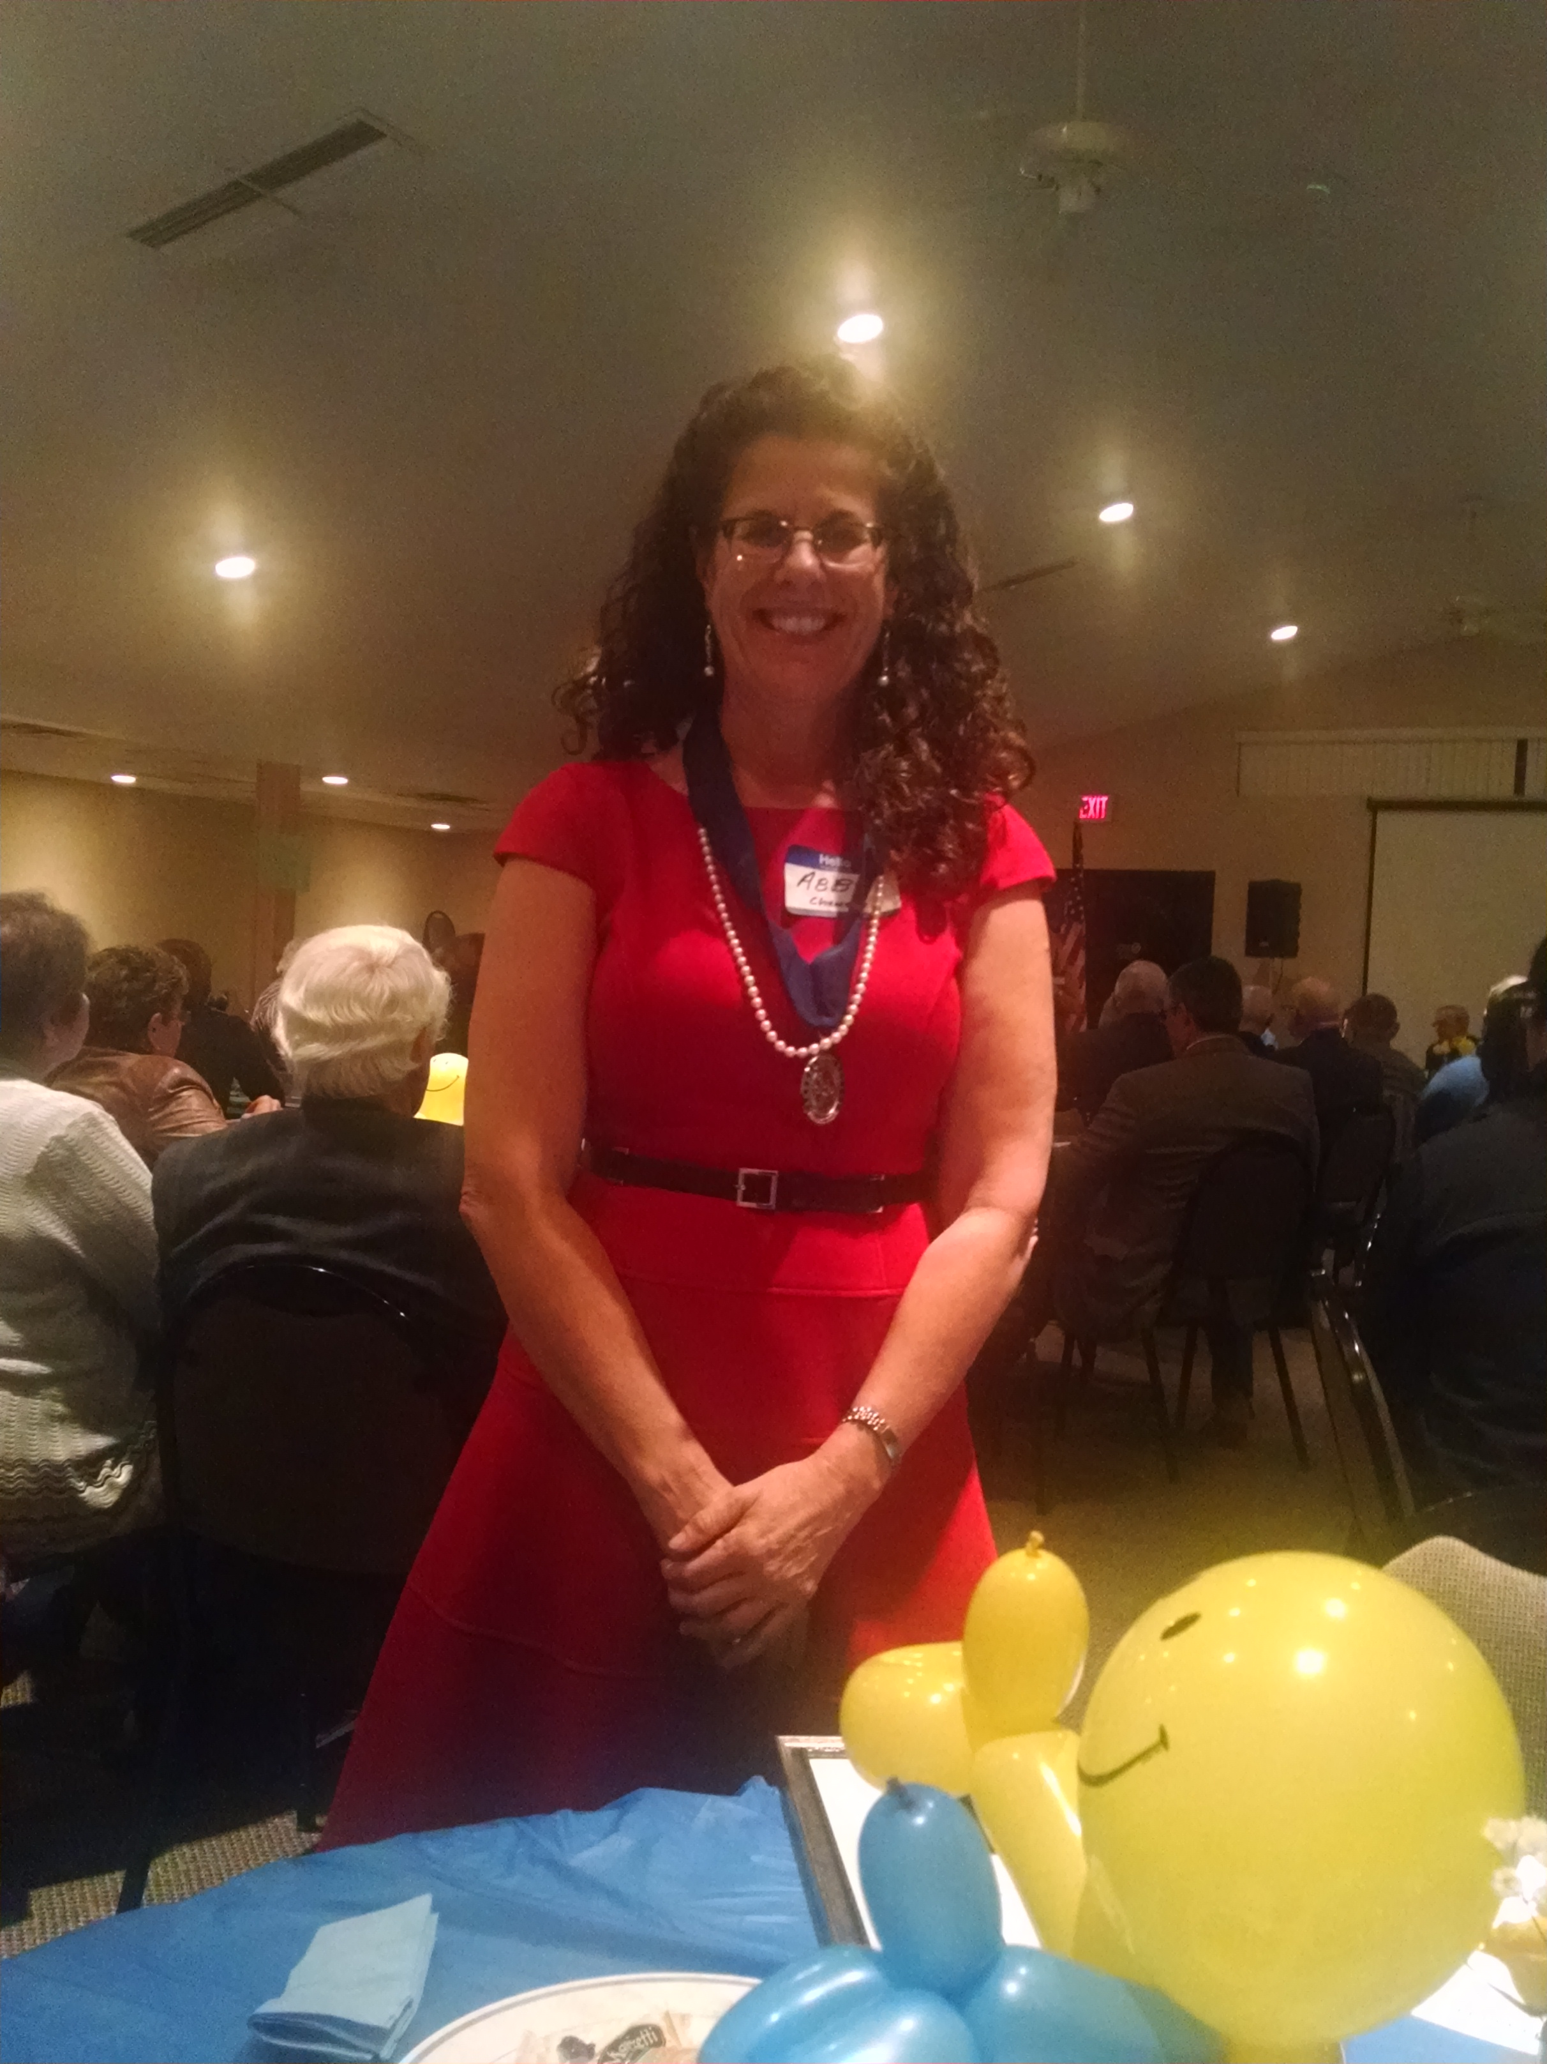
Kudos to Abby and her dedication to the Eliminate program!!

KISH KIWANIS SERVICE LEADERSHIP AWARD: 38 years of service, past president, “Power Broker,” several times a board member, lots and lots of committee: 3 winners: Beryl, Beryl, Beryl! In addition to the certificate and a statuette, a $500.00 donation was given to the DeKalb County Community Foundation in its Community Works program in Beryl’s name. Congratulations on a well deserved honor!
Last year’s recipient, Norm Schaeffer, presents the Service Leadership Award
to Beryl Smith.

PROGRAM

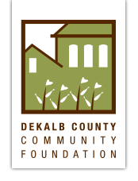
Anita Zurbrugg, Program Director for the DeKalb County Community Foundation joined us to help celebrate our Awards Day. 22 years ago, with the forward thinking of Charlie and Mary Roberts, the DeKalb County Community Foundation was born. The mission of the DCCF is to enhance the quality of life in DeKalb County by proactively addressing community needs and expanding, managing, and distributing philanthropic resources. In these 22 years, there has been an enormous amount of growth. In 1993, DCCF started with $4.1 million and has grown this to $44.5 million to date. They currently have five staff members and are in the process of interviewing for a 6th person. Programs include: Grantmaking; Youth Engaged in Philanthropy (YEP); DeKalb County Nonprofit Partnership (DCNP); Community Works (Early Care and Education, Land Use Initiative, and Workforce Development); NIU Nongovernmental Leadership & Development (NGOLD) DCNP Undergraduate Internship Program (interns earn a $575.00 stipend during the course of the semester); and their latest program, Advancing DeKalb County. Many of these programs are oriented towards assisting the young people in the county and preparing them for the future and how to be successful. Jerry Smith presented the speaker check to Anita to go towards Safe Passage and he also presented the $500.00 check in Beryl Smith’s name. There was much hugging going on!

Heard around the tables: Not sure, I wasn’t paying attention. Too busy concentrating on lunch.

Quote for the day
“It is amazing what you can accomplish if you do not care who gets the credit.”
- Harry S. Truman

UPCOMING PROGRAMS: (Why not invite a guest? – that could also mean a prospective member!)
October 28 Tom Cleveland DeKalb Taylor Municipal Airport
November 4 BOARD MEETING @ Lincoln Inn

Today’s Attendance:
37 | Kish Kiwanians – a WAG
1 | Not really a guest: Nick Lisle (new member); Cherie Smith popped in to see Beryl receive his award
0 | VIPs, etc.
1 | Speakers: Anita
39 | TOTAL
See more of the newsletter on the following pages:
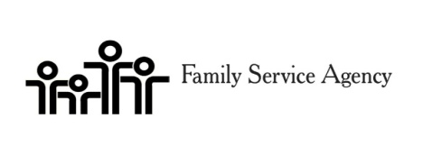

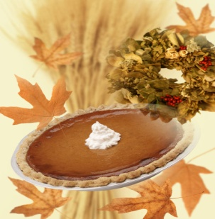
Pie Auction Registration Form

Show off your baking skills or lack of and donate a pie for the event.

The auction will be limited to 20 pies however we will also have pies available for purchase on our Holiday Pie table. Pies can be purchased for $25.
Pies eligible for auction will be judged based on appearance, ingredients, and the most unique basket.

Rules for pies
- Pies must be homemade. This is great time to show-off your talents.
- Pies must be baked in a non-returnable container. Be creative and include a lavish basket with your pie.
Please let us know in advance if you will be registering a pie.
Registration deadline is November 9^{h}.
Pies can be dropped off at FSA 14 Health Services Drive on November 18th from 2-6:30pm.

Please call 815-758-8616 for more information.
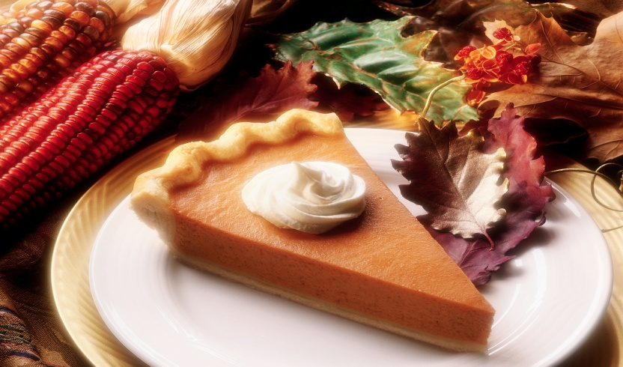Thank you for your support of Senior Services!
Pie Auction Registration Form

Registration Deadline November 9th 2015
Please Print and Complete in Full

Name:
Agency Name:
Address:
City:
Phone:
E-Mail:

Please indicate what type of pie you will be representing

Apple
Citrus
Berry
Fruit
Nut
Pumpkin
Peanut Butter
Sweet Potato
Holiday Pie
Other

Please call Diana 815-758-8616 for questions or more information

YOUTH SERVICE BUREAU WISH LIST:
TAG (Therapeutic Art-Making Group):
Permanent markers, canvases, paint brushes, glue, watercolors, drawing paper, tracing paper, oil pastels, colored pencils, markers….any and all art supplies could help.
VolunTEEN:
Gardening gloves, small handheld shovels, cleaning supplies.
Thank you so much again for the opportunity to share about the Youth Service Bureau, and thank you for your dedication to the community.
Diana L. Hulst, Executive Director of DeKalb County Youth Service Bureau

The following are items we (Safe Passage) regularly need. If you are looking to donate please consider these items!

1. Gas station & Wal-Mart gift cards
2. Non-perishable food
3. Linens for twin beds
4. Towels & washcloths
5. Diapers & Pull-ups (especially larger sizes)
6. Baby wipes
7. Paper towels, toilet paper, & tissues
8. Sweatpants & sweatshirts
9. Women’s underwear (bras and panties)
10. Cleaning supplies (dish soap, spray cleaners, laundry detergent, etc.)
11. Harder hair brushes
12. Hair conditioner
13. Olive Oils for hair (not cooking oil)
14. Pantine shampoo/conditioner (Brown Bottle)
15. Motions haircare products
Serving the Children of the World

