THE NEWS FROM the
VOLUME XLVII, NUMBER 3
39

KISHWAUKEE KIWANIS CLUB of DeKalb, Illinois

October 28, 2015 Editor: Paul Stoddard http://www.kishkiwanis.org

LUNCH: Soup and sandwiches, yummy potato chips, fruit salad,andof course, cookies.
SONG: America The Beautiful, led by Bill C. Invocation:Dick D.

Officers for 2015-2016

President Dick Dowen
President Elect Joe Gastiger
Vice President Bob Higgerson
Treasurer Lisa Small
Asst. Treasurer Sue Doubler
Secretary Ken Doubler
Asst. Secretary Jerry Wahlstrom
Immediate Past President
Abby Chemers
Lt. Governor TarrynThaden
District Governor Penny Linneweh

********************
Kishwaukee Kiwanis Meetings

2nd, 3rd, 4th, (and 5th) Wednesday at 11:45 a.m.
Hopkins Park Community Room

********************
K-Family Events/Meetings

Circle K Every Wednesday night at 8:00 p.m. in DuSable 254. Hint: To stay young, attend one of their meetings!

AKtion Club – Second Tuesday of the month at 2:00 p.m. at Opportunity House (357 N. California St.) in Sycamore.

********************
Defining Statement

Kiwanis is a global organization of volunteers dedicated to changing the world, one child and one community at a time.

********************
Flag Salute

As our flag signifies purity, valor, and justice, may we as true Kiwanians exemplify these virtues as we serve the children of the world.

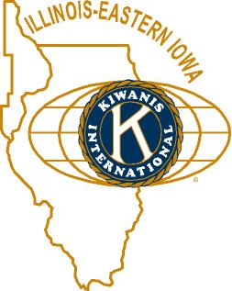

ANNOUNCEMENTS, EVENTS

and OPPORTUNITITES

The last/next Interclubtoday, here. Who knew? (Not too many it seems.) After today, the next will be at Aktion Club next month. I think it’s on the 12th.

Mike Mooney reminded us it’s Feed My Starving Children time. Two ways to participate – come to the meal packing at Suter’s on Thursday, November 12 (7-9 pm). See Jerry W about that. 30 spots are ours. 10 or so still need to be filled. Bring a friend. We’re also selling (or buying) raffle tickets (the club gets $8 for each ticket we sell). The grand prize is $10,000.Mike is the raffle man.

For Future Consideration: Ralph Sherman has come up with an idea that Dick is really keen on, but it needs 100% participation. Talk to Ralph, or come to the next board meeting for details. Dick’s being tight-lipped and mysterious.

We need more members for the Membership committee. This is important, so please consider helping out in this area.

DeKalb Chamber Halloween 1 – 3 pm. (Saturday). Volunteers needed to help out. Contact Jessica Antonacci (815 756 6306; jessica.antonacci@dekalb.org).

HS Football Championships: 300volunteer opportunities exist, Friday November 27th and Saturday November 28th. Talk to Bill Finucane or Deb Armstrong from the DeKalb County Convention & Visitors’ Bureau. Elevator duty (think warm!) signups will be happening.

Bell Ringing Friday November 13 at Schnuck’s. Signups are happening.

See Jenny for info about Toys For Tots and contributing to the Salvation Army Thanksgiving Baskets.

Toiletries- We’re collecting these for Safe Passage. (See below.)

Sue – NEW DUES ARE DUE!(Same as the old dues).

Joan is collecting box tops and Coke lids. Jennie will take your soup labels.AKtion Club is collecting aluminum cansand other recyclable materials.

Archives: If you find any old stuff related to Kiwanis, please give a copy to Norm!

Gavel Passing
The gavel showed up in something that looked like a cartoon bomb, but I think it was a pumpkin painted Kiwanis blue. The accompanying knife did not prove useful. But Dick’s persistence paid off.

PROGRAM

Tom Cleveland flew by to talk about the local airport, of which he is the manager. Built by the US Navy in the mid forties, bought by the city for $1 in 1947. It can handle DC-9s and 737s. The Navy built the airport for their drone program (we had a program about the drone program a while back). Plans are to assemble one of the drones from various parts gathered and yet to be gathered, and display it at the airport. Several commercial concerns make use of the airport, and as such the airport is a gateway to DeKalb for many people. Tom likes to make a good, welcoming impression for these folks. Flight school (in association with Kish College) and tours are ways the local public can be involved. Tom showed pictures of some of the more interesting planes have landed (B17, B25, F18, P40, a tri-engine plane, etc.). Of course, local ag planes make good use of the airport as well. Pictures of snow removal equipment at the airport snuck into the presentation as well. The NIU basketball team has a nice, 30-passenger plane to use for their trips. Tom’s trying to get the airport certified to handle football traffic now. And it’s not all about planes. They had a swing dance there recently. Al M. commented that our airport is bucking a national trend of local airport declines and closings.

Heard around the tables: Opening night jitters last night, and that’s all I’m saying about that.

Quote for the day
“It can hardly be a coincidence that no language on earth has ever produced the expression, 'As pretty as an airport.’ ”
- Douglas Adams, The Long, Dark Tea-Time of the Soul

UPCOMING PROGRAMS: (Why not invite a guest? – that could also mean a prospective member!)
November 4 BOARD MEETING @ Lincoln Inn
November TBA (Who’s on the program committee?)

Today’s Attendance:
37 | Kish Kiwanians
3 | John Toles (Syc), Jeff (DeK), Larry (Syc)
1 | VIPs, etc. LG Tarryn
1 | Speakers: Tom
42 | TOTAL

See more of the newsletter on the following pages:

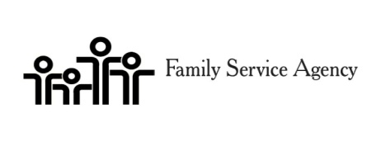
Pie Auction Registration Form
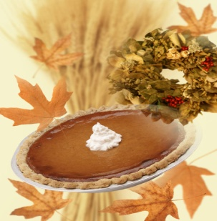

Show off your baking skills or lack of and donate a pie for the event.

The auction will be limited to 20 pies however we will also have pies available for purchase on our Holiday Pie table. Pies can be purchased for $25.
Pies eligible for auction will be judged based on appearance, ingredients, and the most unique basket.

Rules for pies
- Pies must be homemade. This is great time to show-off your talents.
- Pies must be baked in a non-returnable container. Be creative and include a lavish basket with your pie.
Please let us know in advance if you will be registering a pie.
Registration deadline is November 9^{h}.
Pies can be dropped off at FSA 14 Health Services Drive on November 18th from 2-6:30pm.

Please call 815-758-8616 for more information.

Thank you for your support of Senior Services!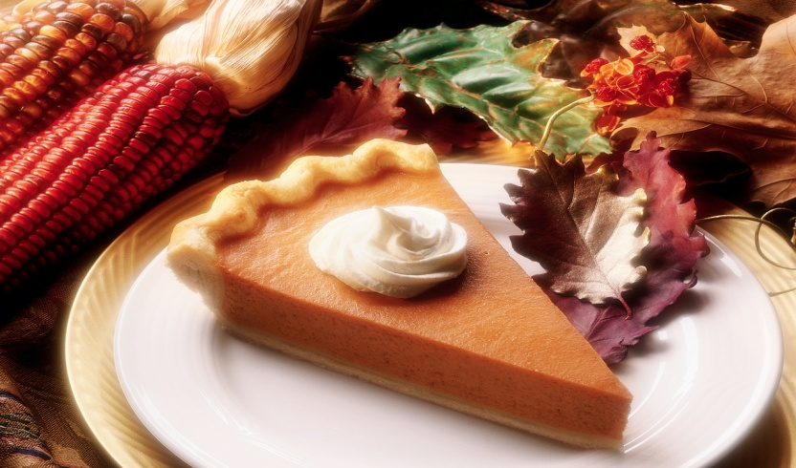
Pie Auction Registration Form

Registration Deadline November 9th 2015
Please Print and Complete in Full

Name:
Agency Name:
Address:
City:
Phone:
E-Mail:

Please indicate what type of pie you will be representing

Apple
Citrus
Berry
Fruit
Nut
Pumpkin
Peanut Butter
Sweet Potato
Holiday Pie
Other

Please call Diana 815-758-8616 for questions or more information

YOUTH SERVICE BUREAU WISH LIST:
TAG (Therapeutic Art-Making Group):
Permanent markers, canvases, paint brushes, glue, watercolors, drawing paper, tracing paper, oil pastels, colored pencils, markers….any and all art supplies could help.
VolunTEEN:
Gardening gloves, small handheld shovels, cleaning supplies.
Thank you so much again for the opportunity to share about the Youth Service Bureau, and thank you for your dedication to the community.
Diana L. Hulst, Executive Director of DeKalb County Youth Service Bureau

The following are items we (Safe Passage) regularly need. If you are looking to donate please consider these items!

1. Gas station & Wal-Mart gift cards
2. Non-perishable food
3. Linens for twin beds
4. Towels & washcloths
5. Diapers & Pull-ups (especially larger sizes)
6. Baby wipes
7. Paper towels, toilet paper, & tissues
8. Sweatpants & sweatshirts
9. Women’s underwear (bras and panties)
10. Cleaning supplies (dish soap, spray cleaners, laundry detergent, etc.)
11. Harder hair brushes
12. Hair conditioner
13. Olive Oils for hair (not cooking oil)
14. Pantine shampoo/conditioner (Brown Bottle)
15. Motions haircare products
Serving the Children of the World

