THE NEWS FROM the
VOLUME XLVII, NUMBER 4
39

KISHWAUKEE KIWANIS CLUB of DeKalb, Illinois

November 18, 2015 Editor: Paul Stoddard http://www.kishkiwanis.org

LUNCH: Beef something, but good beef, veggies, spuds (not mashed), salad, cookies.
SONG: America the Beautiful, led by Bill C. Invocation:Dick D.

Officers for 2015-2016

President Dick Dowen
President Elect Joe Gastiger
Vice President Bob Higgerson
Treasurer Lisa Small
Asst. Treasurer Sue Doubler
Secretary Ken Doubler
Asst. Secretary Jerry Wahlstrom
Immediate Past President
Abby Chemers
Lt. Governor TarrynThaden
District Governor Penny Linneweh

********************
Kishwaukee Kiwanis Meetings

2nd, 3rd, 4th, (and 5th) Wednesday at 11:45 a.m.
Hopkins Park Community Room

********************
K-Family Events/Meetings

Circle K Every Wednesday night at 8:00 p.m. in DuSable 254. Hint: To stay young, attend one of their meetings!

AKtion Club – Second Tuesday of the month at 2:00 p.m. at Opportunity House (357 N. California St.) in Sycamore.

********************
Defining Statement

Kiwanis is a global organization of volunteers dedicated to changing the world, one child and one community at a time.

********************
Flag Salute

As our flag signifies purity, valor, and justice, may we as true Kiwanians exemplify these virtues as we serve the children of the world.

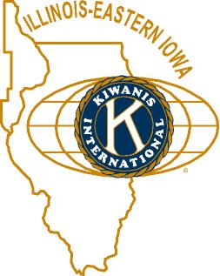

ANNOUNCEMENTS, EVENTS

and OPPORTUNITITES

Dick read some Thank yous.

The next Interclub Tuesday December 1 at Sorento’s. We’re passing the gavel to AKtion Club.

December 23 and 30 meetings: Will be roundtables at the Lincoln Inn (at noon); everyone will be responsible for their own meals off the menu.

Family Service Pie Auction is tomorrow (Thursday) night at 6 pm, at Hopkins Park. See the flyer below - even if you’re not going, it’s a nice flyer.

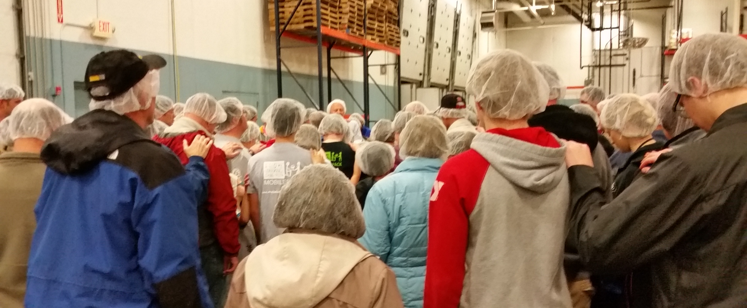
Feed My Starving Children had 16 Kish Kiwanians help out. Over 1 million meals packed over the weekend. Several members sported their hairnets at today’s meeting. Most stylish! Thanks for all your help!

Beanzie meeting, Saturday November 21 at 8 am at the Lincoln Inn.

We need more members for the Membership committee. Betty Hampa has joined! This is important, so please consider helping out in this area.

HS Football Championships: 300volunteer opportunities exist, Friday November 27th and Saturday November 28th. Talk to Bill Finucane or Deb Armstrong (from the DeKalb County Convention & Visitors’ Bureau). Elevator duty (think warm!) signups are happening.

See Jenny for info about Toys For Tots and contributing to the Salvation Army Thanksgiving Baskets and helping out next month.

Madrigal Program – it’s costly to bring (feed) them. The club voted to spring for the cost. Negotiations are ongoing – about time, not cost.

Walnut Grove Barn raising on Friday. See Amy (or Amy’s email, or today’s Daily Chronicle) for details.

Toiletries- We’re collecting these for Safe Passage. (See below.)

Sue – NEW DUES ARE DUE!(Same as the old dues).

Joan is collecting box tops and Coke lids. Jennie will take your soup labels.AKtion Club is collecting aluminum cansand other recyclable materials.

Archives: If you find any old stuff related to Kiwanis, please give a copy to Norm!

PoP Box
We informally PoPped Jerry W for all his efforts with Feed My Starving Children.

PROGRAM

Brett Brown and Denise Weinmann (Mark Sawyer’s better half), proud to be from DeKalb, provided our program today. Brett is a former member and has several DeKalb hats he’s worn. He’s currently back practicing law. Denise is with RVG Milner/Carpenter. Together they’ve been working on an ABC (America’s Best Communities) grant. These grants are sponsored by Frontier Communications, along with the Dish Network and the Weather Channel. It’s an economic development area, for communities of 9,500 – 80,000 people. DeKalb is a quarter-finalist (which earned us $35,000) along with 49 other places. Semi-finalists get $100,000, and finalists get between $1 million and $3 million for revitalization. Brett feels that DeKalb has a good sense of place, which will help with the grant’s success. Denise provided a seven-step revitalization program for they (and others) have worked up for DeKalb. The DeKalg Revitalization Plan components are: ACE Corridor – an arts, culture, and entertainment district; LaunchPad – a virtual incubator including a website and newtwork of advisors, progressing to a physical incubator (also to retain and tap into the talents of NIU alum); DeKalb Coworks – providing a coworking space that may be rented for even an hour for home businesses needing meeting space; DeKalb Food Hub – a multipurpose local foods production and distribution center (a farm to table concept); SmartSpace – STEAM education center (science, technology, engineering, arts, and math); Branding and Marketing – a community wide program to create a new DeKalb brand and market the city (www.proudlydekalb.com or #PROUDLYDEKALB); and DeKalb Leadership Institute - a leadership development program. Brett then spoke some about ProudlyDeKalb, and showed (tried to show?) an inspirational video. They are looking for other videos and pictures from groups to enhance their efforts. Perhaps we could put together a video about Kish Kiwanis? If only we had a videographer. Jim Barker – do you know of any good ones?
Check out proudlydekalb.com. In addition to general information, they have a nice discussion of the ABC program. The video is on their facebook page: https://www.facebook.com/proudlydekalb/?fref=ts

Quote for the day
“This world of ours... must avoid becoming a community of dreadful fear and hate, and be, instead, a proud confederation of mutual trust and respect.”
- Dwight D. Eisenhower

UPCOMING PROGRAMS: (Why not invite a guest? – that could also mean a prospective member!)
November 25 Beth Campen Beloved Community
December 2 BOARD MEETING @ the Lincoln Inn
December 9 Joe Gastiger A Parish’s Role in the Community
December 16 Madrigals? Library Tour? Stay tuned...
December 23 Round table @ the Lincoln Inn
December 30 Round table @ the Lincoln Inn
January 6, 2016 BOARD MEETING @ you guessed it – the Lincoln Inn

See more of the newsletter on the following pages:

Today’s Attendance:
37 | Kish Kiwanians
0 | Circle K
2 | Guest: Al’s former neighbor, Bill; Caldwell Banker (and former club president), Max
2 | Speakers: Brett and Denise
41 | TOTAL

YOUTH SERVICE BUREAU WISH LIST:
TAG (Therapeutic Art-Making Group):
Permanent markers, canvases, paint brushes, glue, watercolors, drawing paper, tracing paper, oil pastels, colored pencils, markers….any and all art supplies could help.
VolunTEEN:
Gardening gloves, small handheld shovels, cleaning supplies.
Thank you so much again for the opportunity to share about the Youth Service Bureau, and thank you for your dedication to the community.
Diana L. Hulst, Executive Director of DeKalb County Youth Service Bureau

The following are items we (Safe Passage) regularly need. If you are looking to donate please consider these items!

1. Gas station & Wal-Mart gift cards
2. Non-perishable food
3. Linens for twin beds
4. Towels & washcloths
5. Diapers & Pull-ups (especially larger sizes)
6. Baby wipes
7. Paper towels, toilet paper, & tissues
8. Sweatpants & sweatshirts
9. Women’s underwear (bras and panties)
10. Cleaning supplies (dish soap, spray cleaners, laundry detergent, etc.)
11. Harder hair brushes
12. Hair conditioner
13. Olive Oils for hair (not cooking oil)
14. Pantine shampoo/conditioner (Brown Bottle)
15. Motions haircare products
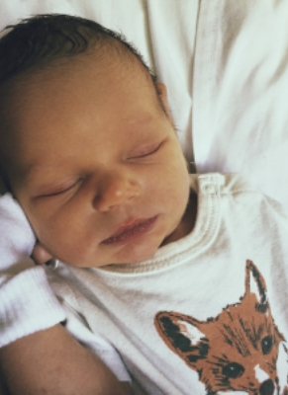
And last, but hardly least, a picture of Abby’s new grandson, Benjamin, born on November 5. Kiwanis is bound to be in his future. Again, congratulations to first-time grandmother Abby, her daughter and son in-law, and to beautiful baby Benjamin. There was a great picture of Abby holding him on her Blissful Yoga Facebook page, but I couldn’t capture it.
Serving the Children of the World

