THE NEWS FROM the
VOLUME XLVII, NUMBER 6
39

KISHWAUKEE KIWANIS CLUB of DeKalb, Illinois

December 9, 2015 Editor: Amy Polzin http://www.kishkiwanis.org

LUNCH: Chicken Parmesan, Salad, Veggies, and Cookies.
SONG: God Bless America, led by Bill Cummings Invocation: Joe Gastiger

Officers for 2015-2016

President Dick Dowen
President Elect Joe Gastiger
Vice President Bob Higgerson
Treasurer Lisa Small
Asst. Treasurer Sue Doubler
Secretary Ken Doubler
Asst. Secretary Jerry Wahlstrom
Immediate Past President
Abby Chemers
Lt. Governor TarrynThaden
District Governor Penny Linneweh

********************
Kishwaukee Kiwanis Meetings

2nd, 3rd, 4th, (and 5th) Wednesday at 11:45 a.m.
Hopkins Park Community Room

********************
K-Family Events/Meetings

Circle K Every Wednesday night at 8:00 p.m. in DuSable 254. Hint: To stay young, attend one of their meetings!

AKtion Club – Second Tuesday of the month at 2:00 p.m. at Opportunity House (357 N. California St.) in Sycamore.

********************
Defining Statement

Kiwanis is a global organization of volunteers dedicated to changing the world, one child and one community at a time.

********************
Flag Salute

As our flag signifies purity, valor, and justice, may we as true Kiwanians exemplify these virtues as we serve the children of the world.

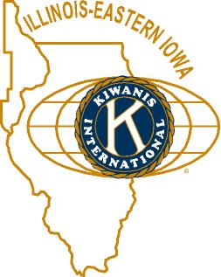

ANNOUNCEMENTS, EVENTS

and OPPORTUNITITES

December 16 (next week’s meeting) will feature the wonderful Madrigals from DeKalb High School. Please bring family, friends, guests, potential members – but if you do, please let Jack Goodrich know by December 13 (Sunday) how many you are bringing so we can be sure to have enough food. Prez Dick reminded us to be polite and hospitable. Tim mentioned that he will be out of town next week … problem solved!

December 23 and 30 meetings: Will be roundtables at the Lincoln Inn (at noon); everyone will be responsible for their own meals off the menu.

If you are able to help unload the truck for the Salvation Army toy distribution, contact Jennie Cummings. Distribution dates are December 15 and 16.

Holiday Cookie Bake Sale – Saturday, December 12 from 9:00 a.m. – 12:00 Noon at the First Congregational United Church of Christ, 615 N. First St. in DeKalb. Select from a variety of delicious homemade cookies, candies, and other holiday favorites! A mere $8.00 per pound (this is per pound of holiday favorites, not your weight or what you may gain after eating these delicious treats). All proceeds support Voluntary Action Center VAC/Meals on Wheels.

Beloved Pot Luck Dinner will be this Sunday, December 13, from 5:00 – 7:30 p.m. at the Newman Center. Since it is a pot luck, please bring some sort of food contribution to the dinner. All are invited and this is an excellent event to help break down barriers and understand our neighbors better. With the holiday season upon us, what a great way to make a major contribution to peace and understanding. Please see the last page of this newsletter for more information.

Prez Dick read a thank you from Lehan Drugs for our contribution to their Daisy Dash 5K run, proceeds going to the Pay It Forward House.

Toiletries- We’re collecting these for Safe Passage. (See below.)

Sue – NEW DUES ARE DUE! (Same as the old dues).

Joan is collecting box tops and Coke lids. Jennie will take your soup labels. AKtion Club is collecting aluminum cansand other recyclable materials.

Archives: If you find any old stuff related to Kiwanis, please give a copy to Norm!

PROGRAM

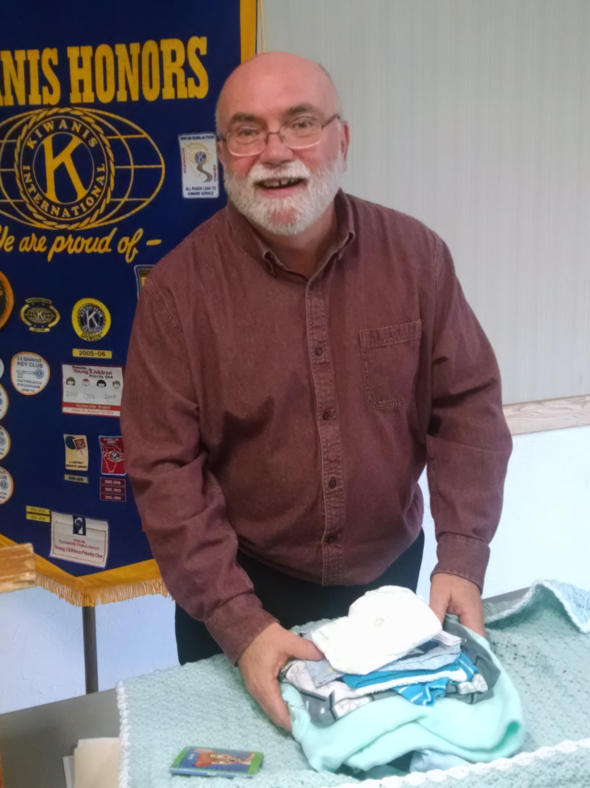
The Program Committee has come up with A Parish’s Role in the Community as a topic for programs. Today we were lucky enough to have our very own Joe Gastiger explain what the First Congregational United Church of Christ has been doing … and it’s a lot! Joe started with giving us a little history of the UCC and explained their mission statement: “To embody God’s love for all people by living an active faith in service to others.” Their service to the community includes hands-on help, fund raisers, radical inclusion/extravagant hospitality, sanctuary, good neighbors, deep commitment to interfaith dialogue, and what the pastoral role. Hands-on help includes providing layettes for new mothers on public aid. These layettes are distributed through the County Health Department and include 14 items: a book, onesies, sleepers, cardigan sweater or jacket, soap and washcloths, and receiving blankets. Joe is showing us everything included in the layette in this picture. If you would like to help, you may purchase any of these 14 items and drop them off at the church, you may make items and donate them to the layette program, or you may also donate cash to help them purchase the items. The UCC also does Thanksgiving baskets, makes food pantry donations, and donates school supplies and backpacks. They provide Christmas gifts for children served by DCFS (between 70 and 100 young people), Christmas gifts for DeKalb County Nursing Home residents (and it seems that pictures of a shirtless Elvis are being requested), meals for Hope Haven, prayer shawls for chronically ill, and community gardens to help feed our residents in need. The UCC hosts fund raisers in which all the proceeds go to the agency they are hosting. None of it goes back to the church! They provide meeting locations for a wide array of groups (some they charge a small fee, some they don’t), many of whom have very few options for meeting locations. Joe’s pastoral roles include (along with being an outstanding Kiwanian), a member of the Board for Oak Crest, Barb City Manor, and Elder Care Services. He also serves on the City of DeKalb Human Relations Commission and secures grants from FEMA for food pantries. These are just a few of the things Joe does for our community. So many thanks to our poet from Detroit, Joe Gastiger, and his church. We are truly blessed to have such caring and compassion in our community.

Quote for the day
"I have found that among its other benefits, giving liberates the soul of the giver."
- Maya Angelou

UPCOMING PROGRAMS: (Why not invite a guest? – that could also mean a prospective member!)

December 16 Madrigals A great meeting to bring a guest (young or old)!
December 23 Round table @ the Lincoln Inn
December 30 Round table @ the Lincoln Inn
January 6, 2016 BOARD MEETING @ you guessed it – the Lincoln Inn

Today’s Attendance:
33 | Kish Kiwanians (another WAG)
0 | Circle K
1 | Guest: Max Heide
1 | Speakers: Joe Gastiger (but he was counted in with the Kish Kiwanian count)
34 | TOTAL

See more of the newsletter on the following pages:
YOUTH SERVICE BUREAU WISH LIST:
TAG (Therapeutic Art-Making Group):
Permanent markers, canvases, paint brushes, glue, watercolors, drawing paper, tracing paper, oil pastels, colored pencils, markers….any and all art supplies could help.
VolunTEEN:
Gardening gloves, small handheld shovels, cleaning supplies.
Thank you so much again for the opportunity to share about the Youth Service Bureau, and thank you for your dedication to the community.
Diana L. Hulst, Executive Director of DeKalb County Youth Service Bureau

The following are items we (Safe Passage) regularly need. If you are looking to donate please consider these items!

1. Gas station & Wal-Mart gift cards
2. Non-perishable food
3. Linens for twin beds
4. Towels & washcloths
5. Diapers & Pull-ups (especially larger sizes)
6. Baby wipes
7. Paper towels, toilet paper, & tissues
8. Sweatpants & sweatshirts
9. Women’s underwear (bras and panties)
10. Cleaning supplies (dish soap, spray cleaners, laundry detergent, etc.)
11. Harder hair brushes
12. Hair conditioner
13. Olive Oils for hair (not cooking oil)
14. Pantine shampoo/conditioner (Brown Bottle)
15. Motions haircare products
DECEMBER BIRTHDAYS
1 Toney Xidis
19 Mark Sawyer
20 Diana King
30 Chanette Oeser
Serving the Children of the World

SEE THE NEXT PAGE FOR INFORMATION ON THE BELOVED POT LUCK DINNER

