THE NEWS FROM the
VOLUME XLVII, NUMBER 13
39

KISHWAUKEE KIWANIS CLUB of DeKalb, Illinois

February 17, 2016 Editor: Paul Stoddard http://www.kishkiwanis.org

LUNCH: Sandwiches of roast beef au jus, salad, brownies.
SONG: My Country ‘tis of Thee, led by Bill C. Invocation: Joe G.

ANNOUNCEMENTS, EVENTS

Officers for 2015-2016

President Dick Dowen
President Elect Joe Gastiger
Vice President Bob Higgerson
Treasurer Lisa Small
Asst. Treasurer Sue Doubler
Secretary Ken Doubler
Asst. Secretary Jerry Wahlstrom
Immediate Past President
Abby Chemers
Lt. Governor Tarryn Thaden
District Governor Penny Linneweh

********************
Kishwaukee Kiwanis Meetings

2nd, 3rd, 4th, (and 5th) Wednesday at 11:45 a.m.
Hopkins Park Community Room

********************
K-Family Events/Meetings

Circle K Every Wednesday night at 8:00 p.m. in DuSable 254. Hint: To stay young, attend one of their meetings!

AKtion Club – Second Wednesday of the month at 4:00 p.m. at Opportunity House (357 N. California St.) in Sycamore.

********************
Defining Statement

Kiwanis is a global organization of volunteers dedicated to changing the world, one child and one community at a time.

********************
Flag Salute

As our flag signifies purity, valor, and justice, may we as true Kiwanians exemplify these virtues as we serve the children of the world.

and OPPORTUNITITES

Special Coup d’Etat: Joe G. filled in for Dick again today.

Special Message from our Fearless Leader (in absentia):
I would like to thank all of you who keep their dues up to date every single quarter. The club has carefully considered the amount and scheduling of the dues in order that we may meet the obligations that we incur for maintaining a high quality organization. I realize that from time to time payment of Kiwanis dues may not be our number one priority and that given our schedules it is possible for this obligation to slip from our minds. However if this has happened to you please take steps to bring your dues up to date as rapidly as possible. I would remind all of us that even if we are on an approved leave of absence we still have an obligation to pay our dues. Finally the membership committee was charged at the last board meeting with developing a draft of a late dues policy to be approved by the board and the membership. We will be considering this draft at the April board meeting. Thank you all for your dedication to Kiwanis. – Dick.

Norm passed around the Eliminate mug.

Beanzie meeting: next one scheduled for some day at 8 a.m. at the Lincoln Inn.

Kirkland Lions Club warm clothing drive is happening. Talk to Amy.

EXCITING OPPORTUNITIES: See the attached flyer for information about a screening of Bikes vs. Cars. A Pay It Forward House benefit that should be a must for the Beanzie in all of us! Also, a Trivia night at Tri-County that should be fun!

Prayer Breakfast will be 7 am, Tuesday May 3rd at Oak Crest

Bowl For Kids sake is happening. Be a part of it – either by bowling or contributing to those who bowl.

Toiletries- We’re collecting these for Safe Passage. (See below.)

Sue – DUES ARE DUE! (Same as the old dues).

Joan is collecting box tops and Coke lids. Jennie will take your soup labels. AKtion Club is collecting aluminum cans and other recyclable materials.

Archives: If you find any old stuff related to Kiwanis, please give a copy to Norm!

PoP Box

None today.

PROGRAM

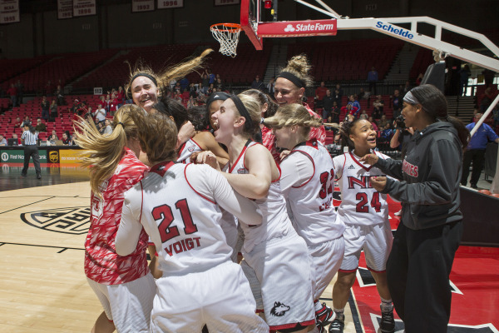
NIU Women’s Basketball coach Lisa Carlsen joined us today. She’s new to the community, having arrived last July 1st, coming from Lewis University in Romeoville with her husband and four kids. She’s been struck by how deep the love for NIU runs. She harkened back to the glory days of the Jane Albright era, and checks in with Jane on occasion. Coach Carlsen had good success at Lewis (reaching the Elite Eight once and having been ranked #1 at one point). One of the key challenges is recruiting. Lisa feels we should be able to do a better job recruiting Illinois kids, and next year’s incoming class will reflect that with 2 from Chicago, one from Rockford and one from Elgin. There’s a more natural connection to NIU with local kids. This year was probably not going to be great, but Lisa had some specific goals: 1) make the game fun for the team again (based on the picture, it looks like that’s working). 2) Make the Huskies the best conditioned team and the least selfish team in the MAC, and 3) play their best basketball in the last part of the season. They have 6 games left (3 at home) to get primed for the MAC tournament. Lisa also takes great pride in the fact that the team was number one scholastically at NIU last semester! Lisa has a lot of optimism and hope for the future. Come out to a game, and visit them on the web at: http://www.niuhuskies.com/sports/w-baskbl/niu-w-baskbl-body.html

Heard around the Tables (and elsewhere):
The NIU/Toledo football game will be at the Cell next fall.

Quote for the Day
“The best way to forget one’s self is to look at the world with attention and love.”
- Red Auerbach, legendary Boston Celtics Coach

UPCOMING PROGRAMS: (Why not invite a guest? – that could also mean a prospective member!)
Feb 24 Spiritual Aims Committee Parish’s Role in our Community
Mar 2 BOARD MEETING @ the Lincoln Inn
Mar 9 Cliff Alexis NIU Steel Drums
Mar 16 New Library Tour

Today’s Attendance:
25 | Kish Kiwanians
0 | Circle-K:
1 | Guest: Angela
2 | Speakers: Lisa and Kristen
28 | TOTAL
See more of the newsletter on the following pages:
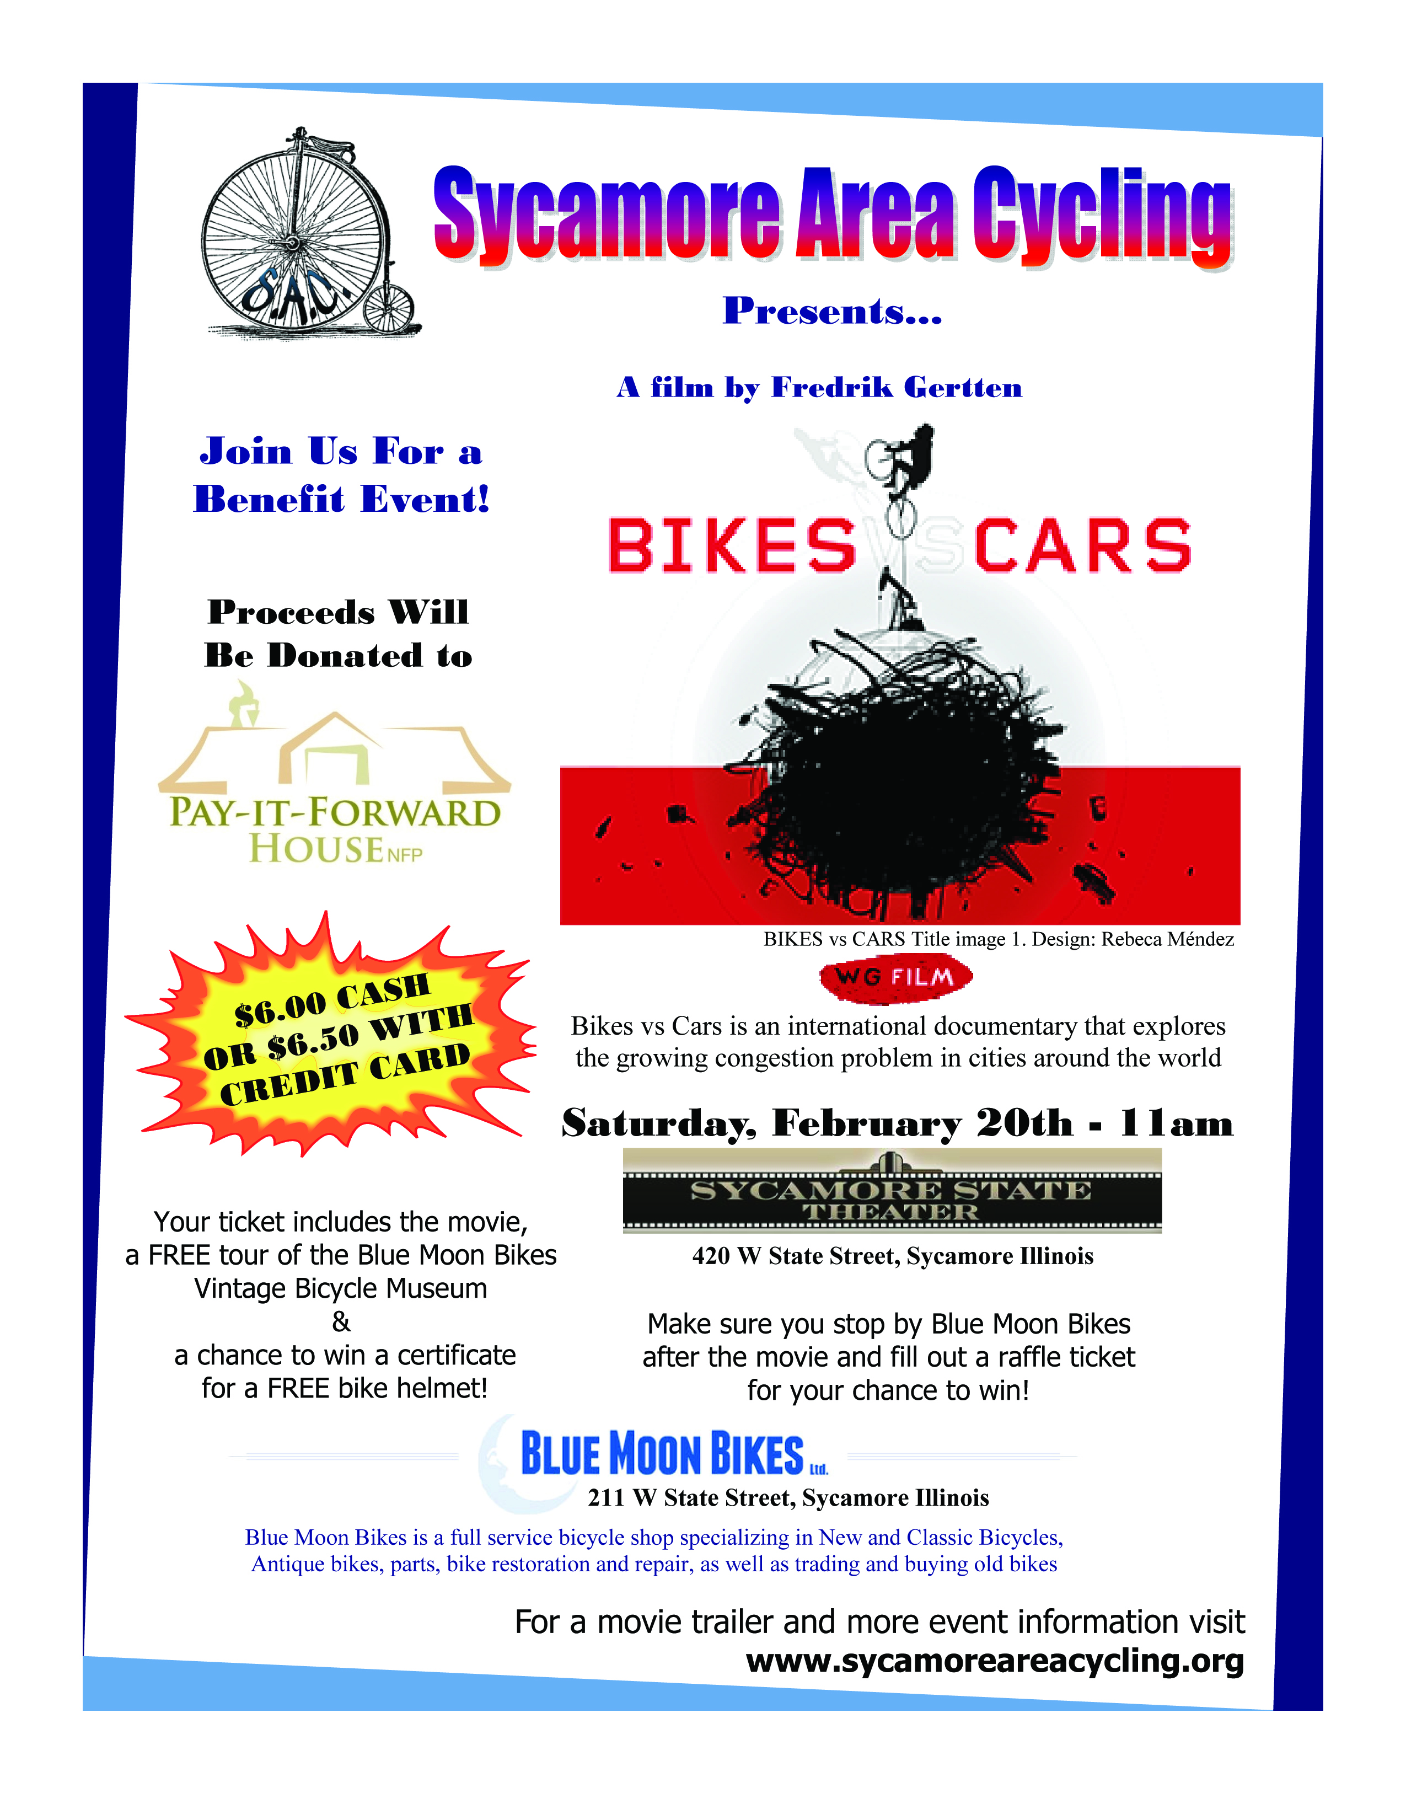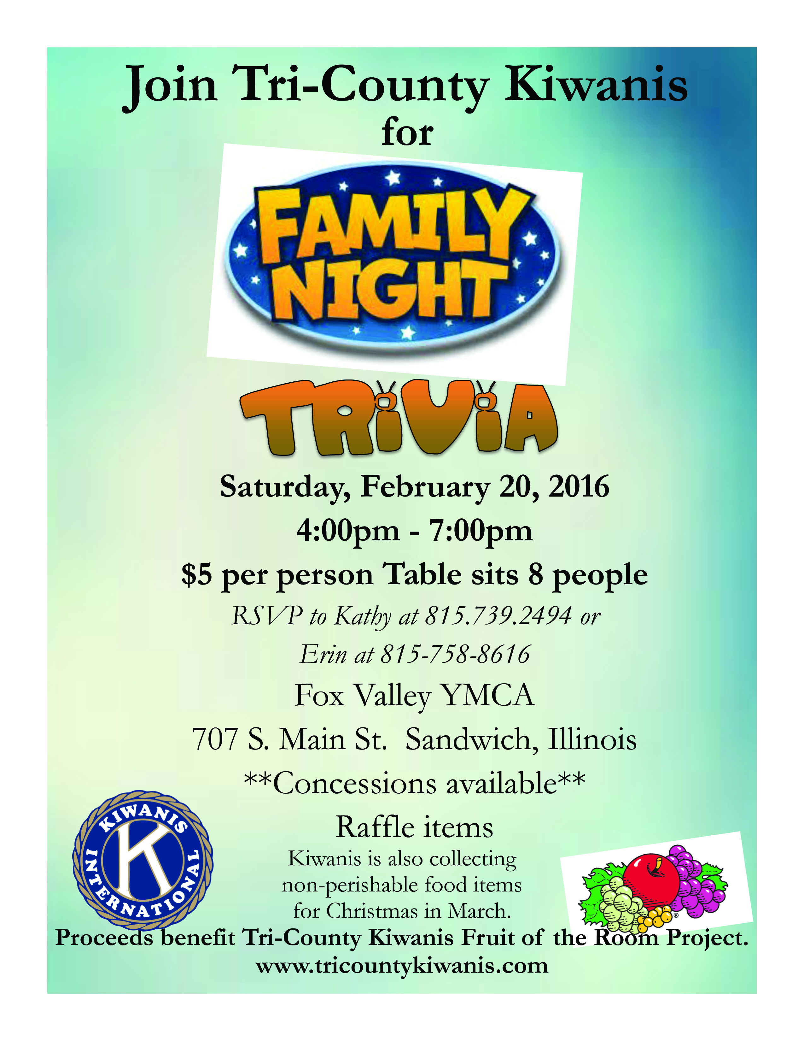YOUTH SERVICE BUREAU WISH LIST:
TAG (Therapeutic Art-Making Group):
Permanent markers, canvases, paint brushes, glue, watercolors, drawing paper, tracing paper, oil pastels, colored pencils, markers….any and all art supplies could help.
VolunTEEN:
Gardening gloves, small handheld shovels, cleaning supplies.
Thank you so much again for the opportunity to share about the Youth Service Bureau, and thank you for your dedication to the community.
Diana L. Hulst, Executive Director of DeKalb County Youth Service Bureau

The following are items we (Safe Passage) regularly need. If you are looking to donate please consider these items!

1. Gas station & Wal-Mart gift cards
2. Non-perishable food
3. Linens for twin beds
4. Towels & washcloths
5. Diapers & Pull-ups (especially larger sizes)
6. Baby wipes
7. Paper towels, toilet paper, & tissues
8. Sweatpants & sweatshirts
9. Women’s underwear (bras and panties)
10. Cleaning supplies (dish soap, spray cleaners, laundry detergent, etc.)
11. Harder hair brushes
12. Hair conditioner
13. Olive Oils for hair (not cooking oil)
14. Pantine shampoo/conditioner (Brown Bottle)
15. Motions haircare products
Serving the Children of the World

