THE NEWS FROM the
VOLUME XLVII, NUMBER 16
39

KISHWAUKEE KIWANIS CLUB of DeKalb, Illinois

March 16, 2016 Editor: Paul Stoddard http://www.kishkiwanis.org

LUNCH: Cold cuts, potato salad, fruit salad, and cookies.
SONG: God Bless America, led by Bill C. Invocation: Al

ANNOUNCEMENTS, EVENTS

Officers for 2015-2016

President Dick Dowen
President Elect Joe Gastiger
Vice President Bob Higgerson
Treasurer Lisa Small
Asst. Treasurer Sue Doubler
Secretary Ken Doubler
Asst. Secretary Jerry Wahlstrom
Immediate Past President
Abby Chemers
Lt. Governor Tarryn Thaden
District Governor Penny Linneweh

********************
Kishwaukee Kiwanis Meetings

2nd, 3rd, 4th, (and 5th) Wednesday at 11:45 a.m.
Hopkins Park Community Room

********************
K-Family Events/Meetings

Circle K Every Wednesday night at 8:00 p.m. in DuSable 254. Hint: To stay young, attend one of their meetings!

AKtion Club – Second Wednesday of the month at 4:00 p.m. at Opportunity House (357 N. California St.) in Sycamore.

********************
Defining Statement

Kiwanis is a global organization of volunteers dedicated to changing the world, one child and one community at a time.

********************
Flag Salute

As our flag signifies purity, valor, and justice, may we as true Kiwanians exemplify these virtues as we serve the children of the world.

and OPPORTUNITITES

Nex Interclub is April 5,6:00 pm (Tri-county -> Sycamore) at Sorento’s.

Beanzie meeting: the next one is scheduled for Tuesday, March 22 at 6:30 pm at Rosita’s.

Kiwanis International sent us a thank you for our $350 to Eliminate.

MEALS ON WHEELS is coming! April is our month (as usual). Amy was back, with sign-up sheet in hand, so be thinking about what dates you’d like to participate (see the bottom of page 2 to see what is available).

Prayer Breakfast will be 7 am, Tuesday May 3rd at Oak Crest

Pathway Cleanup will be Saturday April 23. Details will be forthcoming.

Toiletries- We’re collecting these for Safe Passage. (See below.)

Sue – DUES ARE DUE! (Same as the old dues).

Joan is collecting box tops and Coke lids. Jennie will take your soup labels. AKtion Club is collecting aluminum cans and other recyclable materials.

Archives: If you find any old stuff related to Kiwanis, please give a copy to Norm!

PoP Box
None today.

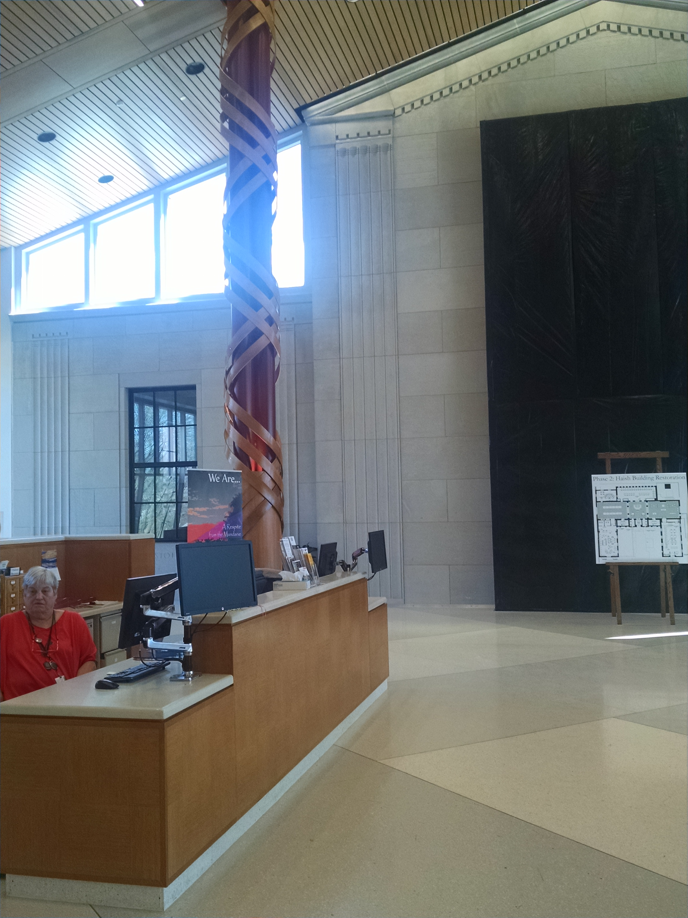
PROGRAM

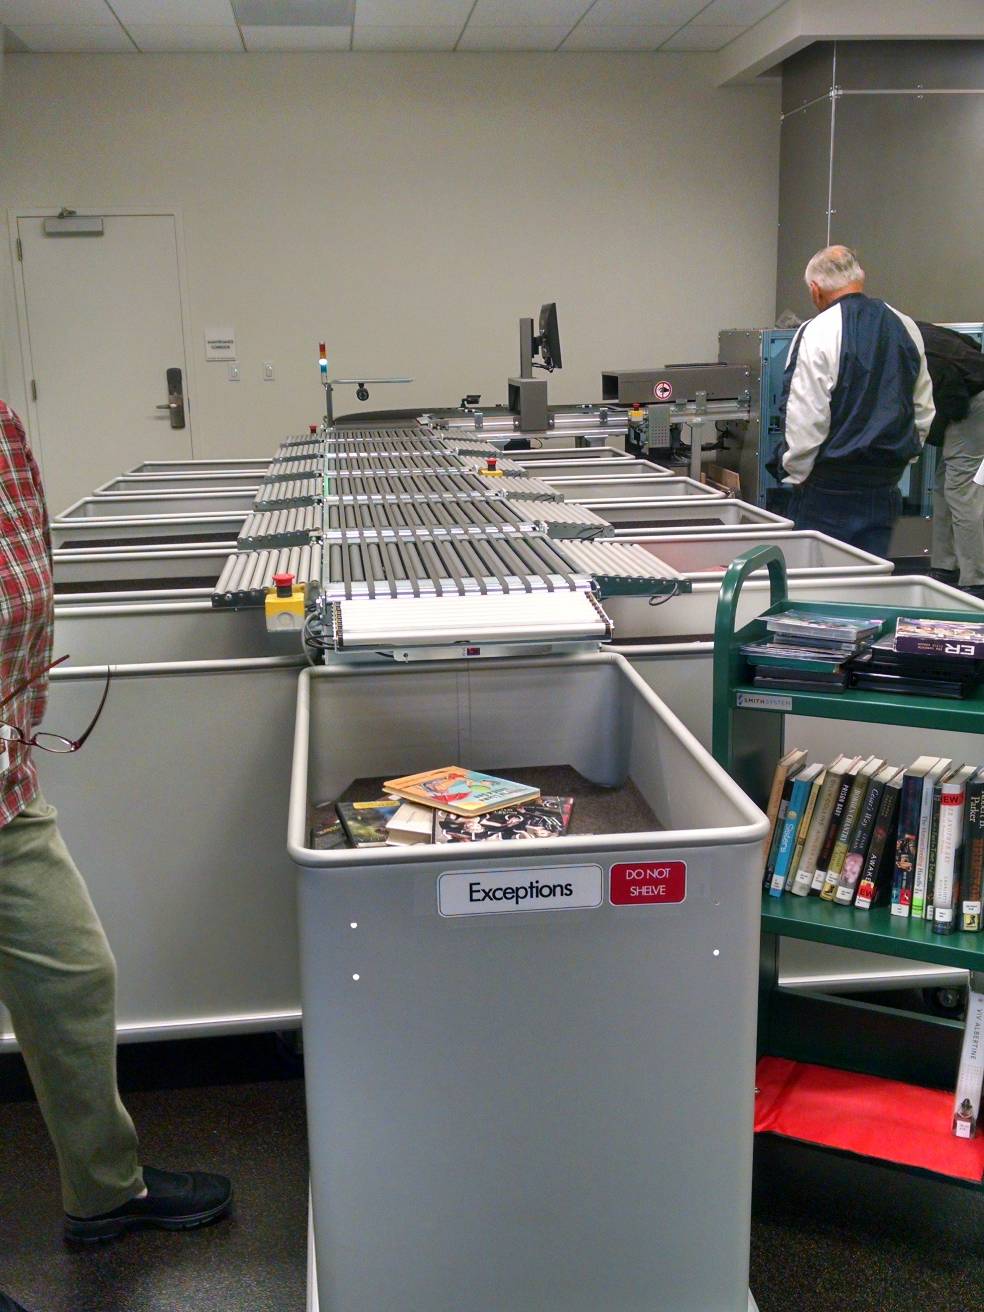
We met at the new DeKalb Library today (this caught the Lincoln Inn by surprise, but they caught up with us anyway). After lunch, we divided into two groups for tours. The new facility is very nice (if you weren’t with us, and haven’t had the chance yet to see it, you owe it to yourself to check it out). The basement (where we had lunch is full of conference rooms and administrative offices. They also have a fancy-schmancy automatic sorter for books and other materials coming down the return chute. They have automated check-out and check-in machines (and people to serve those functions for the local luddites). Upstairs is the children’s wing with kid-friendly bookshelves and seats, and arts and crafts room, and the Lego™ wall we donated. And a neat light sculpture to draw kids in. Must go in. Must go in. Libraries have come a long way from card catalogs and cards in sleeves in the books and rubber stamps to check out books.

Heard around the Tables (and elsewhere):
NIU’s hoops squad has done well this year.

Quote for the Day
“If you have a garden and a library, you have everything you need.
-Marcus Tullius Cicero

UPCOMING PROGRAMS: (Why not invite a guest? – that could also mean a prospective member!)

Mar 23 Cindy Sycamore Natural History
Mar 30 Oaken Acres
Apr 6 Board Meeting @ the Lincoln Inn
Apr 13 Peter Olsen Birds
Apr20 Laurie Borowitz Kish College
Apr 27 Herb – Spiritual Aims First United Methodist Church

Today’s Attendance:
29 | Kish Kiwanians
0 | K family:
1 | Guest: Misty
0 | Speakers:
30 | TOTAL

Meals on Wheels for April

1 Max Heide and Amy Polzin

4
5 Bill Cummings
6 No Delivery – Kiwanis Meeting Day
7 Tony Chulick and Amy Polzin
8

11
12 Mark Sawyer
13 No Delivery – Kiwanis Meeting Day
14
15

18 Jack and Marcia Goodrich
19 Dean and Jane Quarnstrom
20 No Delivery – Kiwanis Meeting Day
21
22 Dick Dowen and Toney Xidis

25
26
27 No Delivery – Kiwanis Meeting Day
28
29

See more of the newsletter on the following pages:

YOUTH SERVICE BUREAU WISH LIST:
TAG (Therapeutic Art-Making Group):
Permanent markers, canvases, paint brushes, glue, watercolors, drawing paper, tracing paper, oil pastels, colored pencils, markers….any and all art supplies could help.
VolunTEEN:
Gardening gloves, small handheld shovels, cleaning supplies.
Thank you so much again for the opportunity to share about the Youth Service Bureau, and thank you for your dedication to the community.
Diana L. Hulst, Executive Director of DeKalb County Youth Service Bureau

The following are items we (Safe Passage) regularly need. If you are looking to donate please consider these items!

1. Gas station & Wal-Mart gift cards
2. Non-perishable food
3. Linens for twin beds
4. Towels & washcloths
5. Diapers & Pull-ups (especially larger sizes)
6. Baby wipes
7. Paper towels, toilet paper, & tissues
8. Sweatpants & sweatshirts
9. Women’s underwear (bras and panties)
10. Cleaning supplies (dish soap, spray cleaners, laundry detergent, etc.)
11. Harder hair brushes
12. Hair conditioner
13. Olive Oils for hair (not cooking oil)
14. Pantine shampoo/conditioner (Brown Bottle)
15. Motions haircare products

Serving the Children of the World

