THE NEWS FROM the
VOLUME XLVII, NUMBER 19
39

KISHWAUKEE KIWANIS CLUB of DeKalb, Illinois

April 13, 2016 Late Editor: Paul Stoddard http://www.kishkiwanis.org

LUNCH: Sandwiches, fruit salad, chips, cookies
. SONG: My Country, ‘tis of Thee, led by Bill C. Invocation: Joe G

ANNOUNCEMENTS, EVENTS

Officers for 2015-2016

President Dick Dowen
President Elect Joe Gastiger
Vice President Bob Higgerson
Treasurer Lisa Small
Asst. Treasurer Sue Doubler
Secretary Ken Doubler
Asst. Secretary Jerry Wahlstrom
Immediate Past President
Abby Chemers
Lt. Governor Tarryn Thaden
District Governor Penny Linneweh

********************
Kishwaukee Kiwanis Meetings

2nd, 3rd, 4th, (and 5th) Wednesday at 11:45 a.m.
Hopkins Park Community Room

********************
K-Family Events/Meetings

Circle K Every Wednesday night at 8:00 p.m. in DuSable 254. Hint: To stay young, attend one of their meetings!

AKtion Club – Second Wednesday of the month at 4:00 p.m. at Opportunity House (357 N. California St.) in Sycamore.

********************
Defining Statement

Kiwanis is a global organization of volunteers dedicated to changing the world, one child and one community at a time.

********************
Flag Salute

As our flag signifies purity, valor, and justice, may we as true Kiwanians exemplify these virtues as we serve the children of the world.

and OPPORTUNITITES

King for the Day: Joe G., filling in for Dick. Sharon’s having a procedure, so send kind thoughts and prayers.

Last Interclub was April 5,6:00 pm (Tri-county -> Sycamore)at Sorrento’s.

Beanzie meeting: the next one isn’t scheduled yet.

MEALS ON WHEELS sign-up has been filled. Thanks to everyone who’s helping out this month!

Prayer Breakfast will be 7 am, Tuesday May 3rd at Oak Crest

Mother’s Day Plant Sale: (to help local service providers) at Joe’s Church. May 6 (10-6) and May 7 (8:30 – 2 pm). If you’ve got perennials to donate, they’d love to take them off your hands.

Rummage Sale will be June 3, 4 from 9 – 2 pm at the Doubler abode. Donations accepted, but not clothes or large furniture. More info to follow.

Eagle Scout Ryan Lotz will recycle your cycle. Bring to Northern ReHab, Saturday April 23 from 9 to 2.

Pathway Cleanup will be Saturday April 23. Meet at 8 am, behind the theater.

Toiletries- We’re collecting these for Safe Passage. (See below.)

Sue – DUES ARE DUE!(Same as the old dues).

Joan is collecting box tops and Coke lids. Jennie will take your soup labels. AKtion Club is collecting aluminum cans and other recyclable materials.

Archives: If you find any old stuff related to Kiwanis, please give a copy to Norm!

Sad Box
Bill C broke his ankle and tore a ligament while walking his dog. He hit some mud. Surgery tomorrow. Long rehab to follow. The dog is fine.

PROGRAM

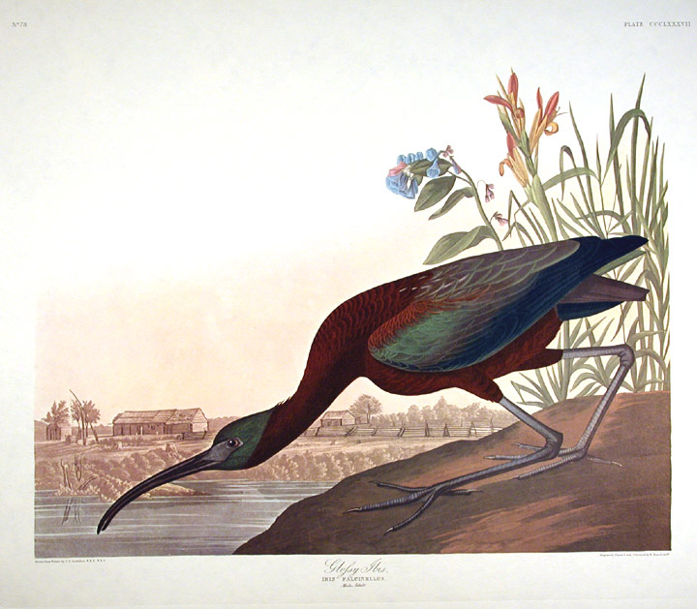
Continuing our theme of programs for the birds, we had Peter Olsen talk to us about his love of birds. (Those of you who spend some time on NIU’s campus may have recognized Peter from the Art Museum.) Pete showed us an Audubon drawing (left) of a glossy ibis, which features nature prominently in the foreground, and man-made objects small in the background. He liked that imagery. (Audubon drew lots of birds. They tend not to sit for artists. So Audubon shot ‘em. That kept them still. True story.) He also showed a small, recently banded bird in a human hand, and talked about how putting bands on birds allows us to track their migrations. Pete showed several slides of ducks, and a slide of a woodcut he did of a loon, and also one of his woodcuts of red winged blackbirds. An image of starlings swarming illustrated how birds form large groups as harsher winter weather approaches. Fun bird facts: Ravens make snowballs. Why?? They also like to slide down snowy roofs. Rose-breasted grosbeaks are neat looking birds that come through here in early May. Dark-eyed juncos are common around here during the winter, as are house finches and common red-poles. You can see some golden crowned kinglets around here this time of year (very small birds).

The first couple weeks of May are prime time for bird migration through our area.
Sunday Morning Bird Walks with Pete Olson: May 1 @ Afton Prairie FP. May 8 @ Sannauk F. P. (down near Sandwich) 8-10 am both days.

Heard around the Tables (and elsewhere):
No one knows what Art Deco is, but we know it when it when we see it (looks like the Chrysler Building).

Quote for the Day
It may be hard for an egg to turn into a bird: it would be a jolly sight harder for it to learn to fly while remaining an egg. We are like eggs at present. And you cannot go on indefinitely being just an ordinary, decent egg. We must be hatched or go bad.
- C. S. Lewis

UPCOMING PROGRAMS: (Why not invite a guest? – that could also mean a prospective member!)
Apr20 Laurie Borowitz Kish College
Apr 27 Pastor Paul Judd Spiritual Aims
May 4 BOARD MEETING @ the Lincoln Inn
May 11 Ralph S. The “Show”
May 18 Chief Gene Lowrey DeKalb Police
May 25 Joe Pasteris Poetry Day

Today’s Attendance:
35ish | Kish Kiwanians
0 | K family:
5 | Guests: Bob Gilmore; Scott and his wife Colleen, and Tom (from VAC);and Rick (Opportunity House)
1 | Speakers: Peter
41ish | TOTAL

See more of the newsletter on the following pages:

YOUTH SERVICE BUREAU WISH LIST:
TAG (Therapeutic Art-Making Group):
Permanent markers, canvases, paint brushes, glue, watercolors, drawing paper, tracing paper, oil pastels, colored pencils, markers….any and all art supplies could help.
VolunTEEN:
Gardening gloves, small handheld shovels, cleaning supplies.
Thank you so much again for the opportunity to share about the Youth Service Bureau, and thank you for your dedication to the community.
Diana L. Hulst, Executive Director of DeKalb County Youth Service Bureau

The following are items we (Safe Passage) regularly need. If you are looking to donate please consider these items!

1. Gas station & Wal-Mart gift cards
2. Non-perishable food
3. Linens for twin beds
4. Towels & washcloths
5. Diapers & Pull-ups (especially larger sizes)
6. Baby wipes
7. Paper towels, toilet paper, & tissues
8. Sweatpants & sweatshirts
9. Women’s underwear (bras and panties)
10. Cleaning supplies (dish soap, spray cleaners, laundry detergent, etc.)
11. Harder hair brushes
12. Hair conditioner
13. Olive Oils for hair (not cooking oil)
14. Pantine shampoo/conditioner (Brown Bottle)
15. Motions haircare products

Serving the Children of the World

