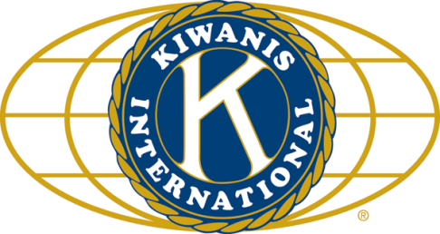

THE NEWS FROM the
VOLUME XLVII, NUMBER 36
3 9

KISHWAUKEE KIWANIS CLUB of DeKalb, Illinois

Sept 14, 2016 Editor: Paul Stoddard http://www.kishkiwanis.org

LUNCH: Stuff that wasn’t meatballs, specifically hot roast beef sandwiches, potato chips, fruit salad, and cookies.
. SONG: God Bless America, led by Chanette. Invocation: Joe G.

ANNOUNCEMENTS, EVENTS

Officers for 2015-2016

President Dick Dowen
President Elect Joe Gastiger
Vice President Bob Higgerson
Treasurer Lisa Small
Asst. Treasurer Sue Doubler
Secretary Ken Doubler
Asst. Secretary Jerry Wahlstrom
Immediate Past President
Abby Chemers
Lt. Governor TarrynThaden
District Governor Penny Linneweh

********************
Kishwaukee Kiwanis Meetings

2nd, 3rd, 4th, (and 5th) Wednesday at 11:45 a.m.
Hopkins Park Community Room

********************
K-Family Events/Meetings

Circle K Every Monday night at 8:00 p.m. in Neptune Central 110. Hint: To stay young, attend one of their meetings!

AKtion Club – Second Wednesday of the month at 4:00 p.m. at Opportunity House (357 N. California St.) in Sycamore.

********************
Defining Statement

Kiwanis is a global organization of volunteers dedicated to changing the world, one child and one community at a time.

********************
Flag Salute

As our flag signifies purity, valor, and justice, may we as true Kiwanians exemplify these virtues as we serve the children of the world.

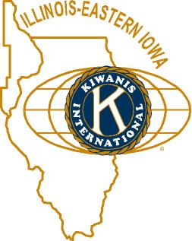

and OPPORTUNITITES

COMMITTEE SIGN-UPS. DO IT! Do it often!

BRAT PARTY: 5:30 pm. September 15 (tomorrow!), at the Goodrich homestead. Signups are happening.

Feed My Starving Children. Jerry W. updated us – the date this year will be Thursday, Nov 10. 4 pm to 6, and 7 pm – 9 pm. Jerry will commit us to those times. Spaces will be saved for Circle-K as well.

Grand Openings – Library on Sept 10. New book store in the Junction, today!

Time to start thinking about peanuts! Sept 23 is the big day. Box sales forms are available (and have been emailed out to the membership)– let’s all go out and sell a box or two or ten. Peanuts, pretzels, trail mix – it’s all good! Sign ups are happening.

The Kiwanis Show. Sign-ups will begin soon. Sounds like it’s something of which you’ll definitely want to be a part!

An oldie but goodie: The club voted to shift our regular meetings from the Terrace Room to Faranda’s, starting in October. (Board meetings still to be at Lincoln Inn.)

Toiletries- We’re collecting these for Safe Passage. (See below.)

Sue – DUES ARE DUE! (Same as the old dues).

Joan is collecting box tops and Coke lids. AKtion Club is collecting aluminum cans and other recyclable materials.
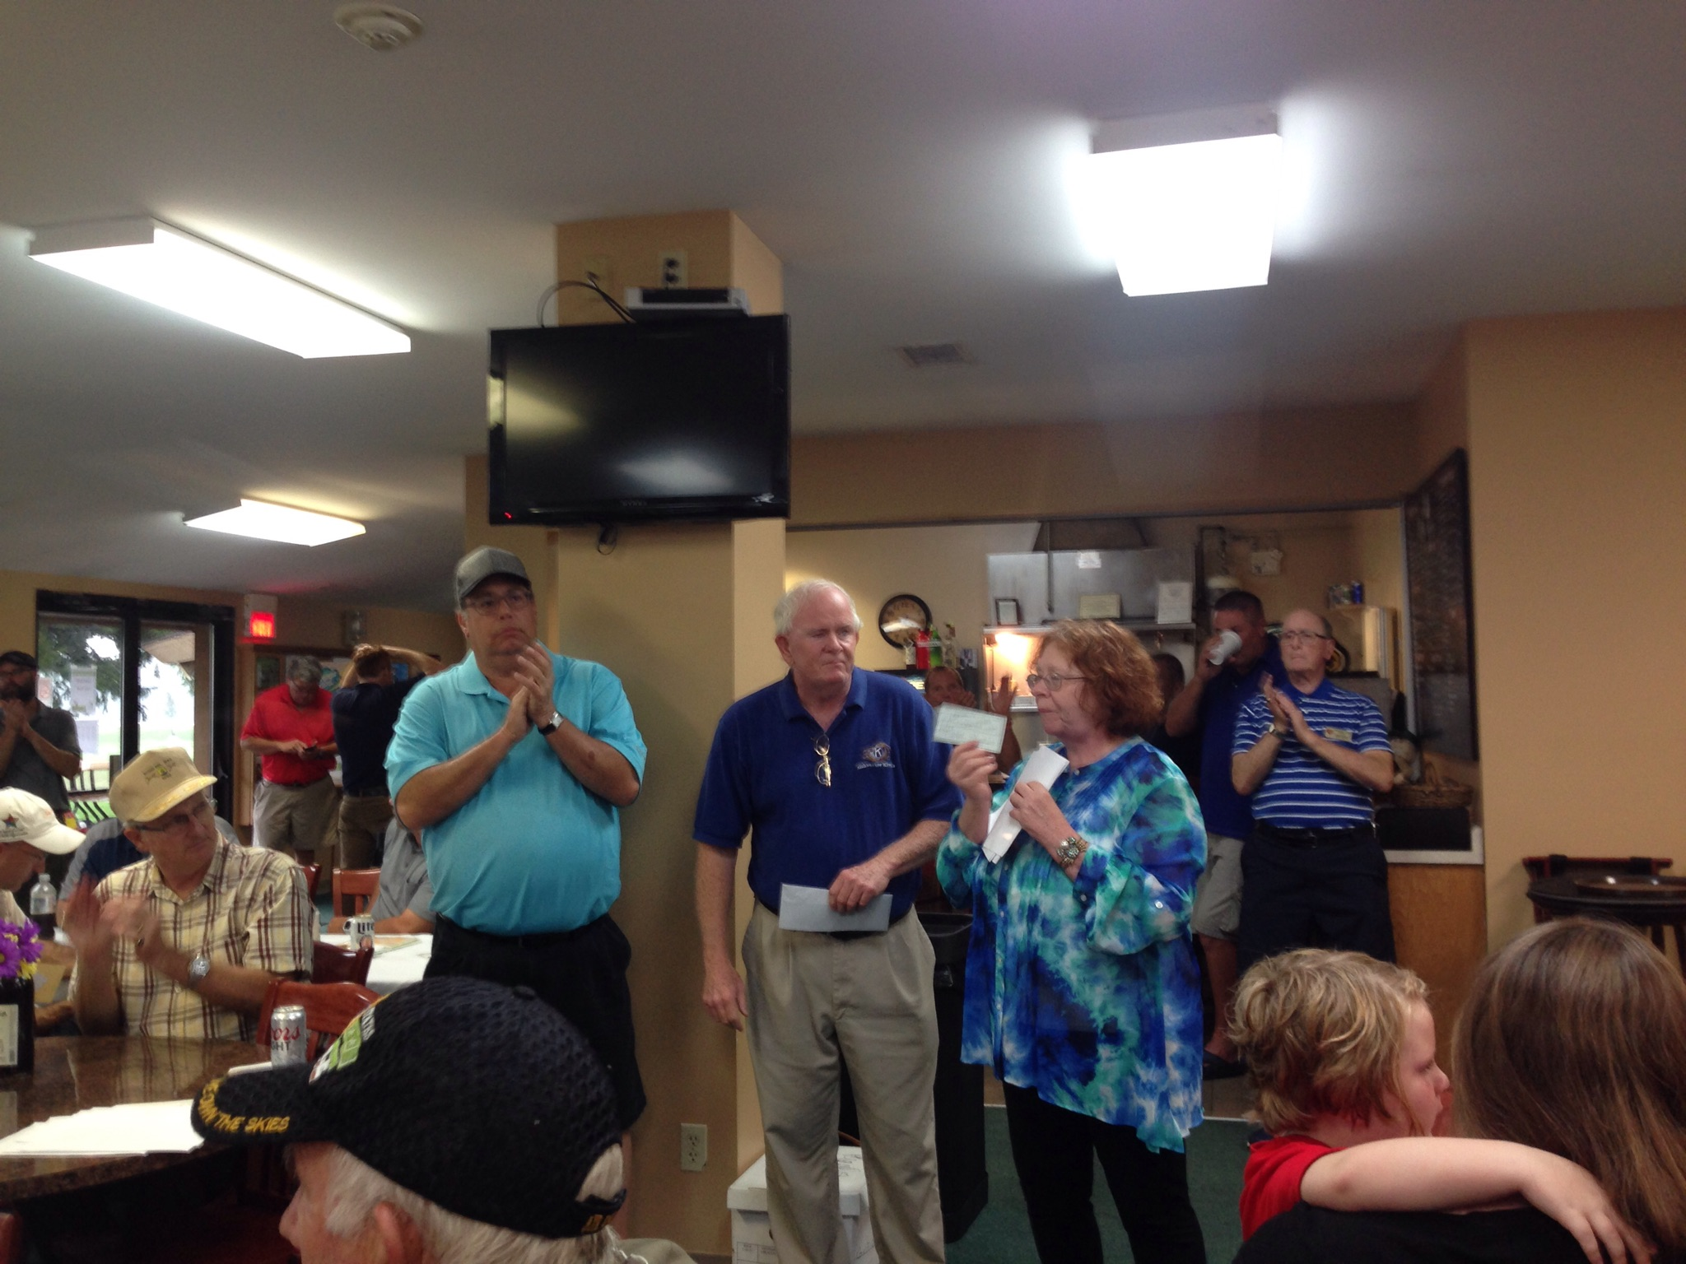
Bill F. presenting our gift to VAC for Meals on Wheels, in memory of Tom Zucker.

P.o.P./Health Box
Hoping for Bill Minor to have a good outcome tomorrow at the
Wheaton Eye Clinic.

 PROGRAM

Cohen Barnes, from Sundog Millionaire, er, Sundog IT came by to give us the lowdown on the computer world. Cohen is a local boy (Littlejohn, Clinton-Rosette, DHS). Military, Desert Storm (almost), which got him a National Defense Ribbon. NIU – go Huskies! High School English teaching was his dream, but wound up with MicroSolutions, and found he loved computers. c. 1996-6: TBC – the first Internet service provider in the community (other than NIU). Does anyone remember when Internet use was only to be at night except for DoD and research (but don’t we all do research on the Internet?)?. TBC was a basement startup with Cohen and his now ex-partner, Dan Halverson. They had four modems, so only four people could be online at once. But things grew quickly. Moved out of the basement to real office space in 1997. A year later, they brought broadband to DeKalb, using Frontier’s copper wire network. Expansion kept happening – doubling their office space in 2002. They started building computers. 2004 – DeKalb chamber awarded them Business of the Year, of which they are very proud. 2004, up to 6000 ft² and 20 employees. Eventually (about ten years ago) demand outpaced supply, and access started slowing down, not just for TBC customers, but for NIU users as well: Joint Venture! TBC, NIU, City of DeKalb, private entities, came together to link DeKalb down to the “dark fiber” running along I-88. Fiber optics is the latest Internet conduit. All of NIU’s Internet requirements can be fulfilled by a single strand of optic fiber. A $14 million grant from the federal government has allowed us to expand the fledgling fiber network from 10 miles to the 140 miles of fiber we have today. In 2007 TBC started shifting their business from hardware to IT services. Things are swimming along very nicely, and then 2012 hits. They recognize that a small Internet provider couldn’t compete with the Verizons of the world. They personally smoothed the transition of their clients to Frontier. Moved into a high-end office facility owned by Chuck Sheppard, and were free to concentrate solely on the IT end of the business. Sold out interest of DeKalb Fiber Optic, bought out Dan and became sole owner of TBC. Change of product/service led to change of name to Sun Dog (Google “sundog image”).

Heard around the tables:
Change your passwords frequently (and think more along the lines of “pass phrases”) and don’t fall down on your tail bone.

Quote for the Day
“Never trust a computer you can't throw out a window”
― Steve Wozniak
UPCOMING PROGRAMS: (Why not invite a guest? – that could also mean a prospective member!)
September 21 Fr. Leo Kazeri From Bricks to Books
September 28 Lt Govs Tarryn and Juanita Officer Induction/New members
October 5 Board Meeting @ Lincoln Inn
October 12 TBA @ Faranda’s

Today’s Attendance:
36 | Kish Kiwanians
0 | K family Big Wig:
0 | Other Guests:
1 | Speakers: Cohen
37 | TOTAL
Serving the Children of the World

