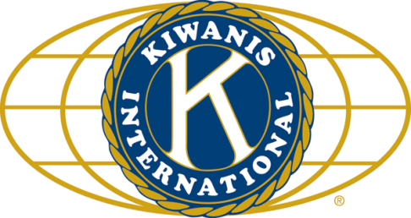

THE NEWS FROM the
VOLUME XLVIII, NUMBER First
3 9

LUNCH: In honor of our first meeting at Faranda’s, we had a Chinese buffet!, and cookies.
KISHWAUKEE KIWANIS CLUB of DeKalb, Illinois

October 12, 2016 Editor: Paul Stoddard http://www.kishkiwanis.org
. SONG: God Bless America, led by Chanette. Invocation: Al M.

ANNOUNCEMENTS, EVENTS

Officers for 2016-2017

President Joe Gastiger
President Elect Bob Higgerson
Vice President Roger Seymore
Treasurer Lisa Small
Asst. Treasurer Sue Doubler
Secretary Ken Doubler
Asst. Secretary Jerry Wahlstrom
Immediate Past President
Dick Dowen
Lt. Governor Juanita Mundy
District Governor Rick Poulton

********************
Kishwaukee Kiwanis Meetings

2nd, 3rd, 4th, (and 5th) Wednesday at 11:45 a.m.
Faranda’s Banquet Center
302 Grove St.
DeKalb, IL

********************
K-Family Events/Meetings

Circle K Every Monday night at 8:00 p.m. in Neptune Central 110. Hint: To stay young, attend one of their meetings!

AKtion Club – Second Wednesday of the month at 4:00 p.m. at Opportunity House (357 N. California St.) in Sycamore.

********************
Defining Statement

Kiwanis is a global organization of volunteers dedicated to changing the world, one child and one community at a time.

********************
Flag Salute

As our flag signifies purity, valor, and justice, may we as true Kiwanians exemplify these virtues as we serve the children of the world.

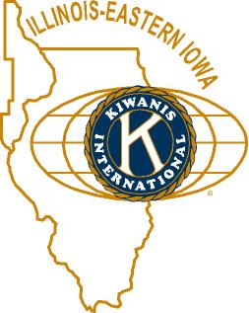

and OPPORTUNITITES

COMMITTEE SIGN-UPS. Amy will send out the revised listing. There are committees still needing more members and/or chairs (or both). Please let me know if you are interested in any of these.

Feed My Starving Children. Jerry W. updated us – the date this year will be Thursday, Nov 10. 4 pm to 6, and 7 pm – 9 pm. Jerry has committed us to those times. Spaces will be saved for Circle-K as well.

Governor’s Visit at Sauk Valley College in Dixon, 6pm October 14th (this Friday). Reservations need to be made by October 6 (oops!). Come meet Governor Rick Poulton. Cost is $12.00/person

Peanuts – Al still has boxes to be claimed or sold.

AKtion Club is selling T-shirts and sweatshirts. Yellow, with their logo.

Prayer Breakfast: Thursday October 27 at 7 am. Sycamore United Methodist Church. Members sponsored by H&SV, other guests – $7.

The Kiwanis Show. Sign-ups will begin soon. Sounds like it’s something of which you’ll definitely want to be a part! Show Committee meeting today at 11 am at Faranda’s. Based on our past performances, we need to rehearse our singing.

An oldie but goodie: The club voted to shift our regular meetings from the Terrace Room to Faranda’s, starting in October. (Board meetings still to be at Lincoln Inn.) THAT’S THIS REGULAR MEETING!

Toiletries- We’re collecting these for Safe Passage. (See below.)

Sue – DUES ARE DUE! (Same as the old dues).

Joan is collecting box tops and Coke lids. General Mills products, helps local schools.

AKtion Club is collecting aluminum cans and other recyclable materials.

P.o.P./Health Box
Bill Minor underwent successful surgery to relieve the pressure on his brain. Beryl is still recuperating from his recent heart surgery. Here’s wishing both of them speedy recoveries!

 PROGRAM

Today we had our Awards Committee Presentation! It was very rewarding. Our local service and leadership award (minimum of 10 years, recognized as a leader in service, served as a committee chair or officer). Ken, Bill F. and Amy, Norm, and Beryl have been our previous awardees. As part of the award, a cash donation is made in the member’s name to the Community Foundation as part of an endowment fund. Bill F. listed many of our members who have received Kiwanis awards, and acknowledged those of us who have served as president of the club. Then we got down to the business of awarding the awards – the first presented by Finucane: Lifetime DeKalb resident, multiple award-winning, ink-stained husband of Ging - Jerry Smith! Much applause ensued. Amy introduced our next recipient – came to NIU and stayed. Has been with us for 35 years. While sometimes spacey, he never shirks his duties. Father of 3. That’s right – it’s Jerry Wahlstrom. Much applause ensued again. Only having two Jerrys, we only gave two awards this year. Congratulations, and thanks! to both! Dan Templin accepted the donation on behalf of the Foundation. Dan took the opportunity to remind us of the funds we have with the Foundation – Kish Kiwanis Community Works and Endowment Fund (helping youth get into the workplace, and land use studies), and the Kish Kiwanis Community Leadership Fund (administrative endowment fund, which helps with staffing and thus allows for more activity), and the Community Impact Fund (to support club special projects). Ben, Betsy, Noah, and Sarah introduced themselves and what they do with the Foundation.

Heard around the tables:
For a group that likes to avoid politics, we sure have some politically-minded people.

Quote for the Day
“No act of kindness, no matter how small, is ever wasted”
― Aesop
UPCOMING PROGRAMS: (Why not invite a guest? – that could also mean a prospective member!)
October 19 Ralph Tompkins My ’56 Packard
October 26 Heidi Wright Feed My Starving Children
November 2 Board Meeting @ Lincoln Inn
November 9 Noah Macklust Circle-K

Today’s Attendance:
35ish | Kish Kiwanians
0 | K family Big Wigs:
4 | Other Guests: Ben, Betsy, Noah, Sarah (from the Foundation)
1 | Speakers: Dan
40ish | TOTAL

Serving the Children of the World

