THE NEWS FROM the
VOLUME XLVIII, NUMBER 2t
3 9

LUNCH: Today was Italian Day – Salad, Meatballs, Lasagna!, and cookies.
KISHWAUKEE KIWANIS CLUB of DeKalb, Illinois

October 19, 2016 Editor: Amy Polzin http://www.kishkiwanis.org
. SONG: Oh Beautiful, led by Chanette. Invocation: Dick Dowen

ANNOUNCEMENTS, EVENTS

Officers for 2016-2017

President Joe Gastiger
President Elect Bob Higgerson
Vice President Roger Seymore
Treasurer Lisa Small
Asst. Treasurer Sue Doubler
Secretary Ken Doubler
Asst. Secretary Jerry Wahlstrom
Immediate Past President
Dick Dowen
Lt. Governor Juanita Mundy
District Governor Rick Poulton

********************
Kishwaukee Kiwanis Meetings

2nd, 3rd, 4th, (and 5th) Wednesday at 11:45 a.m.
Faranda’s Banquet Center
302 Grove St.
DeKalb, IL

********************
K-Family Events/Meetings

Circle K Every Monday night at 8:00 p.m. in Neptune Central 110. Hint: To stay young, attend one of their meetings!

AKtion Club – Second Wednesday of the month at 4:00 p.m. at Opportunity House (357 N. California St.) in Sycamore.

********************
Defining Statement

Kiwanis is a global organization of volunteers dedicated to changing the world, one child and one community at a time.

********************
Flag Salute

As our flag signifies purity, valor, and justice, may we as true Kiwanians exemplify these virtues as we serve the children of the world.

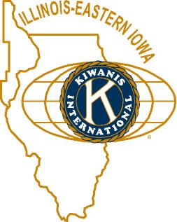

and OPPORTUNITITES

COMMITTEE SIGN-UPS. Amy sent out the revised listing. There are committees still needing more members and/or chairs (or both). Please let her know if you are interested in any of these.

Feed My Starving Children. Jerry W. updated us – the date this year will be Thursday, Nov 10. 4 pm to 6, and 7 pm – 9 pm. Jerry has committed us to those times. Spaces will be saved for Circle-K as well. We need more people to sign up. See Jerry W.

Prayer Breakfast: Thursday October 27 at 7 am. Sycamore United Methodist Church. Members sponsored by H&SV, other guests – $7.

Bill Cummings gave a brief report on the Governor’s visit last Friday. We had four members in attendance.

Community Services Meeting next Wednesday at 11:30 a.m. (before our regular meeting).

Program Committee Meeting next Wednesday at 1:00 p.m. (after our regular meeting).

Peanut Guy, Al Mueller announced that there are still a couple of boxes of peanuts. If you’re looking for something to pass out for Halloween – or you just want to have some peanuts on hand, see Al.

Congratulations to the five DeKalb High School students going to Dallas Texas. There will be approximately 500 young people competing – 11 are from Illinois and FIVE are from DeKalb. Good luck!

Toiletries- We’re collecting these for Safe Passage. (See below.)

Sue – DUES ARE DUE! (Same as the old dues).

Joan is collecting box tops and Coke lids. General Mills products, helps local schools.

AKtion Club is collecting aluminum cans and other recyclable materials.

P.o.P./Health Box
We miss you, Beryl, Beryl, Beryl. Get well soon!

 PROGRAM

“History of the Packard Motor Car Company” by John Maxson
John Maxson presented a very informative program on the Packard – a unique luxury car. The first prototype was developed in 1898 by the Packard Brothers in Warren, OH and the Model A was the first Packard built for sales in 1899. James Packard was their first president and when asked about marketing their motor car, he responded that he was too busy and that they should “Ask the man who owns one.” This became their advertising slogan and worked quite well for them. In 1903, Henry Jay took over as president and moved the company to Detroit, where it remained until it closed its doors in 1958. Interesting, the first cars had the steering wheel on the right hand side of the car so that the drivers could make sure they would stay out of the ditch. In 1915, the steering wheel moved to the left side of the car as more cars were on the road and drivers needed to pay attention to not hit other drivers. Four telltale signs of the Packard were the ox bow grill, the red hexagon (originally housed the wrench to change the tire and then just became decorative), the Packard family crest, and the spear along the side of the car (this later became chrome). Celebrities drove Packards and starting in 1936, the Packard Pace Car for the Indy 500 was given to the winner of the race. Ralph Tomkins drove his 1956 Packard to the meeting today and shared some stories … of which there are many. The car has been in the family since December 27, 1955 and has been lovingly restored. One day Ralph drove Jerry Smith to Dixon to give Jerry’s 97-year old mother a ride. She was so tickled she said it was “like she got a new set of teeth or something.” Ralph’s mother took her last ride in that Packard. It holds many fond memories for Ralph and is a beautiful car. He was gracious enough to let us sit in it and have our pictures taken. We were wondering how many Kiwanians would have fit in it. It should also be noted that this is the first program we used the technology in our new meeting location and it worked GREAT!
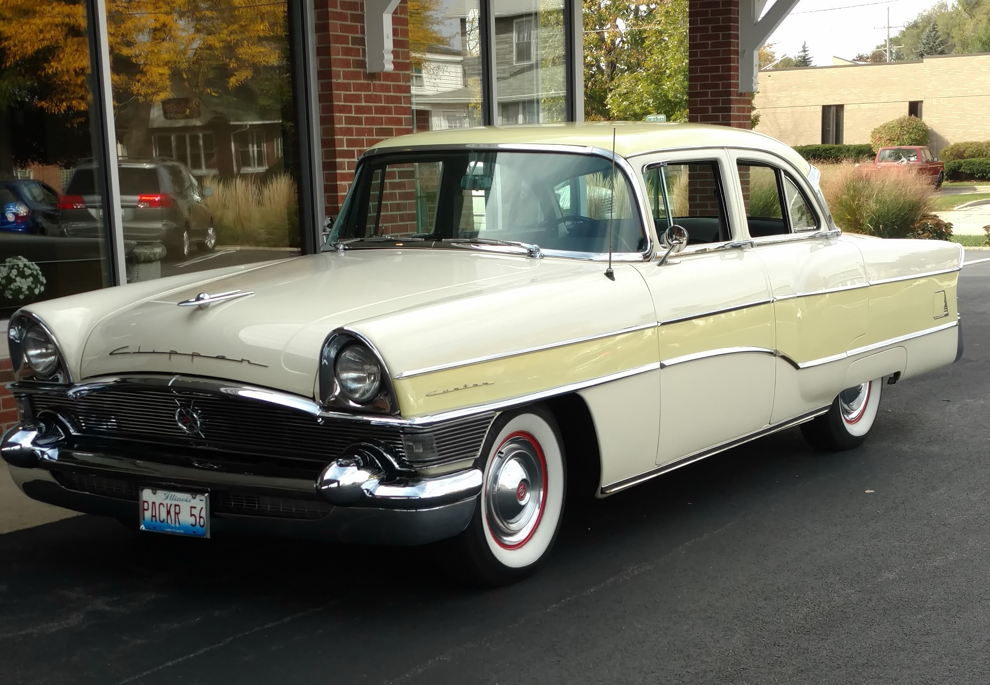

Here is Ralph’s 1956 Packard.
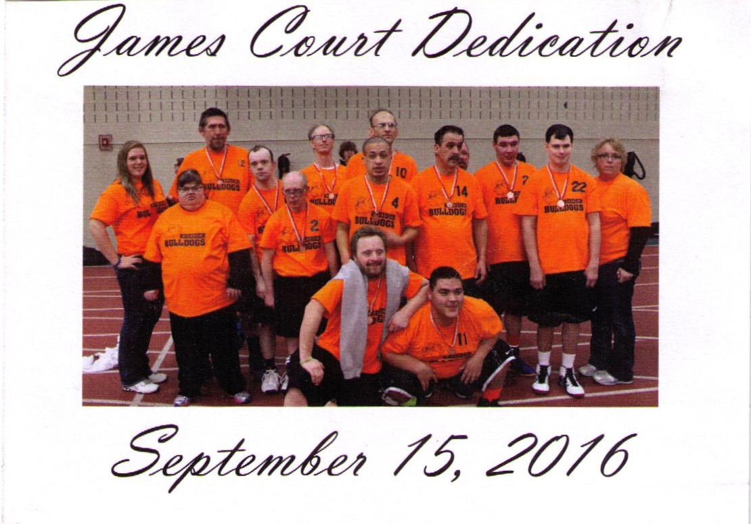

Jerry Smith also told us a little bit about Ralph and Ralph’s son, James (Jimmy), who had lived at Kreider, passed away at age 37. The Tompkins donated money to Kreider for a basketball court in memory of Jimmy. Known as James’ Court, it was dedicated on September 15, 2016 – a wonderful legacy. Jimmy is standing in the back row second from the right.

Heard around the tables:
Lots of car talk and reminiscing of cars: stories and memories.

Quote for the Day
“Get your facts first, then you can distort them as you please.”
-Mark Twain

UPCOMING PROGRAMS: (Why not invite a guest? – that could also mean a prospective member!)
October 26 Heidi Wright Feed My Starving Children
November 2 Board Meeting @ Lincoln Inn
November 9 Noah Macklust Circle-K

Today’s Attendance:
31 | Kish Kiwanians
0 | K family Big Wigs:
2 | Other Guests: Pam Reynolds (accompanying brother Bill Minor), Paul Callighan
2 | Speakers: John Maxson and Ralph Tompkins
35 | TOTAL

October Birthdays
1 Ken Doubler
3 Dick Dowen
4 Michelle Graham
10 Bob Higgerson
17 Kevin Breuer
21 Bill Finucane
28 Mike Mooney

Serving the Children of the World

