THE NEWS FROM the
VOLUME XLVIII, NUMBER 5

LUNCH: Roast pork, mashed spuds, carrots, corn, pasta salad, and cookies.
KISHWAUKEE KIWANIS CLUB of DeKalb, Illinois

November 16, 2016 Editor: Paul Stoddard http://www.kishkiwanis.org
. SONG: God Bless American led Chanette. Invocation: Al

ANNOUNCEMENTS, EVENTS

Officers for 2016-2017

President Joe Gastiger
President Elect Bob Higgerson
Vice President Roger Seymore
Treasurer Lisa Small
Asst. Treasurer Sue Doubler
Secretary Ken Doubler
Asst. Secretary Jerry Wahlstrom
Immediate Past President
Dick Dowen
Lt. Governor Juanita Mundy
District Governor Rick Poulton

********************
Kishwaukee Kiwanis Meetings

2nd, 3rd, 4th, (and 5th) Wednesday at 11:45 a.m.
Faranda’s Banquet Center
302 Grove St.
DeKalb, IL

********************
K-Family Events/Meetings

Circle K Every Monday night at 8:00 p.m. in Neptune Central 110. Hint: To stay young, attend one of their meetings!

AKtion Club – Second Wednesday of the month at 4:00 p.m. at Opportunity House (357 N. California St.) in Sycamore.

********************
Defining Statement

Kiwanis is a global organization of volunteers dedicated to changing the world, one child and one community at a time.

********************
Flag Salute

As our flag signifies purity, valor, and justice, may we as true Kiwanians exemplify these virtues as we serve the children of the world.

and OPPORTUNITITES

The Yearbook is just about done. Congrats to Beryl on his 221 years of perfect attendance!

COMMITTEE SIGN-UPS. Amy sent out the revised listing. There are committees still needing more members and/or chairs (or both). Please let her know if you are interested in any of these. Roger stepped up to co-chair Beanzie! Thanks, Roger!

Our Next Interclub: will be on Wednesday, December 14, 2016 DeKalb will be passing the gavel to Kishwaukee (hey! That’s us!) at 11:45 a.m. at our new usual place: Faranda’s! The Madrigals are the program that day so it should be a full house!

Coat Czar: Joe (aka the “Ayatollah of Love”) is helping coordinate the coat donation programs here in DeKalb. If you’d like to donate, see Joe.

Volunteer Opportunities: Bell Ringing on 11/19/16 at both doors of Jewel. See last page of this newsletter for assignments. Salvation Army Thanksgiving work days are 11/21, 22, 23. See sign ups below. We still have slots open from 4-6 pm. December 6 – a new project – Christmas Purses – putting together purses (and their contents) for Safe Passage clients.

Let’s Talk Turkey – feel free to donate a frozen turkey to the Salvation Army on Friday.
Mike M. has more Make a Difference Day Raffle tickets too.

Toiletries- We’re collecting these for Safe Passage. (See below.)

Sue – DUES ARE DUE! (Same as the old dues).

Joan is collecting box tops and Coke lids. General Mills products, helps local schools.

AKtion Club is collecting aluminum cans and other recyclable materials.

P.o.P./Health Box
Beryl was back with us! Great to see you again Beryl. Bill M. was also with us, and continues to improve. Good news all around!

PROGRAM

Our very own Colleen Bredeson presented the program today – on VAC and all the good they do. She broke in the new display paraphernalia at Faranda’s (well at least it’s new to us). VAC started in 1974 as a volunteer clearinghouse. Transportation was quickly recognized as a needed service. 1 vehicle, 1100 rides in the first year. Meals on Wheels (MoW) started in 1987. The kitchen was built in 1991. They’re now focused on transportation and nutrition. Transportation lines: Transvac, Medvac, Blue and Green lines, and a Kish College line. Anyone can use Transvac for $1.50 each way (for seniors and disabled patrons the fee is only suggested). You have to register, and reserve the ride 6 days in advance. Medvac is for rides (within 90 miles of their office) to medical appointments, at $0.50/mile. Reserve a ride whenever you can, but rides get booked quickly. Green and Blue lines are set routes open to all, for $0.50. Nutrition programs: MoW, senior luncheons, vendor for area daycares and the DeKalb County Jail, and provide summer meals through the USDA. MoW is open to folks 60 or older, for a suggested donation ranging from $2.20-$4.50, depending ability to pay. It’s really helping to let seniors remain living in their homes. They also host several special functions – Meals for Moms, the Annual Volunteer Celebration, the County Wide Senior Luncheon, and the Tom Zucker Memorial Golf Outing. As part of their nutrition mission, they hold several health and wellness workshops. Colleen helps VAC with their community outreach programs, and coordinates with the DeKalb County TRIAD, local senior service providers, Networking for Families, and the Permanency Action Team. And let’s not forget their excellent catering! All profits go back to help support the MoW program.
http://vacdk.com has all the details, and more!

Heard around the tables:
Want to see everyone reach for their purse or pocket? Sound a chime.

Quote for the Day
“Spaghetti can be eaten most successfully if you inhale it like a VACuum cleaner.”
— Sofia Loren

UPCOMING PROGRAMS: (Why not invite a guest? – that could also mean a prospective member!)
Nov 23 Denise Rode My Amazing Career Change
Nov 30 Anne Marie Gaura State of the City of DeKalb
Dec 7 Board Meeting @ the Lincoln Inn
Dec 14 Holiday Songs DeKalb High School Madrigals
Dec 21 Deanna Cada Mental Health
Dec 28 Ken Doubler Kiwanis Education (members invited to submit questions)

Today’s Attendance:
33 | Kish Kiwanians
0 | K family:
0 | Other Guests:
0 | Speakers:
33 | TOTAL

Thanksgiving Food Item List (if you choose to help supply a basket, instead of/in addition to donating money):
Reusable Grocery Bags (x2)
$10 Gift Certificate for a Turkey
Canned Cranberry Sauce
4 Cans of Vegetables
Stuffing Mix
Instant Mashed Potatoes
Gravy Mix
Boxed Dessert Mix
Powdered Drink Mix
And/or Toys!
Contact Rhonda Brown (815 756 4308 ext 4311) to schedule the food basket drop off.

Salvation Army Bell Ringing - Saturday, November 19th, Jewel in DeKalb
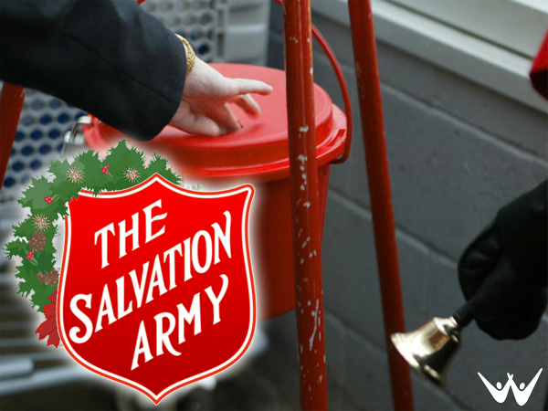
10:00-12:00 north door Anne Marie Gaura
south door Bob Higgerson
12:00-2:00 north door Amy Polzin
south door Jerry Wahlstrom 12-1
Jack Goodrich 1-2
2:00 - 4:00 north door Joan London
south door Jan Byrnes
4:00 - 6:00 north door Bob Gilmore
south door Tim Dunlop

Sue Doubler won't be available for questions so police yourselves, bring your Kish Kiwanis address books in case you need a phone number.

--------------------------------

Salvation Army Thanksgiving Basket work days. Days for working, 11/21, 22, 23 (Mon. thru Weds am). Per Al Mueller still need help on 11/21 & 11/23 please let him know when you can work.

Also, you can put together your own basket to donate: 2 reusable bags, $10 gift card for a turkey, canned cranberry sauce, 4 cans of vegetables, stuffing mix, instant mashed potatoes, gravy mix, boxed dessert mix, powdered drink mix. To schedule drop off or pick up all Rhonda Brown at the Salvation Army, 815/756-4308 ext 4311.

You can also make a direct monetary donation ($30.00 for a basket of food) to: Salvation Army, PO Box 442, DeKalb, IL 60115

If you want you can bring food or funds to next week’s meeting and Al or Sue will get your donation to the Salvation Army. If you make a direct donation let me know so we can record it for the monthly report & get you an attendance credit.

Serving the Children of the World

