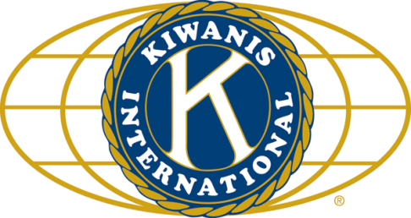

THE NEWS FROM the
VOLUME XLVIII, NUMBER 24

LUNCH: Chicken Parm, mostaccioli, veggies, salad, and cookies. President Pro Tem: Bob H.
KISHWAUKEE KIWANIS CLUB of DeKalb, Illinois

May 10, 2017 Editor: Paul Stoddard http://www.kishkiwanis.org
. SONG: America the Beautiful, led by Bill C. Invocation: Jerry S.

ANNOUNCEMENTS, EVENTS

Officers for 2016-2017

President Joe Gastiger
President Elect Bob Higgerson
Vice President Roger Seymore
Treasurer Lisa Small
Asst. Treasurer Sue Doubler
Secretary Ken Doubler
Asst. Secretary Jerry Wahlstrom
Immediate Past President
Dick Dowen
Lt. Governor Juanita Mundy
District Governor Rick Poulton

********************
Kishwaukee Kiwanis Meetings

2nd, 3rd, 4th, (and 5th) Wednesday at 11:45 a.m.
Faranda’s Banquet Center
302 Grove St.
DeKalb, IL

********************
K-Family Events/Meetings

Circle K Every Monday night at 8:00 p.m. in Neptune Central 110. Hint: To stay young, attend one of their meetings!

AKtion Club – Second Wednesday of the month at 4:00 p.m. at Opportunity House (357 N. California St.) in Sycamore.

********************
Defining Statement

Kiwanis is a global organization of volunteers dedicated to changing the world, one child and one community at a time.

********************
Flag Salute

As our flag signifies purity, valor, and justice, may we as true Kiwanians exemplify these virtues as we serve the children of the world.

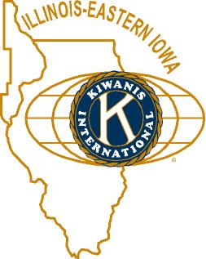

and OPPORTUNITITES

Our Last Interclub: May 8, 2017 Sycamore to DeKalb 5:30 pm. Elks Club. Our own Misty Haji-Sheikh was elected to be the next Lt. Gov. Congrats to Misty! She’ll do a great job – and have an amazing year!

July will be our next Meals on Wheels month. Stay tuned for details.

Jerry W. passed around a sign-up sheet to volunteer with the Youth Service Bureau’s bike auction.

Circle K is hosting a K-family picnic July 22 at the Kiwanis Park in Ottawa.

May 31: Community Service meeting right after our regular meeting.

June 3: Storage shed inventory.

Beanzie is only 2 months away!

Aktion Club is having a tea on June 3 (2 to 4pm), tickets are $10. Contact Mollie at mwang@ohinc.org (815 991-2990)

St. Paul’s Lobster Boil – May 20th. Order needs to be in by May 15th. Live or cooked. $18-20.

There’s a furniture moving opportunity for a local woman. See Joe G.

Officer slate (Moved by Bill F/Paul S): Prez Bob Higgerson, Prez-Elect Roger Seymour, VP Sue Doubler, Treasurer: Lisa Small; Asst Treas Al Mueller; Secretary: Ken Doubler, Asst Secy: Jerry Wahlstrom. IPP Joe Gastiger. Tony Chulick will replace Al on the board. Continuing Board: Debbie Madeley, Steve Cichy, Betty Hampa, Bill Finucane. New board: Jack Goodrich, Toney Xidis, Bill Cummings, Colleen Bredeson. Unanimously approved.

The DeKalb County Barn tour will be Saturday, August 12, 2017, 9 am to 4pm. See Jennie.

Toiletries- We’re collecting these for Safe Passage.

Sue – DUES ARE DUE! (Same as the old dues).

Joan is collecting box tops and Coke lids. General Mills products, helps local schools.

AKtion Club is collecting aluminum cans and other recyclable materials.
P. o. P. / H e a l t h B o x

No news is good news.

PROGRAM

Drew VandeCreek was our guest, speaking about NIU’s library digitization program – or so we were led to believe. Actually, it was the History Harvest. Well, maybe both. Libraries buy not only books, but digital content (journals and books in electronic form, which are downloadable on the web). University libraries also produce digital content. Digital scholarship (Drew’s field) is figuring out how to use digital information available on the web for academic and professional purposes. Text mining is a subset of this, and concerned with word usage and how to cull useful information from troves of documents (such as the complete Congressional Record). History Harvests are present in towns throughout the country. They are repositories of local historical documents, in digital form. Our History Harvest is part of a student project at NIU. Getting community participation is not as easy as it may seem. Betty Hampa helped out getting materials, such as birth certificates, old photos, etc.
You can go there to check out a book, or go to http://dcl.niu.edu/index.php/94-home/194-history-harvest-experiential-learning-activity to check them out. To check out what they’ve done with the Glidden Estate and barbed wire, go to http://glidden.dcl.niu.edu.

Heard around the tables:

Bill F has a really neat app for keeping score at baseball and softball games.

Quote for the Day

“Knowing I lov’d my books, he furnish’d me
From mine own library with volumes that
I prize above my dukedom.”
- William Shakespeare: The Tempest, Act I, Scene 2

UPCOMING PROGRAMS: (Why not invite a guest? – that could also mean a prospective member!)

May 17 Ken Doubler/Ralph Sherman Survey Results/Show Results
May 24 Chuck Carroll Escape from the WTC on 9/11
May 31 Marv Kombrink Canine Companions
June 7 BOARD MEETING @ the Lincoln Inn
June 14 Interclub @ Faranda’s 4-H Winners
June 21 DCCF Youth Engaged in Philanthropy

Today’s Attendance:

30 | Kish Kiwanians
4 | K family Monique, Noah, Caitlin, Connor (Circle-K)
2 | Other Guests: Lynn, Tony, Virginia
1 | Speaker: Drew
37 | TOTAL

May Birthdays –
17 Colleen Bredesen 28 Misty Haji-Sheikh
17 Debbie Madeley 30 All Mueller
25 Betty Hampa
Serving the Children of the World

