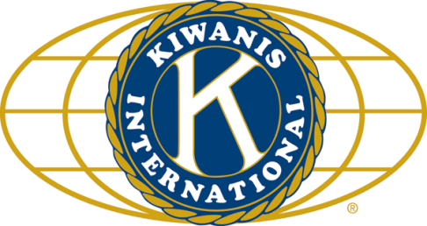

THE NEWS FROM the
VOLUME XLVIII, NUMBER 28

LUNCH: Cold cuts, salads, chips, and cookies.
KISHWAUKEE KIWANIS CLUB of DeKalb, Illinois

June 14, 2017 Editor: Paul Stoddard http://www.kishkiwanis.org
. SONG: God Bless America, led by Chanette. Invocation: Jack G

ANNOUNCEMENTS, EVENTS

Officers for 2016-2017

President Joe Gastiger
President Elect Bob Higgerson
Vice President Roger Seymore
Treasurer Lisa Small
Asst. Treasurer Sue Doubler
Secretary Ken Doubler
Asst. Secretary Jerry Wahlstrom
Immediate Past President
Dick Dowen
Lt. Governor Juanita Mundy
District Governor Rick Poulton

********************
Kishwaukee Kiwanis Meetings

2nd, 3rd, 4th, (and 5th) Wednesday at 11:45 a.m.
Faranda’s Banquet Center
302 Grove St.
DeKalb, IL

********************
K-Family Events/Meetings

Circle K Every Monday night at 8:00 p.m. in Neptune Central 110. Hint: To stay young, attend one of their meetings!

AKtion Club – Second Wednesday of the month at 4:00 p.m. at Opportunity House (357 N. California St.) in Sycamore.

********************
Defining Statement

Kiwanis is a global organization of volunteers dedicated to changing the world, one child and one community at a time.

********************
Flag Salute

As our flag signifies purity, valor, and justice, may we as true Kiwanians exemplify these virtues as we serve the children of the world.

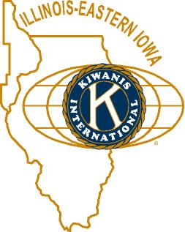

and OPPORTUNITITES

Our Next Interclub: TODAY!

211 Launch was this morning (service hotline). See additional attachment to this newsletter email.

July will be our next Meals on Wheels month. Signups are happening.

Circle K is hosting a K-family picnic July 22 at the Kiwanis Park in Ottawa.

Beanzie is only 32 days away! Why not help and/or ride! Meeting tomorrow (Thursday) at 8 at Barb City Bagel.

Aktion Club is having a tea on June 3 (2 to 4pm), tickets are $10. Contact Mollie at mwang@ohinc.org (815 991-2990)

The DeKalb County Barn tour will be Saturday, August 12, 2017, 9 am to 4pm. See Jennie.

Toiletries- We’re collecting these for Safe Passage.

Sue – DUES ARE DUE! (Same as the old dues).

Joan is collecting box tops and Coke lids. General Mills products, helps local schools.

AKtion Club is collecting aluminum cans and other recyclable materials.

P. o. P. / H e a l t h B o x

No news is good news.

PROGRAM

YEP – Youth Engaged in Philanthropy – is a DeKalb County Community Foundation initiative to improve the quality of life for youth in the county. They meet monthly through the school year, and learn about leadership and philanthropy. The high school students in YEP solicit, evaluate, and award grant money from the Foundation to local charitable organizations. Last year 39 YEP youth allocated $11,588 to 6 youth-serving organizations in DeKalb County. They also hold various outreach events such as the Altrusa Spelling Bee, FMSC, Food Bank work, among others. Last year they amassed over 300 volunteer hours.

Gavel Pass:

DeKalb to Kish, in an American flag, with a putter.

Quote for the Day

“Generosity is giving more than you can, and pride is taking less than you need.”
- Khalil Gibran

UPCOMING PROGRAMS: (Why not invite a guest? – that could also mean a prospective member!)

June 21 Ken Doubler Kish Kiwanis Survey Results
June 28 Beanzie et al. Beanzie, Biking with
July 5 BOARD MEETING @ the Lincoln Inn
July 12 Justine Whitehouse RAMP
July 19 Clint Carglie In Search of a Fair Wind
July 26 FIELD TRIP Midwest Museum of Nat’l History, Sycamore
Aug 2 BOARD MEETING @ the Lincoln Inn
Aug 9 Emily Faulkner DeKalb Public Library
Aug 16 NIU Athletics 2017 NIU Football

Today’s Attendance:

31 | Kish Kiwanians
8 | K family Syc: Cliff, Bob & Nancy, Dave, DeK: Gary, Ralph, Mark, Bob
5 | Other Guests: JT, Alex, Bill M’s granddaughter; DCCFers: Becky, Milla,
2 | Speakers: YEPpers Stephen, Libby
46 | TOTAL

Serving the Children of the World

