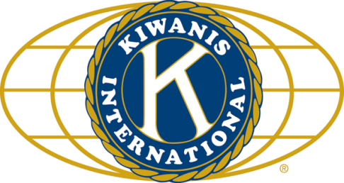

THE NEWS FROM the
VOLUME XLVIII, NUMBER 29

LUNCH: DIY sandwiches, potato salad & chips, and cookies.
KISHWAUKEE KIWANIS CLUB of DeKalb, Illinois

June 28, 2017 Editor: Paul Stoddard http://www.kishkiwanis.org
. SONG: God Bless America, led by Chanette. Invocation: Joe G?

ANNOUNCEMENTS, EVENTS

Officers for 2016-2017

President Joe Gastiger
President Elect Bob Higgerson
Vice President Roger Seymore
Treasurer Lisa Small
Asst. Treasurer Sue Doubler
Secretary Ken Doubler
Asst. Secretary Jerry Wahlstrom
Immediate Past President
Dick Dowen
Lt. Governor Juanita Mundy
District Governor Rick Poulton

********************
Kishwaukee Kiwanis Meetings

2nd, 3rd, 4th, (and 5th) Wednesday at 11:45 a.m.
Faranda’s Banquet Center
302 Grove St.
DeKalb, IL

********************
K-Family Events/Meetings

Circle K Every Monday night at 8:00 p.m. in Neptune Central 110. Hint: To stay young, attend one of their meetings!

AKtion Club – Second Wednesday of the month at 4:00 p.m. at Opportunity House (357 N. California St.) in Sycamore.

********************
Defining Statement

Kiwanis is a global organization of volunteers dedicated to changing the world, one child and one community at a time.

********************
Flag Salute

As our flag signifies purity, valor, and justice, may we as true Kiwanians exemplify these virtues as we serve the children of the world.

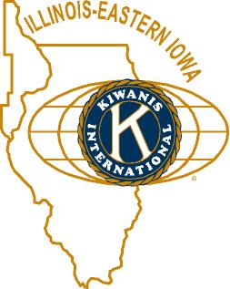

and OPPORTUNITITES

Our Next Interclub: We pass the gavel to Tri-County. Date and place: TBA

July will be our next Meals on Wheels month. Signups are happening.

Circle K is hosting a K-family picnic July 22 at the Kiwanis Park in Ottawa.

Beanzie is only 18 days away! Why not help and/or ride!

The DeKalb County Barn tour will be Saturday, August 12, 2017, 9 am to 4pm. See Jennie.

Toiletries- We’re collecting these for Safe Passage.

Sue – DUES ARE DUE! (Same as the old dues).

Joan is collecting box tops and Coke lids. General Mills products, helps local schools.

AKtion Club is collecting aluminum cans and other recyclable materials.

P. o. P. / H e a l t h B o x

No news is good news.

PROGRAM

Bill &Tony went over Beanzie 2017 with us, and certainly the emphasis was and is on the club getting out and having fun and participating! This is our best event for summer fun, so please make the effort to come on Sunday and help in some fashion. We also certainly had some Beanzie stories from various tellers of tales, with the lead being Jay Schneider painting a directional arrow on a dead raccoon! It turned out to be a big hit with riders and the club has made an effort to mark any road kills they can find. (Though this year we are using chalk instead of paint, so.. not a pretty picture.) We also need the use any large coolers for ice storage on Sunday, so if you have any please put your name on them and drop them off at any meetings prior to the event. Also, stay tuned for 2018 Beanzie – being the 20th year of the ride! Special things in store…

Quote for the Day

We must be free not because we claim freedom, but because we practice it. – William Faulkner

UPCOMING PROGRAMS: (Why not invite a guest? – that could also mean a prospective member!)

July 5 BOARD MEETING @ the Lincoln Inn
July 12 Justine Whitehouse RAMP
July 19 Clint Carglie In Search of a Fair Wind
July 26 FIELD TRIP Midwest Museum of Nat’l History, Sycamore
Aug 2 BOARD MEETING @ the Lincoln Inn
Aug 9 Emily Faulkner DeKalb Public Library
Aug 16 NIU Athletics 2017 NIU Football

Today’s Attendance:

29 | Kish Kiwanians
0 | K family
2 | Other Guests:
0 | Speakers:
31 | TOTAL

Serving the Children of the World

