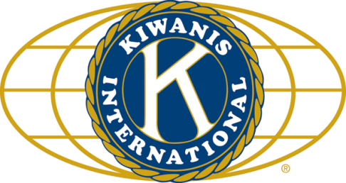

THE NEWS FROM the
VOLUME XLVIII, NUMBER 31

LUNCH: Roast beef sandwiches, pasta and fruit salads, chips, and cookies.
KISHWAUKEE KIWANIS CLUB of DeKalb, Illinois

July 12, 2017 Editor: Paul Stoddard http://www.kishkiwanis.org
. SONG: My Country ‘tis of Thee, led by Bill C. Invocation: Dick D.

ANNOUNCEMENTS, EVENTS

Officers for 2016-2017

President Joe Gastiger
President Elect Bob Higgerson
Vice President Roger Seymore
Treasurer Lisa Small
Asst. Treasurer Sue Doubler
Secretary Ken Doubler
Asst. Secretary Jerry Wahlstrom
Immediate Past President
Dick Dowen
Lt. Governor Juanita Mundy
District Governor Rick Poulton

********************
Kishwaukee Kiwanis Meetings

2nd, 3rd, 4th, (and 5th) Wednesday at 11:45 a.m.
Faranda’s Banquet Center
302 Grove St.
DeKalb, IL

********************
K-Family Events/Meetings

Circle K Every Monday night at 8:00 p.m. in Neptune Central 110. Hint: To stay young, attend one of their meetings!

AKtion Club – Second Wednesday of the month at 4:00 p.m. at Opportunity House (357 N. California St.) in Sycamore.

********************
Defining Statement

Kiwanis is a global organization of volunteers dedicated to changing the world, one child and one community at a time.

********************
Flag Salute

As our flag signifies purity, valor, and justice, may we as true Kiwanians exemplify these virtues as we serve the children of the world.

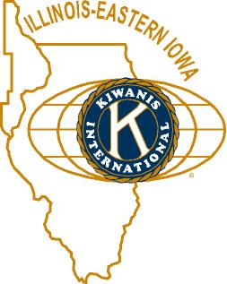

and OPPORTUNITITES

Our Next Interclub: We pass the gavel to Tri-County. Date and place: Sandwich VFW 713 S Main, July 20 at 6 pm. This one’s a pot luck, and Jack G. is willing to drive.

July IS our Meals on Wheels month. Signups are done. Deliveries are happening now. Don’t forget!

Circle K is hosting a K-family picnic July 22 at the Kiwanis Park in Ottawa.

Beanzie is only 4 days away! Why not help and/or ride? See Sue (or an email) to sign up to help. We have about 170 pre-registrations. Gate access code: *1969#

Next Talent Show: April 7, 2018. Rehearsals Tues, Weds, Thurs beforehand.

The DeKalb County Barn tour will be Saturday, August 12, 2017, 9 am to 4pm. See Jennie.

Toiletries- We’re collecting these for Safe Passage.

Sue – Please pay the new Dues! (Same as the old dues).

Joan has retired and is no longer collecting box tops and Coke lids. General Mills products, helps local schools. Someone else has taken over, but I forget who that is. Someone will let me know soon, I assume.

AKtion Club is collecting aluminum cans and other recyclable materials.

P. o. P. / H e a l t h B o x

No news is good news.

PROGRAM

Several folks from RAMP provided today’s program. Katie Lee is the new manager for DeKalb County. She was joined by Sarah Graves and client/employee Bill Hanes. Katie started off describing RAMP – center for independent living (serving and advocating for those with disabilities). They provide educational services, independent living help (budgeting, maintaining a residence, accessing community services). On average the DeKalb office serves 100-120 clients at any time. They have a youth advocacy education program. There’s a related conference at Faranda’s on the morning of September 21 which will feature Dr. Dan R. Griffith. Bill then took over. Bill is a Rockford Kiwanian. Back in 2008 Bill suffered from a serious bout of meningitis, which affected his brain. It has been a long, slow recovery. For example, he has gradually worked his way from a wheel chair to the cane he now uses. Bill went back to school to earn a degree in social work. After his mother died in 2014, Bill eventually connected with RAMP and became a Traumatic Brain Injury (TBI) case worker. But the work can be very trying, and so he had to retire last month. Sarah is a recent NIU graduate, and interned with RAMP as an undergrad (a rare thing).
You can learn more, see what they’re up to, or offer your support at http://rampcil.org/

Quote for the Day

“Your success and happiness lies in you. Resolve to keep happy, and your joy and you shall form an invincible host against difficulties.”
- Helen Keller

UPCOMING PROGRAMS: (Why not invite a guest? – that could also mean a prospective member!)

July 19 Clint Carglie In Search of a Fair Wind
July 26 FIELD TRIP Midwest Museum of Nat’l History, Sycamore
Aug 2 BOARD MEETING @ the Lincoln Inn
Aug 9 Emily Faulkner DeKalb Public Library
Aug 16 NIU Athletics 2017 NIU Football

Today’s Attendance:

29 | Kish Kiwanians
0 | K family
1 | Other Guests: Prodigal daughter, Abby
3 | Speakers: Bill, Katie, Sarah (all from RAMP)
33 | TOTAL

July Birthdays

July 3 Jim Barker July 23 Anne Marie Gaura
July 17 Paul Stoddard July 29 Tim Dunlop

HAPPY BIRTHDAY TO OUR JULY KIWANIANS!

Serving the Children of the World

