THE NEWS FROM the
VOLUME XLVIII, NUMBER 38

LUNCH: Chicken with mushroom dill sauce, veggie lasagna, eggplant parm, salad, and cookies.
KISHWAUKEE KIWANIS CLUB of DeKalb, Illinois

September 20, 2017 Editor: Paul Stoddard http://www.kishkiwanis.org
. SONG: America the Beautiful, led by Chanette Invocation: Joe G.

ANNOUNCEMENTS, EVENTS

Officers for 2016-2017

President Joe Gastiger
President Elect Bob Higgerson
Vice President Roger Seymore
Treasurer Lisa Small
Asst. Treasurer Sue Doubler
Secretary Ken Doubler
Asst. Secretary Jerry Wahlstrom
Immediate Past President
Dick Dowen
Lt. Governor Tarryn Thaden
District Governor Rick Poulton

********************
Kishwaukee Kiwanis Meetings

2nd, 3rd, 4th, (and 5th) Wednesday at 11:45 a.m.
Faranda’s Banquet Center
302 Grove St.
DeKalb, IL

********************
K-Family Events/Meetings

Circle K Every Monday night at 8:00 p.m. in Neptune Central 110. Hint: To stay young, attend one of their meetings!

AKtion Club – Second Wednesday of the month at 4:00 p.m. at Opportunity House (357 N. California St.) in Sycamore.

********************
Defining Statement

Kiwanis is a global organization of volunteers dedicated to changing the world, one child and one community at a time.

********************
Flag Salute

As our flag signifies purity, valor, and justice, may we as true Kiwanians exemplify these virtues as we serve the children of the world.

and OPPORTUNITITES

Happy Birthday was sung to Herb. We probably now owe royalties to someone.

Our next Interclub: is TBA. Check with the incoming Lt. Gov.

Next Talent Show: April 7, 2018. Rehearsals Tues, Weds, Thurs beforehand. A meeting will be held next Wednesday at 11:15 at Faranda’s.

Colleen – All those 60 yrs & over are invited to VAC Senior Luncheon October 4, 11:30-2:00, $5 suggested donation. If you’d like to volunteer, see Colleen.

Kirkland Lions coat drive is ongoing. Talk to Amy for details.

Amy’s having a party at her place Saturday 2-7pm. Bring a beverage and a chair.

Mayor Jerry was a Rotary speaker recently, and his honorarium was a raffle ticket that could win the club $250.

Program committee meeting next week, 1 pm.

The Governor’s visit is still TBA.

The Y is hosting a senior showcase lunch on October 11. Lead a healthy lifestyle!

The EAA chapter in DeKalb is sponsoring a ride on the Ford Tri-motor Sept 21-24. (See attached flyer in last week’s newsletter). That’s this weekend!

SOS Fundraiser at Blumen Gardens Sept 23, to benefit hurricane survivors. Bring Your Own Bottle, $50 tickets, money to the Red Cross.

PEANUT DAY (Sept 22) sign-ups and box orders are underway! See Al. Bad news: Walmart and Jewel turned us down for locations. Good news: We can use the median to the Market Square area (by Lowe’s). We also have 1st and Taylor. Peanuts have arrived. Misty has flyers to pass out.

Mike’s got Save My Starving Children Raffle tickets. Our volunteer time will be Thursday-Sunday November 9-12. See Jerry W. Our slots are Nov 10, 11 from 3-5 on each day at Suter foods. We have 20 spots to fill each day.

IHSA football weekend – Thanksgiving weekend – will need us to man elevators.

Toiletries- We’re collecting these for Safe Passage.

Sue – Please pay the new Dues! (Same as the old dues).

Colleen B (aka “Arms”) is collecting box tops and Coke lids. General Mills products, helps local schools.

AKtion Club is collecting aluminum cans and other recyclable materials.

P. o. P. / H e a l t h B o x

Former member Melissa’s cat, Patches, passed away this morning. Our condolences to MEL.

PROGRAM
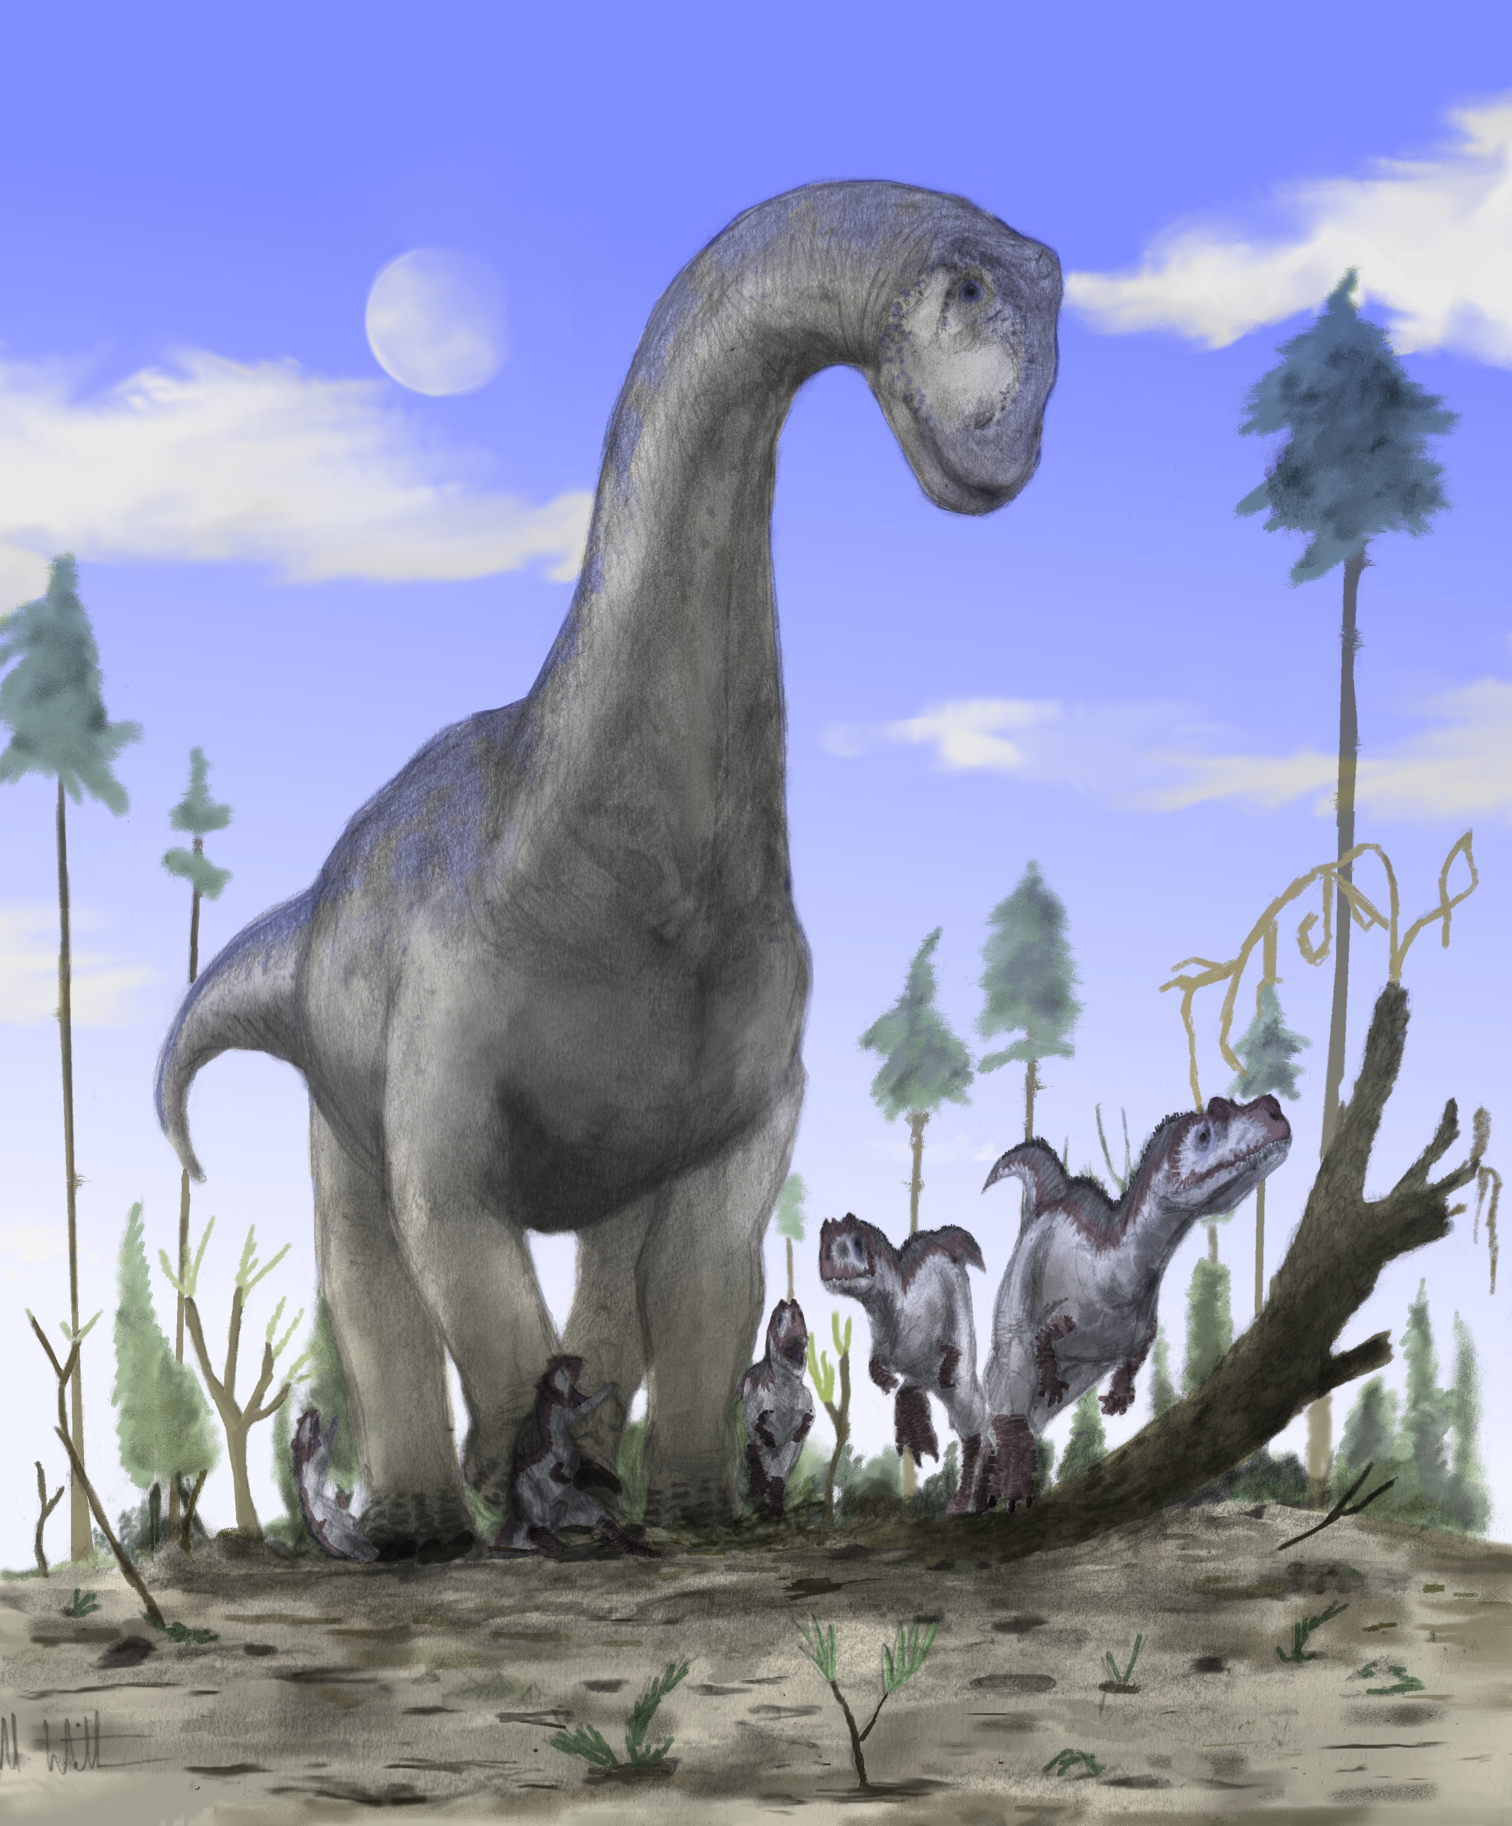
NIU Biology Professor Virginia Naples, and our own Misty Haji-Sheikh talked about digging up old bones. Dinosaur bones, to be more precise. Misty started by introducing the Burpee museum and their pride and joy – Jane the T. Rex. Jane’s the most complete juvenile T. Rex collected thus far. We then moved to Hanksville, Utah and saw some nice pictures of rocks (woohoo!). Burpee has been working at the Hanksville quarry for about 10 years. They have Jurassic fossils from the Morrison formation (about 110 million years old). Allosaurus, Stegosaurus, Camarasaurus, Apatosaurus, and Diplodocus are all found in the Morrison Fm. Special air brushes, called microjacks, are used to clear the matrix (background rock and dirt) from the fossil. This can take time. If a fossil should get broken while cleaning, it gets glued back together with Vinac™ (removable) or Paleo-Bond™ (permanent). Once the fossil is cleared from the formation, it is wrapped in tinfoil and then plaster for transport. PaleoFest March 3-4, 2018 at Burpee: www.burpee.org/event/paleofest-2018/

Quote for the Day

“The dinosaurs disappeared because they could not adapt to their changing environment. We shall disappear if we cannot adapt to an environment that now contains spaceships, computers — and thermonuclear weapons.”
― Arthur C. Clarke, forward to Collected Stories

UPCOMING PROGRAMS: (Why not invite a guest? – that could also mean a prospective member!)
Sept 27 Officer Installation & New Member Induction
Oct 4 BOARD MEETING @ the Lincoln Inn
Oct 11 Awards Committee Presentation Dan Templin (DCCF)
Oct 14 NIU STEM Gillian King Cargile

Today’s Attendance:
38 | Kish Kiwanians
4 | Guests: Mike Pell, Reva Friedman, Jaehee Jong (new NIU prof!), Mike H-S.
0 | K Family:
1 | Co-Speaker: Virginia Naples
43 | TOTAL
Serving the Children of the World

