THE NEWS FROM the
VOLUME XLIX, NUMBER 1

LUNCH: Cream of spud soup, veggie beef soup, cold cuts, cake, and cookies.
KISHWAUKEE KIWANIS CLUB of DeKalb, Illinois

October 11, 2017 Editor: Paul Stoddard http://www.kishkiwanis.org
. SONG: Will the Circle, led by Roger Seymore. Invocation: Joe G.

ANNOUNCEMENTS, EVENTS

Officers for 2017-2018

President Bob Higgerson
President Elect Roger Seymore
Vice President Sue Doubler
Treasurer Ken Doubler
Asst. Treasurer Al Mueller
Secretary Ken Doubler
Asst. Secretary Jerry Wahlstrom
Immediate Past President
Joe Gastiger
Lt. Governor Misty Haji-Sheikh
District Governor Rick Poulton

********************
Kishwaukee Kiwanis Meetings

2nd, 3rd, 4th, (and 5th) Wednesday at 11:45 a.m.
Faranda’s Banquet Center
302 Grove St.
DeKalb, IL

********************
K-Family Events/Meetings

Circle K Every Monday night at 8:00 p.m. in DuSable 302. Hint: To stay young, attend one of their meetings!

AKtion Club – Second Wednesday of the month at 4:00 p.m. at Opportunity House (357 N. California St.) in Sycamore.

********************
Defining Statement

Kiwanis is a global organization of volunteers dedicated to changing the world, one child and one community at a time.

********************
Flag Salute

As our flag signifies purity, valor, and justice, may we as true Kiwanians exemplify these virtues as we serve the children of the world.

and OPPORTUNITITES

Our next Interclub: is TBA. Check with the incoming Lt. Gov. It’s coming soon!

Kirkland Lions coat drive is ongoing. Talk to Amy for details.

Storage Facility – Red Dot is raising the rental costs by about 60%. Ken contacted them and by describing who we are and what we do, managed to cut that increase by about 50%. (The result is an increase from $89 to $108 per month.) No place else around seems to be a better fit. The club voted to stay where we are and pay the extra $19/month.

If you can spell, see Jennie about being on a joint team with the DeKalb club.

Lt. Gov Misty is forming a new club in Huntley. If any of us would like to be part of that (join the new club to help them get started), see Misty.

There’s some talk about merging the two young childrens’ committees.

Thursday Oct 26 at the Sycamore Methodist church – Prayer Breakfast. Sheriff Roger Scott will be the speaker. $7 for guests. (Members are covered by the club.)

Gene is selling pictures he’s taken as placemats, with proceeds to the club to support the local forest preserves.

DeKalb Public Library Book Sale Oct 20-22.

Keep an eye out for greeters at upcoming meetings.

Membership committee meeting next Wednesday at 11:30 am.

Mike’s got Save My Starving Children Raffle tickets. Our volunteer time will be Thursday-Sunday November 9-12. See Jerry W. Our slots are Nov 10, 11 from 3-5 on each day at Suter foods. We have 20 spots to fill each day. This event is open to members, spouses guests, etc! The more the merrier.

IHSA football weekend – Thanksgiving weekend – will need us to man elevators.

Toiletries- We’re collecting these for Safe Passage.

Al – Please pay the new Dues! (Same as the old dues).

Colleen B (aka “Arms”) is collecting box tops and Coke lids. General Mills products, helps local schools.

AKtion Club is collecting aluminum cans and other recyclable materials.

P. o. P. / H e a l t h B o x

Joe G congratulated Tim Dunlop for winning Oak Crest’s Good Samaritan Award

PROGRAM

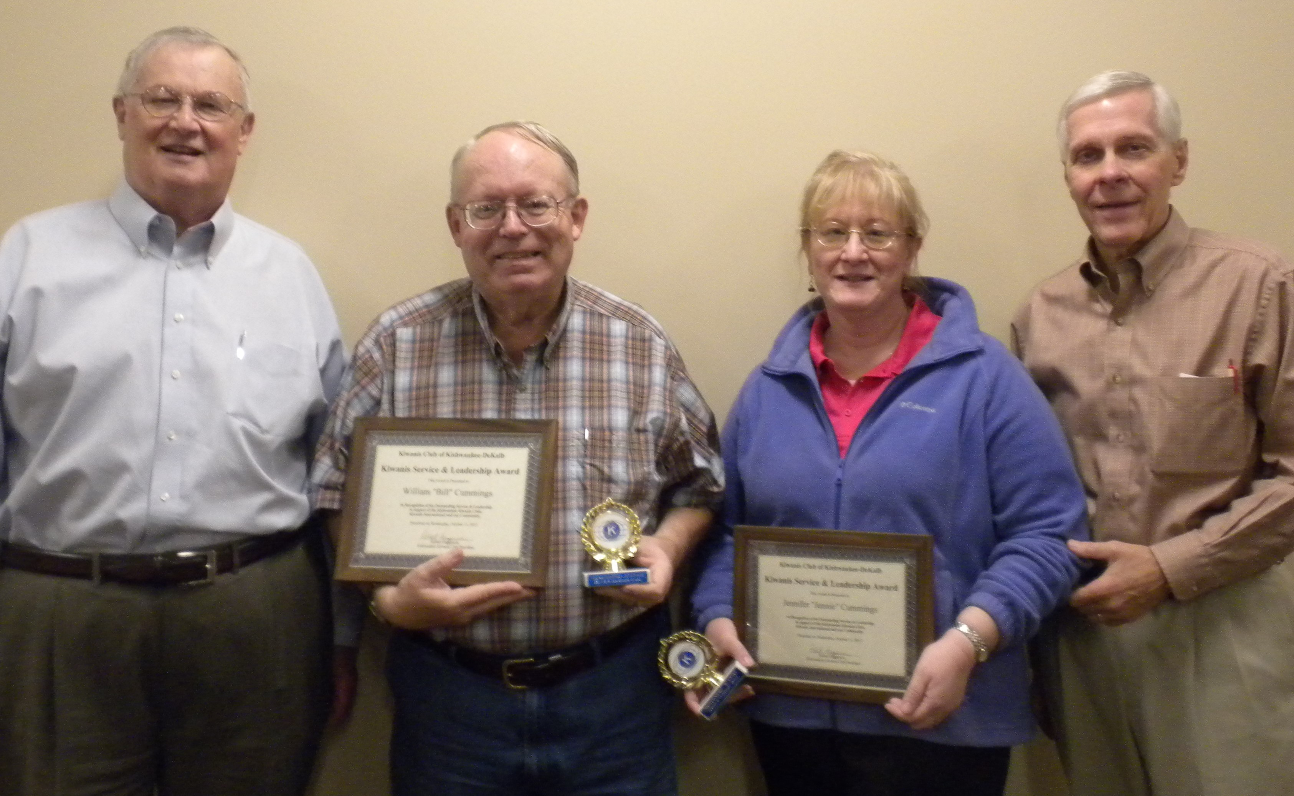
Another big club day today! Dan Templin, from the DeKalb County Community Foundation, joined us for our Awards Presentation. (Keep an eye out for red carpet pictures coming not-so-soon!) The 6th annual Club Service and Leadership Award came with lots of caveats this year. The Jerry and Jerry show should take to the road. Sooner better than later. Our recipients have a combined 47 years in the club. They’re big time Biking with Beanzie activists. A past prez, and a past sec’y. And the recipients are … Bill and Jennie Cummings!!
Dan, whom we all know well, reviewed the status our funds with the Foundation. The Foundation is inviting community gatherings to find out the perceived needs of various communities around the county. DeKalb/Sycamore will be Nov 16th at the old depot in Sycamore. The DCCF’s 25th anniversary is fast approaching. Look for an anniversary gala next fall. There’s new equation 3.6 – 25 = 50. $3.6 million was the lead donation from Charlie and Mary Roberts. 25 years ago. Not sure where the 50 comes from, but maybe if you check out their webpage (https://dekalbccf.org/), you can figure it out.

Quote for the Day
The only reward of virtue is virtue; the only way to have a friend is to be one..
― Ralph Waldo Emerson: Essays, First Series. Friendship.

UPCOMING PROGRAMS: (Why not invite a guest? – that could also mean a prospective member!)
Oct 18 NIU STEM Gillian King Cargile
Oct 25 All About Drones Bob Meyers
Nov 1 BOARD MEETING @ the Lincoln Inn
Nov 8 Ways to grow the club Membership Committee
Nov 15 United Way Dawn Littlefield
Nov 22 Food Desert Dan Kenny
Dec 13 Yuletide Songs Madrigals

Today’s Attendance:
36 | Kish Kiwanians
1 | Guest: Some hairy guy that looked a little like Toney, Al’s friend John O’Neal
0 | K Family Big Wig:
1 | Speaker: Dan
38 | TOTAL
Serving the Children of the World

