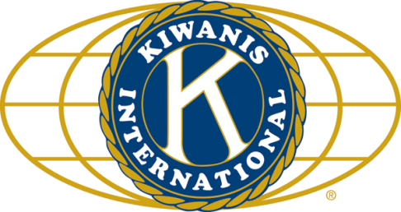

THE NEWS FROM the
VOLUME XLIX, NUMBER 2

LUNCH: Sloppy joes some veggie sandwiches, fruit salad, chips, and cookies.
KISHWAUKEE KIWANIS CLUB of DeKalb, Illinois

October 18, 2017 Editor: Paul Stoddard http://www.kishkiwanis.org
. SONG: The Star Spangled Banner, led by Roger Seymore. Invocation: Jack G.

ANNOUNCEMENTS, EVENTS

Officers for 2017-2018

President Bob Higgerson
President Elect Roger Seymore
Vice President Sue Doubler
Treasurer Ken Doubler
Asst. Treasurer Al Mueller
Secretary Ken Doubler
Asst. Secretary Jerry Wahlstrom
Immediate Past President
Joe Gastiger
Lt. Governor Misty Haji-Sheikh
District Governor Rick Poulton

********************
Kishwaukee Kiwanis Meetings

2nd, 3rd, 4th, (and 5th) Wednesday at 11:45 a.m.
Faranda’s Banquet Center
302 Grove St.
DeKalb, IL

********************
K-Family Events/Meetings

Circle K Every Monday night at 8:00 p.m. in Dusable 302. Hint: To stay young, attend one of their meetings!

AKtion Club – Second Wednesday of the month at 4:00 p.m. at Opportunity House (357 N. California St.) in Sycamore.

********************
Defining Statement

Kiwanis is a global organization of volunteers dedicated to changing the world, one child and one community at a time.

********************
Flag Salute

As our flag signifies purity, valor, and justice, may we as true Kiwanians exemplify these virtues as we serve the children of the world.

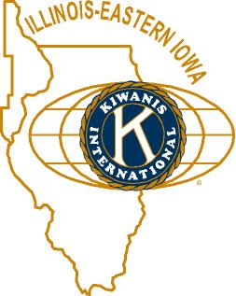

and OPPORTUNITITES

Our next Interclub: is TBA. Check with the incoming Lt. Gov. It’s coming soon!

Kirkland Lions coat drive is ongoing. Talk to Amy for details.

Perfect Attendance Awards were announced by Jerry W, with his usual flair. Congrats to all mentioned. (The complete list is attached below.)

If you can spell, see Jennie about being on a joint team with the DeKalb club.

Lt. Gov Misty is forming a new club in Huntley. If any of us would like to be part of that (join the new club to help them get started), see Misty.

Thursday Oct 26 at the Sycamore Methodist church – Prayer Breakfast. Sheriff Roger Scott will be the speaker. $7 for guests. (Members are covered by the club.)

Gene is selling pictures he’s taken as placemats, with proceeds to the club to support the local forest preserves.

Community Services Committee meeting next Wednesday at 11:30 am, Faranda’s. Biking with Beanzie, at 11:15, too!

DeKalb Public Library Book Sale Oct 20-22.

Keep an eye out for greeters at upcoming meetings.

Mike’s got Save My Starving Children Raffle tickets. Our volunteer time will be Thursday-Sunday November 9-12. See Jerry W. Our slots are Nov 10, 11 from 3-5 on each day at Suter foods. We have 20 spots to fill each day. This event is open to members, spouses guests, etc! The more the merrier.

IHSA football weekend – Thanksgiving weekend – will need us to man elevators. Sign-ups are going around.

Toiletries- We’re collecting these for Safe Passage.

Al – Please pay the new Dues! (Note the change in dues collector!).

Colleen B (aka “Arms”) is collecting box tops and Coke lids. General Mills products, helps local schools.

AKtion Club is collecting aluminum cans and other recyclable materials.

P. o. P. / H e a l t h B o x
Dick Dowen got PoPped for his work as Prez, earning us a Distinguished Club Award. Excellent job, Dick!

PROGRAM

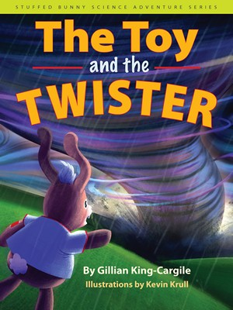
Former Key Club President Gillian King Cargile stopped by to discuss STEM (“Science, Tech, Engineering, Math,” but I always thought it should be “Math, Engineering, Tech, Science”) at NIU (Northern Illinois University, which a previous President wanted to change to University of Northern Illinois). Gillian brought with her some books from her Stuffed Bunny Science Adventures series. Gillian works for NIU’s Outreach division. STEM Read is part of that. STEM Read likes to make mothers cry. One mother cried because she’d never seen her high school-aged son read for pleasure before. Gillian told us about a book series featuring Rosie the Riveter’s great niece, Rosie Revere, Engineer. Gillian has a background in writing and filmmaking, which resulted in a series of her own books. Gillian works with experts to make sure the science in her work is scientifically accurate. Jack and his stuffed bunny (named Bear) have adventures with Jack’s sister Sadie Scientist. STEM Read also participates in NIU’s StemFest, which coincidently enough is this weekend from 10 – 5 in the Convo Center. Everybody is invited. Fun for children of all ages! (That includes us old fogeys.) http://www.stemfest.niu.edu/stemfest/

Quote for the Day
We cannot solve our problems with the same thinking we used when we created them.
― Albert Einstein.

UPCOMING PROGRAMS: (Why not invite a guest? – that could also mean a prospective member!)
Oct 25 All About Drones Bob Meyers
Nov 1 BOARD MEETING @ the Lincoln Inn
Nov 8 Ways to grow the club Membership Committee
Nov 15 United Way Dawn Littlefield
Nov 22 Food Desert Dan Kenny
Dec 13 Yuletide Songs Madrigals

Today’s Attendance:
36 | Kish Kiwanians
2 | Guest: 2 small people with Bill F.
0 | K Family Big Wig:
2 | Speaker: Gillian and husband, Clint Cargyle
40 | TOTAL

Perfect attendance list on next page.

Serving the Children of the World

Perfect Attendance for 2016-2017

Kiwanian | # of Years
Collen Bredeson | 1
Bob Gilmore | 1
Misty Haji-Sheikh | 1
Max Heide | 1
Roger Seymore | 2
Bill Minor | 4
Mike Mooney | 4
Betty Hampa | 5
Joe Gastiger | 7
Bob Higgerson | 7
Dick Dowen | 8
Paul Stoddard | 12
Jennie Cummings | 17
Sue Doubler | 17
Chanette Oeser | 17
Mark Sawyer | 18
Amy Polzin | 21
Bill Cummings | 23
Al Mueller | 23
Jan Byrnes | 25
Jerry Smith | 25
Toney Xidis | 28
Ken Doubler | 29
Bill Finucane | 30
Bob Snow | 30
Jerry Wahlstrom | 33
Jack Goodrich | 35
Peter Lawes | 39
Norm Schaeffer | 45
Herb Burh | 48*
Gordon Melms | 48*

*Perfect attendance since our inception. Way to go, one and all!

