THE NEWS FROM the
VOLUME XLIX, NUMBER 9

LUNCH: Turkey, pot roast, spuds, veggies, salad, and cookies. C-in-C:
KISHWAUKEE KIWANIS CLUB of DeKalb, Illinois

December 20, 2017 Editor: Paul Stoddard http://www.kishkiwanis.org
. SONG: Auld Lang Syne, led by Roger S. Invocation: Rev. Ed Bird

ANNOUNCEMENTS, EVENTS

Officers for 2017-2018

President Bob Higgerson
President Elect Roger Seymore
Vice President Sue Doubler
Treasurer Ken Doubler
Asst. Treasurer Al Mueller
Secretary Ken Doubler
Asst. Secretary Jerry Wahlstrom
Immediate Past President
Joe Gastiger
Lt. Governor Misty Haji-Sheikh
District Governor Rick Poulton

********************
Kishwaukee Kiwanis Meetings

2nd, 3rd, 4th, (and 5th) Wednesday at 11:45 a.m.
Faranda’s Banquet Center
302 Grove St.
DeKalb, IL

********************
K-Family Events/Meetings

Circle K Every Monday night at 8:00 p.m. in Dusable 302. Hint: To stay young, attend one of their meetings!

AKtion Club – Second Wednesday of the month at 4:00 p.m. at Opportunity House (357 N. California St.) in Sycamore.

********************
Defining Statement

Kiwanis is a global organization of volunteers dedicated to changing the world, one child and one community at a time.

********************
Flag Salute

As our flag signifies purity, valor, and justice, may we as true Kiwanians exemplify these virtues as we serve the children of the world.

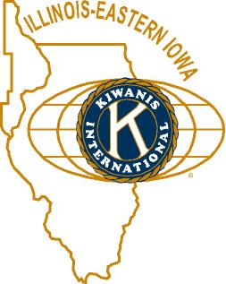

and OPPORTUNITITES

Our next Interclubs: Jan 17 (Kish), Feb 12 (Circle K) are the next dates.

Circle K is selling T-shirts. They’re going for $15, and look pretty sharp. See Paul.

Bill F. recapped the weekend’s football championship activities. Jack G. got stuck in the elevator.

Kirkland Lions coat drive is ongoing. Talk to Amy for details.

Holiday Embrace will follow in January (5th and 6th, at the Westin Chicago Northwest). The dinner and dance ($50) will be Saturday evening, Jan 6th.

Huntley club work is still underway.

Amy made her round of the round of tables passing out good yearbooks of cheer.

Keep an eye out for greeters at upcoming meetings.

Toiletries- We’re collecting these for Safe Passage.

From Al – Please pay the new Dues! (Note the change in dues collector!).

Colleen B (aka “Arms”) is collecting box tops and Coke lids. General Mills products, helps local schools.

P. o. P. / H e a l t h B o x
No news is good news.

PROGRAM

Today our special guests were the Madrigals, who regaled us with several Yuletide Songs: The Wassail Song, So Now is Come our Joyful Feast, Fum, Fum, Fum, Carol of the Bells, Tura Lura Lura. Congratulations and heart-felt thanks to our singers, and the director Travis Evans., and to Donna Xidis for creating the costumes!
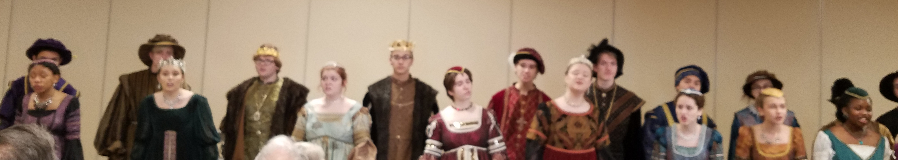

Quotes for the Season

"The seven principles of Kwanzaa — unity, self-determination, collective work and responsibility, cooperative economics, purpose, creativity and faith — teach us that when we come together to strengthen our families and communities and honor the lesson of the past, we can face the future with joy and optimism."
- William J. Clinton
"Hanukkah is about the spark of the divine in all of us made in God's image."
- Suzanne Fields
"Christmas waves a magic wand over the world, and behold, everything is softer and more beautiful."

— Norman Vincent Peale

UPCOMING PROGRAMS: (Why not invite a guest? – that could also mean a prospective member!)
Jan 27 Round Table @ the Lincoln Inn
Jan 3 BOARD MEETING @ the Lincoln Inn
Jan 10 Strangers in Our Land – US Immigration Joe G.
Jan 17 2017 Year in Review Eric Olson, Chronicle Editor
Jan 24 North Korea Overview Morse Tan, NIU College of Law
Jan 31 5th Wednesday Program Membership committee?
Feb 7 BOARD MEETING @ the Lincoln Inn
Feb 14 Poetry? Joe Pasteris?

Today’s Attendance:
34 | Kish Kiwanians
16 | Guests: Reva F., Virginia N, Rita F., Marcia G., Pat L., Joanne P., Denise W., Mary Lou and Brian S., Anita, Maria M., Patty C., Rev Ed B., Anne, Mary, and Liz
0 | K Family:
(22) | Singers: Madrigals
50 (+22) | TOTAL
Serving the Children of the World

