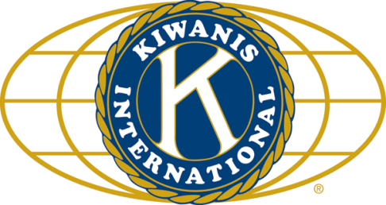

THE NEWS FROM the
VOLUME XLIX, NUMBER 12

LUNCH: Lasagna, green beans, green salad, and dessert bites.
KISHWAUKEE KIWANIS CLUB of DeKalb, Illinois

January 24, 2018 Editor: Paul Stoddard http://www.kishkiwanis.org
. SONG: When Kiwanis Calls, led by Roger S. Invocation: Al M.

ANNOUNCEMENTS, EVENTS

Officers for 2017-2018

President Bob Higgerson
President Elect Roger Seymore
Vice President Sue Doubler
Treasurer Ken Doubler
Asst. Treasurer Al Mueller
Secretary Ken Doubler
Asst. Secretary Jerry Wahlstrom
Immediate Past President
Joe Gastiger
Lt. Governor Misty Haji-Sheikh
District Governor Rick Poulton

********************
Kishwaukee Kiwanis Meetings

2nd, 3rd, 4th, (and 5th) Wednesday at 11:45 a.m.
Faranda’s Banquet Center
302 Grove St.
DeKalb, IL

********************
K-Family Events/Meetings

Circle K Every Monday night at 8:00 p.m. in Dusable 302. Hint: To stay young, attend one of their meetings!

AKtion Club – Second Wednesday of the month at 4:00 p.m. at Opportunity House (357 N. California St.) in Sycamore.

********************
Defining Statement

Kiwanis is a global organization of volunteers dedicated to changing the world, one child and one community at a time.

********************
Flag Salute

As our flag signifies purity, valor, and justice, may we as true Kiwanians exemplify these virtues as we serve the children of the world.

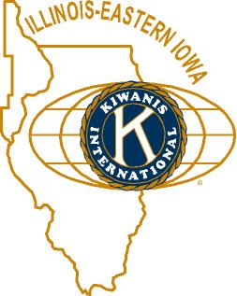

and OPPORTUNITITES

Our next Interclub: Feb 12, 8 pm (Circle K).

Circle K is selling T-shirts. They’re going for $15, and look pretty sharp. See Paul.

Kirkland Lions coat drive is ongoing. Talk to Amy for details.

Bowl for Kids’ Sake, March 1,2,3, and 9 at Mardi Gras.

Speaking of Erin (from Tri-County Kiwanis), she’s volunteered to run for Lt. Gov! Woohoo!

Huntley club work is still underway. The next action is scheduled for February. A Gov’s visit would be tied into their opening.

Beanzie meeting Jan 26 at 8 am at Lincoln Inn. It’s our 20th BwB! We’re in the DeKalb County Visitor’s Guide, and the Illinois Bike Trails guide book.

Talent Show auditions are being scheduled. If you can help judge or otherwise help out, the dates are Jan 27 (9am-noon, 1-3pm), Jan 31 (5pm), and Feb 3. Signups to help are happening. Extra help this Saturday would be great! At the 1st Congregational Church.

Salvation Army needs canned fruit. If you can bring some in, Bill F will see that the SA gets it. We got some this week, and collections will continue next week.

Toiletries- We’re collecting these for Safe Passage.

From Al – Please pay the new Dues! (Note the change in dues collector!)

Colleen B (aka “Arms”) is collecting box tops and Coke lids. General Mills products, helps local schools.

P. o. P. / H e a l t h B o x

No news would be good news.

PROGRAM

In these troubled times, it’s good to get a reassuring word. So Morse Tan, from NIU’s College of Law came by to calm our fears. Morse has literally written the book on North Korea (https://www.amazon.com/North-Korea-International-Dual-Crises/dp/0415830621/ref=sr_1_1?ie=UTF8&qid=1516818528&sr=8-1&keywords=%22morse+tan%22+%22north+korea%22). Morse would define North Korea as a “criminal cult” due to the huge number of human rights violations, and the worship of the Kim dynasty by the populace. Literal worship. North Korea is a totalitarian government, repressing freedoms we take for granted. It has the 4th largest military in the world (after the US, Russia, and China). They have all sorts of WMD, including nuclear. Their missiles now have the range to reach the US, although there may still be some issues with targeting and re-entry. North Korea has 3 goals – increase warm feelings from South Korea, get the US out of Korean affairs, and take over the entire Korean peninsula. Strictly speaking, due to the lack of a peace treaty and violations of the signed armistice, the peninsula is in a state of war. Morse could not emphasize enough the horrid political conditions within North Korea. He suggests we give the North Koreans accurate information about the world to counter the propaganda they are constantly fed. We must, in his opinion, have the strongest possible diplomacy (think really big stick). Prosecution of the leadership could be another tactic. All this, in the best of all possible worlds, could lead to the peaceful reunification of the peninsula. Perhaps Morse wasn’t so calming and reassuring.

Heard around the Tables:

First National is a family-owned bank. Has been for six generations. Who knew? (Well, other than Amanda.)

Quote for the Day

"In a Pyongyang restaurant, don't ever ask for a doggie bag.”

- Christopher Hitchens, Love, Poverty, and War: Journeys and Essays

UPCOMING PROGRAMS: (Why not invite a guest? – that could also mean a prospective member!)
Jan 31 5th Wednesday Program Membership committee?
Feb 7 BOARD MEETING @ the Lincoln Inn
Feb 14 Poetry Joe Pasteris
Feb 21 Dessert! Meg Galus, Exec. Pastry Chef

Today’s Attendance:
40 | Kish Kiwanians
1 | Guests: Virginia
0 | K Family:
1 | Outside Speaker: Morse
42 | TOTAL

Serving the Children of the World

