THE NEWS FROM the
VOLUME XLIX, NUMBER 17

LUNCH: Heroes, Hoagies, Grinders, Subs, chips, fruit salad, and cookies.
KISHWAUKEE KIWANIS CLUB of DeKalb, Illinois

March 14, 2018 Editor: Paul Stoddard http://www.kishkiwanis.org
. SONG: The Star Spangled Banner, led by Roger S. Invocation: Joe G.

ANNOUNCEMENTS, EVENTS

Officers for 2017-2018

President Bob Higgerson
President Elect Roger Seymore
Vice President Sue Doubler
Treasurer Ken Doubler
Asst. Treasurer Al Mueller
Secretary Ken Doubler
Asst. Secretary Jerry Wahlstrom
Immediate Past President
Joe Gastiger
Lt. Governor Misty Haji-Sheikh
District Governor Terry Cunefare

********************
Kishwaukee Kiwanis Meetings

2nd, 3rd, 4th, (and 5th) Wednesday at 11:45 a.m.
Faranda’s Banquet Center
302 Grove St.
DeKalb, IL

********************
K-Family Events/Meetings

Circle K Every Monday night at 8:00 p.m. in Dusable 302. Hint: To stay young, attend one of their meetings!

AKtion Club – Second Wednesday of the month at 4:00 p.m. at Opportunity House (357 N. California St.) in Sycamore.

********************
Defining Statement

Kiwanis is a global organization of volunteers dedicated to changing the world, one child and one community at a time.

********************
Flag Salute

As our flag signifies purity, valor, and justice, may we as true Kiwanians exemplify these virtues as we serve the children of the world.

and OPPORTUNITITES

Our next Interclub: March 20 @ 6pm, Circle K Sycamore, Sorrento’s Ranch.

Erin Tamms (from Tri-county) was voted in as our next Lt. Gov! Woohoo!

DeKalb Club’s Pancake Breakfast tix are on sale ($8). Date is April 14th.

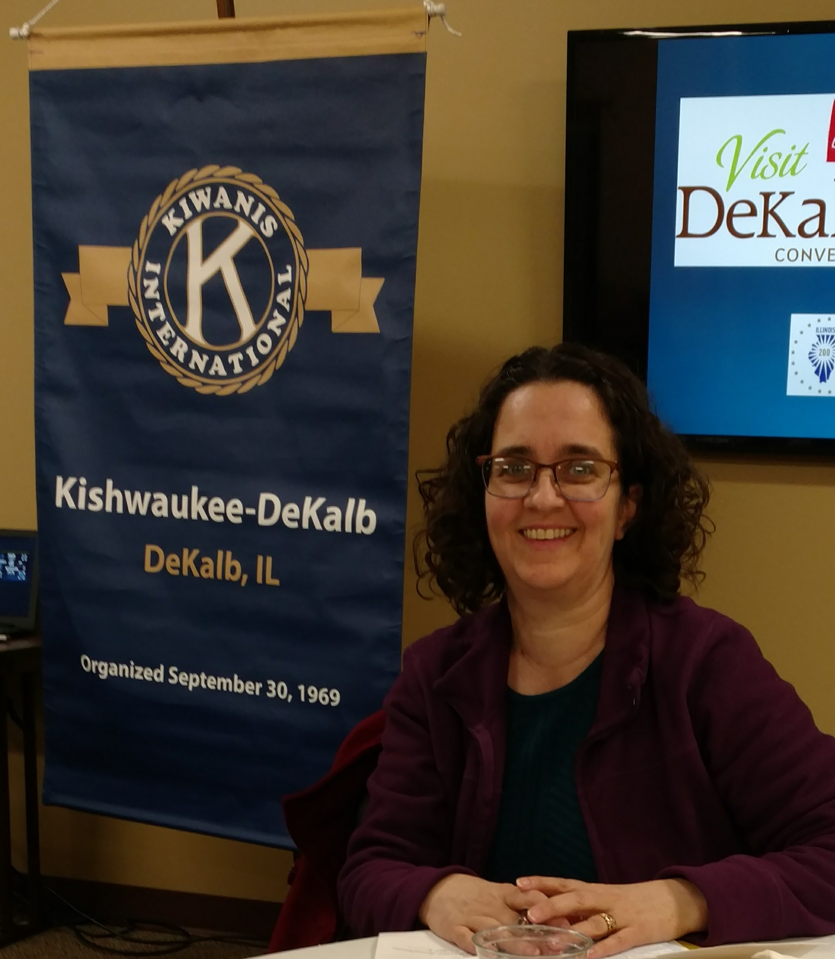
The Alpine Club is having a 50th anniversary dinner April 7 (which is the night of the Talent Show, unfortunately).

Colleen B won the Heart of the Community award from Heartland Bank! Congrats!

On March 24 Hillcrest Covenant Church will be hosting clean comedian Robert G. Lee. See attachment on page 3.

Talent Show is continuing. Ducks are getting lined up. Looks like we have a full complement of performers. Look for volunteer sign-ups soon. Ad sales – think about it… Gene P is offering to display some pictures in the lobby. Anyone interested in helping the intermission sing-along should let Jim know. If you’re putting something into the program, Ken needs it by Friday!!

Team Beanzie got the new flyers. Beanzie jerseys are now available to order. The new flyers have the order form. Deadline is March 7. Contact Toney.

Toiletries- We’re collecting these for Safe Passage.

From Al – Please pay the new Dues! (No arm breaking needed thus far!)

Colleen B (aka “Arms”) is collecting box tops and Coke lids. General Mills products, helps local school.

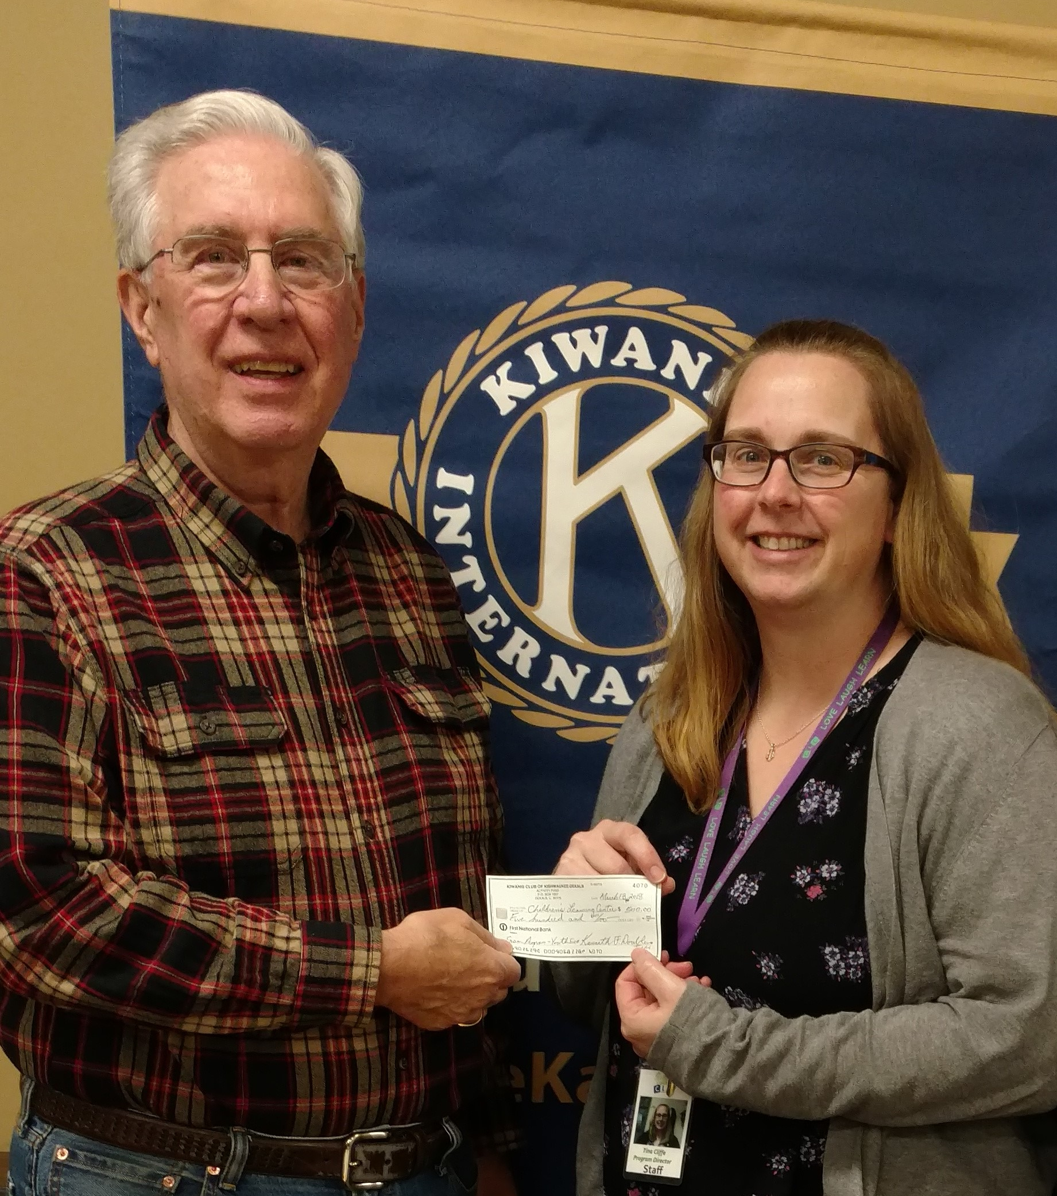
We presented a $500.00 check to the Children’s Learning Center today for their Summer Swim program. Prez Bob Higgerson presented the check to Tina from CLC. She explained a little about the program and how appreciated the donation is.

P. o. P. / H e a l t h B o x

Bill Cummings’ daughter, Meg, (who brought us dessert a couple of weeks ago) was nominated for a James Beard award (one of five in the country nominated).
Congratulations!!

PROGRAM

Debbie Armstrong, Executive Director of the DeKalb County Convention and Visitors’ Bureau visited us today. Debbie helped bring a movie filming and the High School football championships here, bringing almost $2 million to the community. In 2016, visitors to DeKalb County brought in close to $100 million in travel expenses, $15 million in payroll, 570 jobs and about $1.5 million in tax receipts. These numbers have been climbing over the last 10 years. Tourism dollars include more than just hotel rooms (588 in the county) – it’s gas, event parking and restaurants as well. The state has an award-winning travel website – EnjoyIllinois.com. Plus we’ve got our own: http://dekalbcountycvb.com. For those of you more socially media savvy, you can also check them out on Facebook, Twitter, and Instagram (and if you’re that savvy, you can figure out how to find them there). One of the big events last year was the NCAA Div. I Golf Championships, which brought over $300K to the area.

Heard around the Tables:

Las Vegas can be stinkin’ hot.

Quote for the Day

“The other day I went to a tourist information booth and asked, 'Tell me about some of the people who were here last year.”
― Steven Wright

UPCOMING PROGRAMS: (Why not invite a guest? – that could also mean a prospective member!)
Mar 21 TAILS Michelle Groeper
Mar 28 State of the City Mayor Jerry Smith
Apr 4 BOARD MEETING @ the Lincoln Inn
Apr 11 Safe Passage Linnea Laskowski
Apr 18 Talent Show report Jim B. and Anne Marie

Today’s Attendance:
37 | Kish Kiwanians
5 | Guests: Virginia, Mica, Jenny, Donna, Tina
1 | K Family:
0 | Outside Speaker: Debbie
43 | TOTAL

MARCH BIRTHDAYS
8 – Steve Cichy
12 – Norm Schaeffer
23 – Gene Perry

Happy birthday, gentlemen!

Serving the Children of the World

