THE NEWS FROM the
VOLUME XLIX, NUMBER 25

LUNCH: Pulled pork in a tangy bbq sauce, mac & cheese, chips, cookies.
KISHWAUKEE KIWANIS CLUB of DeKalb, Illinois

May 23, 2018 Editor: Paul Stoddard http://www.kishkiwanis.org
. SONG: When Kiwanis Calls, led by Roger S Invocation: Joe G.

ANNOUNCEMENTS, EVENTS

Officers for 2017-2018

President Bob Higgerson
President Elect Roger Seymore
Vice President Sue Doubler
Treasurer Ken Doubler
Asst. Treasurer Al Mueller
Secretary Ken Doubler
Asst. Secretary Jerry Wahlstrom
Immediate Past President
Joe Gastiger
Lt. Governor Misty Haji-Sheikh
District Governor Terry Cunefare

********************
Kishwaukee Kiwanis Meetings

2nd, 3rd, 4th, (and 5th) Wednesday at 11:45 a.m.
Faranda’s Banquet Center
302 Grove St.
DeKalb, IL

********************
K-Family Events/Meetings

Circle K Every Monday night at 8:00 p.m. in Dusable 302. Hint: To stay young, attend one of their meetings!

AKtion Club – Second Wednesday of the month at 4:00 p.m. at Opportunity House (357 N. California St.) in Sycamore.

********************
Defining Statement

Kiwanis is a global organization of volunteers dedicated to changing the world, one child and one community at a time.

********************
Flag Salute

As our flag signifies purity, valor, and justice, may we as true Kiwanians exemplify these virtues as we serve the children of the world.

and OPPORTUNITITES

Next Interclub: June 13, here. Aktion Club Kish. The program will be the 4H speakers. There will be no golfing this year. July interclub will be on the 9th, not the 16th.

Slate of Officers: Directors: 2019 class: Dick Dowen, Alex Wilson, Dawn Littlefield, Misty Haji-Sheik, Bill Finucane. 2018 class: Toney Xidis, Tony Chulick, Jack Goodrich, Colleen Bredeson. Prez: Roger Seymore, Prez-elect: Sue Doubler, VP: Jennie Cummings, Treasurer: Bill Cummings, Ass’t Treasurer: Al Mueller, Secretary: Ken Doubler, Ass’t Sec’y: Jerry Wahlstrom, Imm. Past Prez: Bob Higgerson. Moved by Norm Schaeffer, seconded by Jack Goodrich, accepted unanimously.

Governor’s visit – the Governor wants to meet with us and two other divisions.
You are cordially invited to attend a “Meet and Greet” for District Governor Terry Cunefare and his wife Ruby on Saturday, June 9, 2018.
Where: Christ United Methodist Church
4509 Highcrest Road
Rockford, Illinois 61107
Enter through Door #6. South entrance closest to Alpine Road
Time: 5:00pm – 7:00pm
Who’s Invited: Kiwanis members from all clubs, former members, spouses and friends. Cost: $8.00 per person. Includes pizza and special salad (their salad is awesome!) from Lino’s Restaurant as well as water, soda and wine. Featured Speaker: Governor Terry Cunefare. He has a message for all of us and is excited to meet the members of our clubs in Divisions 12, 13 and 14 who do such great work for the children in our communities. Reservations: Sign-up sheets will be available at your club. Payment ahead is preferred but payment will be accepted at the door. Please make checks out to Alpine Kiwanis. (Club Presidents – sign-up sheets should be forwarded to your Division LTG by June 5. Walk-ins the day of the event are very welcome)
Division 14 LTG. Mitzi Haji-Sheikh, misty.haji@gmail.com. 815-501-3166
Hosted by Kiwanis Club of Alpine

Memorial Day is Misty’s birthday this year.

First Midwest is sending us another new member! Alex Wilson, on the other hand, is leaving us to head down to Tennessee. Sorry to see you go, Alex. If you want to contact him down there, his address will be: 320 Smoky Crossing Way, Seymour, TN 37865.

Fairview Park Cemetery is having a Parade of Flags on Memorial Day. Perhaps you’d like to check it out.

Team Beanzie. The big day is July 15. Save the date! Toney displayed this year’s tie-dye T-Shirt and the 20th Anniversary Jersey. Orders now due today, Wednesday (May 23). Call Toney. He’s also got posters and flyers if anyone wants to display them. BTW, May is National Bicycle Month.

PoP Box
No poop to pop today.

PROGRAM

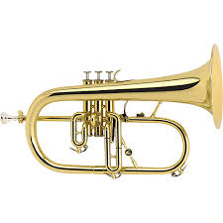
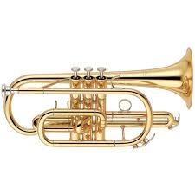
Our own Alex Wilson presented “Bugles Across America” (not to be confused with the Weight Watchers’ program – “Bulges Across America”). BAA was founded in 2000, by Tom Day. Alex began the program with the bugle call To The Colors. BAA was formed because Tom thought Memorial Day services should have live buglers playing Taps, rather than a recording. Alex showed a couple of videos of recordings gone wrong. It wasn’t pretty. If this isn’t for you, you can request a live bugler (for veterans’ services) from the BAA webpage. Click on the rotating logo and fill out the resulting form. There is no charge (but donations are accepted). Anyone who can play Taps on a bugle, trumpet, cornet, or flugelhorn can join BAA. There’s a bugle museum in Berwyn, IL (Tom Day’s hometown). Call first. Appropriately, for the program, and for his tenure with us, Alex closed out with Taps.
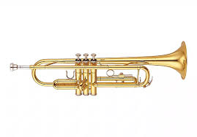
http://www.buglesacrossamerica.org/

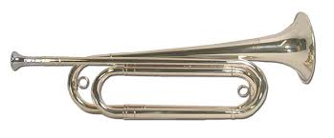

Bugle Trumpet Cornet Flugelhorn

Quote for the Day

“Alone we can do so little; together we can do so much.”
- Helen Keller

Heard around the tables: When was the first telegraph message sent from an aircraft? Call Dick D, or take his LLI course, for the answer.

UPCOMING PROGRAMS: (Why not invite a guest? – that could also mean a prospective member!)

May 30 5th Wednesday Committee day
June 6 Board Meeting @ the Lincoln Inn
June 13 County 4-H Public Speaking Contest Winners
June 20 Biking with Beanzie Toney and Bill
June 27 DeKalb County History Center Michelle Donahoe and Sue Breeze

Today’s Attendance:
37 | Kish Kiwanians
0 | Guests:
0 | K Family:
0 | Outside Speaker
37 | TOTAL (meals)
Serving the Children of the World

