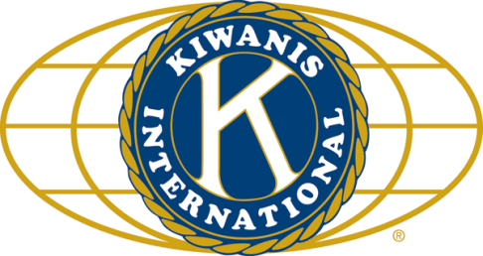

THE NEWS FROM the
VOLUME XLIX, NUMBER 26

LUNCH: DIY sandwiches, fruit salad, chips, cookies.
KISHWAUKEE KIWANIS CLUB of DeKalb, Illinois

May 30, 2018 Editor: Paul Stoddard http://www.kishkiwanis.org
. SONG: This Land is Your Land, led by Roger S Invocation: Roger S.

ANNOUNCEMENTS, EVENTS

Officers for 2017-2018

President Bob Higgerson
President Elect Roger Seymore
Vice President Sue Doubler
Treasurer Ken Doubler
Asst. Treasurer Al Mueller
Secretary Ken Doubler
Asst. Secretary Jerry Wahlstrom
Immediate Past President
Joe Gastiger
Lt. Governor Misty Haji-Sheikh
District Governor Terry Cunefare

********************
Kishwaukee Kiwanis Meetings

2nd, 3rd, 4th, (and 5th) Wednesday at 11:45 a.m.
Faranda’s Banquet Center
302 Grove St.
DeKalb, IL

********************
K-Family Events/Meetings

Circle K Every Monday night at 8:00 p.m. in Dusable 302. Hint: To stay young, attend one of their meetings!

AKtion Club – Second Wednesday of the month at 4:00 p.m. at Opportunity House (357 N. California St.) in Sycamore.

********************
Defining Statement

Kiwanis is a global organization of volunteers dedicated to changing the world, one child and one community at a time.

********************
Flag Salute

As our flag signifies purity, valor, and justice, may we as true Kiwanians exemplify these virtues as we serve the children of the world.

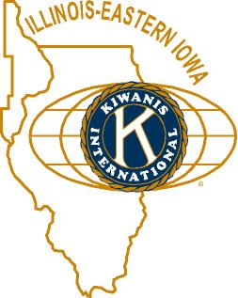

and OPPORTUNITITES

Next Interclub: June 13, here. Aktion Club Kish. The program will be the 4H speakers. There will be no golfing this year. July interclub will be on the 9th, not the 16th.

ICYMI: Slate of Officers: Directors: 2019 class: Dick Dowen, Alex Wilson, Dawn Littlefield, Misty Haji-Sheik, Bill Finucane. 2018 class: Toney Xidis, Tony Chulick, Jack Goodrich, Colleen Bredeson. Prez: Roger Seymore, Prez-elect: Sue Doubler, VP: Jennie Cummings, Treasurer: Bill Cummings, Ass’t Treasurer: Al Mueller, Secretary: Ken Doubler, Ass’t Sec’y: Jerry Wahlstrom, Imm. Past Prez: Bob Higgerson. Moved by Norm Schaeffer, seconded by Jack Goodrich, accepted unanimously.

Governor’s visit – the Governor wants to meet with us and two other divisions. The visit will be June 9, in Rockford. Pizza, about $8. Low key.

First Midwest is sending us another new member! Alex Wilson, on the other hand, is leaving us to head down to Tennessee. Sorry to see you go, Alex. If you want to contact him down there, his address will be: 320 Smoky Crossing Way, Seymour, TN 37865.

Team Beanzie. The big day is July 15 (not August 15, Toney!). Save the date! Let Sue know if you need a worker shirt. Please do so by July 1st. Call Toney. He’s also got posters and flyers if anyone wants to display them. BTW, May is National Bicycle Month.

PoP Box
No poop to pop today.

June Birthdays – HAPPY BIIRTHDAY!

June 4 - Joe Gastiger
June 24 – Virginia Naples

PROGRAM

Today was committee day, since it’s the 5th Wednesday of the month. As a group we discussed a request for $300 from Circle-K for registration at a convention. They only have $12 left, so this would have to be borrowed against next year’s budget. All in all, we decided Circle-K is moving in the right direction, and approved the request.
Also, Jim Barker is looking for a co-chair for the talent show next year (April 6). Jim also things we need a subcommittee dedicated to talent show promotion.
Ken brought the diminishing General Fund to our attention, with the thought of possible small dues increases in each of the next two years. It will be discussed at future board meetings, and would have to be approved by the entire club. The last increase was in 2008.
If you check the incoming officers above, you’ll see Alex W was elected to be on the board. With his move to Tennessee, he will need to be replaced.
Individual committee meetings ensued.

Quote for the Day

“Alone we can do so little; together we can do so much.”
- Helen Keller

Heard around the tables: Roger’s got some big plans for the talent show next year. You won’t want to miss it!

UPCOMING PROGRAMS: (Why not invite a guest? – that could also mean a prospective member!)
June 6 Board Meeting @ the Lincoln Inn
June 13 County 4-H Public Speaking Contest Winners
June 20 Biking with Beanzie Toney and Bill
June 27 DeKalb County History Center Michelle Donahoe and Sue Breeze
JULY 4 NO MEETING (go to Kirkland for the parade)
July 11 Board Meeting @ the Lincoln Inn

Today’s Attendance:
33 | Kish Kiwanians
1 | Guests: Al’s granddaughter, Annabella Anne
0 | K Family:
0 | Outside Speaker
34 | TOTAL (meals)

Serving the Children of the World

