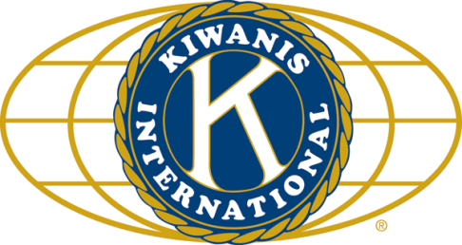

THE NEWS FROM the
VOLUME XLIX, NUMBER 33

LUNCH: Chicken burritos, spaghetti, and brownies.
KISHWAUKEE KIWANIS CLUB of DeKalb, Illinois

August 15, 2018 Editor: Paul Stoddard http://www.kishkiwanis.org
. SONG: God Bless America, led by Bill H. Invocation: Rev Joe.

ANNOUNCEMENTS, EVENTS

Officers for 2017-2018

President Bob Higgerson
President Elect Roger Seymore
Vice President Sue Doubler
Treasurer Ken Doubler
Asst. Treasurer Al Mueller
Secretary Ken Doubler
Asst. Secretary Jerry Wahlstrom
Immediate Past President
Joe Gastiger
Lt. Governor Misty Haji-Sheikh
District Governor Terry Cunefare

********************
Kishwaukee Kiwanis Meetings

2nd, 3rd, 4th, (and 5th) Wednesday at 11:45 a.m.
Faranda’s Banquet Center
302 Grove St.
DeKalb, IL

********************
K-Family Events/Meetings

Circle K Every Monday night at 8:00 p.m. in Dusable 302. Hint: To stay young, attend one of their meetings!

AKtion Club – Second Wednesday of the month at 4:00 p.m. at Opportunity House (357 N. California St.) in Sycamore.

********************
Defining Statement

Kiwanis is a global organization of volunteers dedicated to changing the world, one child and one community at a time.

********************
Flag Salute

As our flag signifies purity, valor, and justice, may we as true Kiwanians exemplify these virtues as we serve the children of the world.

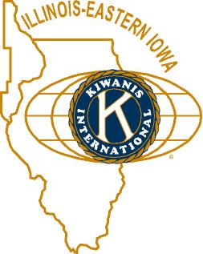

and OPPORTUNITITES

Next Interclub: TBA

Peanut Day is coming! Sept 28. Jerry W. passed around order forms for the boxes. Roger has the sign-up sheet. Street corners and deliveries.

Senior Services need volunteers Aug 28, 10 – 12 noon, to help at the food pantry. Diana has a sign-up sheet.

The DeKalb Club is offering a volunteer opportunity for someone willing to drive stuff to Rockford once a month for The Country Store (a resale shop), a support facility for FSA.

The Barn Tour was very successful, with over 700 people!

Misty hit up Jim Dooley regarding a Huntley Club at D-Con.

Car parking will happen at Corn Fest again this year! Jack will have a sign-up sheet. Thanks to Mike Mooney for the use of the lot!!

Mayor Jerry announced that the Pathway Extension ribbon cutting will probably be at 5:15 pm on Tuesday Sept 4.

Circle K got a $500 grant from the Student Association at NIU this year! Woohoo!

Rummage Sale September 7 at Ken and Sue’s house. You can start dropping stuff off (no clothes or bulky furniture) on Sept 5. Talk to Sue if you’d like to help.

Committee Signups are happening!
Also, the Ellwoods have invited us to their house tonight at 6:15, to listen to music. Join the Jerrys, who have made every one so far. This may well be the last time this summer, so try to take advantage! Plus you can celebrate with Bill and Rita!

By special request, a link for your consideration:
https://finance.yahoo.com/news/dominos-pizza-unveils-u-s-infrastructure-project-filling-potholes-130802630.html
Perhaps this is something we can do in DeKalb…

PoP Box
No poop to pop today.

PROGRAM

Today NIU AD Sean Frazier was our guest. Sports at NIU are already underway, even though classes don’t start for another week and a half. Men’s soccer won an exhibition game last night. Times are tough financially, given the state’s decreasing support of higher education, but Huskie donors and supporters have stepped up, much to Sean’s joy. This year brings some football firsts – a home-and-home with Utah visiting us this year (Sept 8). This is NIU’s first match-up with a PAC-12 team. The Huskies head down to the Sunshine State to take on Florida State on Sept 22. The season kicks off September 1 at Iowa State. Also look for a big clash on Oct 27, as they battle Brigham Young University in Provo. NIU has been picked to win the MAC this year. Sean sees this as a mixed blessing. It’s deserved, but it weighs on the student athletes.
The Convocation Center is being upgraded with a new video board and an improved Nelson Suite.
You can learn a lot about NIU athletics at https://niuhuskies.com/index.aspx

Quote for the Day

“I never did say that you can’t be a nice guy and win. I said that if I was playing third base and my mother rounded third with the winning run, I’d trip her up.”
- Leo Durocher

UPCOMING PROGRAMS: (Why not invite a guest? – that could also mean a prospective member!)
Aug 22 DeKalb Police Department Officer Kelly Sullivan
Aug 29 5th Wednesday Committee Day
Sept 5 BOARD MEETING @ the Lincoln Inn
Sept 12 Ellwood House Brian Ries
Sept 19 Kish Hospital Wellness Center Joe Molter
Sept 26 Installation of New Officers

Today’s Attendance:
29ish | Kish Kiwanians
0 | K-Family:
0 | Guest:
1 | Outside Speaker: Sean
30ish | Total

Serving the Children of the World

