THE NEWS FROM the
VOLUME XLIX, NUMBER 34

LUNCH: Roast beef or meatloaf (your choice!) and gravy, mashed spuds, veggies, salad, and little cakes for dessert.
KISHWAUKEE KIWANIS CLUB of DeKalb, Illinois

August 22, 2018 Editor: Paul Stoddard http://www.kishkiwanis.org
. SONG: Karaoke: a rather morose Hey Jude, led by Roger S. Invocation: Rev Joe.

ANNOUNCEMENTS, EVENTS

Officers for 2017-2018

President Bob Higgerson
President Elect Roger Seymore
Vice President Sue Doubler
Treasurer Ken Doubler
Asst. Treasurer Al Mueller
Secretary Ken Doubler
Asst. Secretary Jerry Wahlstrom
Immediate Past President
Joe Gastiger
Lt. Governor Misty Haji-Sheikh
District Governor Terry Cunefare

********************
Kishwaukee Kiwanis Meetings

2nd, 3rd, 4th, (and 5th) Wednesday at 11:45 a.m.
Faranda’s Banquet Center
302 Grove St.
DeKalb, IL

********************
K-Family Events/Meetings

Circle K Every Monday night at 8:00 p.m. in Dusable 302. Hint: To stay young, attend one of their meetings!

AKtion Club – Second Wednesday of the month at 4:00 p.m. at Opportunity House (357 N. California St.) in Sycamore.

********************
Defining Statement

Kiwanis is a global organization of volunteers dedicated to changing the world, one child and one community at a time.

********************
Flag Salute

As our flag signifies purity, valor, and justice, may we as true Kiwanians exemplify these virtues as we serve the children of the world.

and OPPORTUNITITES

Next Interclub: TBA

Peanut Day is coming! Sept 28. Jerry W. passed around order forms for the boxes. Roger has the sign-up sheet. Street corners and deliveries.

Senior Services need volunteers Aug 28, 10 – 12 noon, to help at the food pantry. Diana has a sign-up sheet.

We had a collection to buy candy for Kite Fest, since Nestle’s isn’t giving it away this year.

The DeKalb Club is offering a volunteer opportunity for someone willing to drive stuff to Rockford once a month for The Country Store (a resale shop), a support facility for FSA.

Car parking will happen at Corn Fest again this year! Jack has the sign-up sheet. Thanks a lot to Mike Mooney for the use of the lot!!

Mayor Jerry announced that the Pathway Extension ribbon cutting will probably be at 5:15 pm on Tuesday Sept 4.

Circle K got a $500 grant from the Student Association at NIU this year! Woohoo!

Rummage Sale September 7 at Ken and Sue’s house. Setup on the 6th. You can start dropping stuff off (no clothes or bulky furniture) on Sept 5. Talk to Sue if you’d like to help.

Committee Signups are happening!
By special request, a link for your consideration:
https://finance.yahoo.com/news/dominos-pizza-unveils-u-s-infrastructure-project-filling-potholes-130802630.html
Perhaps this is something we can do in DeKalb…

PoP Box
Happy Birthday to was sung Bill M. (No appropriate royalties were paid.) Not to be outdone, Pete and Pat Lawes are celebrating their 59th anniversary this month. They were married in 1959. And …
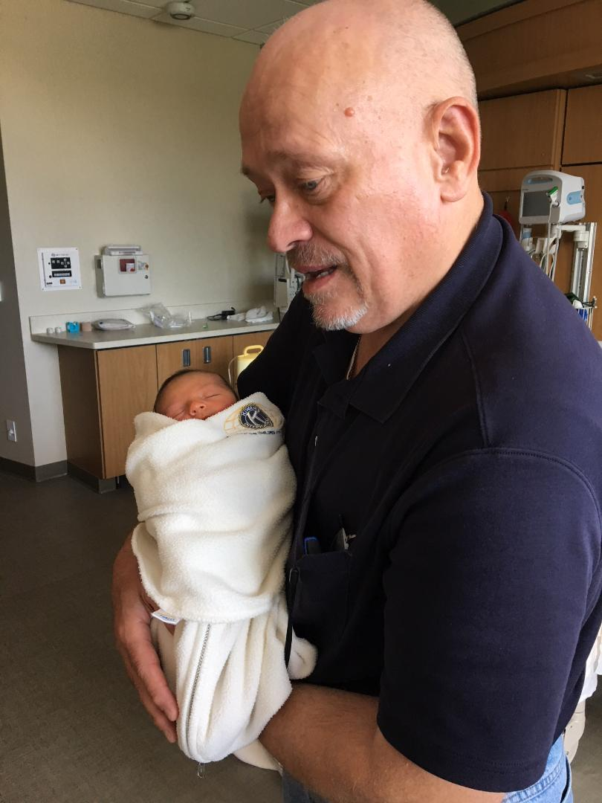

PROGRAM

Officer Kelly Sullivan, from the DeKalb Police Department was here. Surprisingly, no arrests were made. Officer Sullivan is the communications relations officer for the department. She’s been an officer for 20 years, 17 of them here in DeKalb – 5 years on patrol, 10 in investigations, and 2 in her current role. The program offered several safety tips. Number 1 – be aware of your surroundings (don’t get immersed in your phone). Let people know when you go out and when you’re likely to return. Don’t carry large sums of cash or unnecessary credit cards. When you get robbed – give up your valuables, get a description, remember which way they ran/drove off. Don’t leave valuables on your car seat (keep them out of view). If it looks like you’re being followed while driving, don’t drive home. Go to a police or fire station instead. Call the police. Even though you should generally do what bad guys want (for your own safety), don’t get in a car with them! Bad things happen if they take you someplace else. Report suspicious people to the police. You know – like Toney, and anyone named Bill (well not Bill Minor – it’s his birthday). Stop your mail and newspapers when you go on vacation. Get timers for the lights, and have a friend park in your driveway and/or open and close the blinds. Make it look like someone’s there.
You can learn a lot about the DeKalb Police at https://www.cityofdekalb.com/184/Police-Department.

Heard around the tables:
It was really good stuff. Kind of a shame that I wasn’t paying attention.

Quote for the Day
“A really good detective never gets married.”
- Raymond Chandler
UPCOMING PROGRAMS: (Why not invite a guest? – that could also mean a prospective member!)
Aug 29 5th Wednesday Committee Day
Sept 5 BOARD MEETING @ the Lincoln Inn
Sept 12 Ellwood House Brian Ries
Sept 19 Kish Hospital Wellness Center Joe Molter
Sept 26 Installation of New Officers

Today’s Attendance:
35 | Kish Kiwanians
0 | K-Family:
0 | Guest:
1 | Outside Speaker: Officer Kelly
36 | Total
Serving the Children of the World

