THE NEWS FROM the
VOLUME L, NUMBER 6

LUNCH: BBQ chicken, mixed veggies, diced potatoes, e. coli salad, cookies and breads.
KISHWAUKEE KIWANIS CLUB of DeKalb, Illinois

Nov 21, 2018 Editor: Paul Stoddard http://www.kishkiwanis.org
. SONG: When You’re Smiling, led by Roger S. Invocation: Jack G.

ANNOUNCEMENTS, EVENTS

Officers for 2017-2018

President Roger Seymore
President Elect Sue Doubler
Vice President Jennie Cummings
Treasurer Bill Cummings
Asst. Treasurer Al Mueller
Secretary Ken Doubler
Asst. Secretary Jerry Wahlstrom
Immediate Past President
Bob Higgerson
Lt. Governor Erin Tamms
District Governor Alan Arbuckle

********************
Kishwaukee Kiwanis Meetings

2nd, 3rd, 4th, (and 5th) Wednesday at 11:45 a.m.
Faranda’s Banquet Center
302 Grove St.
DeKalb, IL

********************
K-Family Events/Meetings

Circle K Every Wednesday night at 7:00 p.m. in Stevenson Fishbowl. Hint: To stay young, attend one of their meetings!

AKtion Club – Second Wednesday of the month at 4:00 p.m. at Opportunity House (357 N. California St.) in Sycamore.

********************
Defining Statement

Kiwanis is a global organization of volunteers dedicated to changing the world, one child and one community at a time.

********************
Flag Salute

As our flag signifies purity, valor, and justice, may we as true Kiwanians exemplify these virtues as we serve the children of the world.

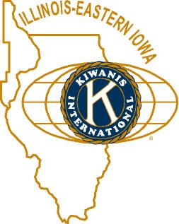

and OPPORTUNITITES

Next Interclub: TBA

Salvation Army Our Bell Ringing shifts will be on December 8 at Schnuck’s. It will be indoors!

Beanzie Committee: TBA

Safe Passage is running a Christmas Purse Project. If you’ve got a new or gently used purse you’re not using, why not fill it with small gift items, and drop it off at VAC by December 17? You’ll be glad you did! Contact Colleen for more info.

Tim gave away a FMSC t-shirt to Bill C. See, good things happen when you volunteer!

DeKalb County Not-For-Profit Project challenge from Doug Roberts. He will match $300,000 in contributions, and the DeKalb County Community Foundation still needs $150,000. Reviving the “Let’s make Tim pay” campaign, Tim Dunlop, Jerry Smith, and Paul Stoddard will be matching club donations up to $1000. With Doug’s match, for every $1 you give, DCCF gets $3 for the DCNFPP. Such a deal!

Talent Show committee is kicking it up with regular meetings. First one was October 10, at 11:30 am, before the regular club meeting. We need help with publicity.

Feed My Starving Children. 21 members showed up. It was a record volume shift. Overall, over 1,000,000 meals were packed.

PoP Box
Roger recognized our club’s veterans. A well-deserved round of applause greeted them. Thank you, all, for your service!

PROGRAM

In a dramatic change of events, our originally scheduled program (Part II of Water Resources) has been postponed to a later date, and instead Joleen Willis provided our program on the DeKalb County Business Incubator located at the Community Outreach Building (COB) at the County’s Health Department campus. Joleen is new to the County, having moved here in 2016 when her husband took the superintendent position at Indian Creek. The incubator is designed to help and house start-up businesses and those in transition (as from a garage or on-line to a brick-and-mortar establishment). The incubator started in 2016, and currently has 4 tenants including a publisher, a rehab center, and a law office. They have room for 3 more tenants who could take advantage of their professional office space, a business internet address and free wi-fi, 24/7 secure access, business advisors, conference rooms, and so much more! All that will cost you only $75/month for a desk, or 250-600/month for fully furnished offices. The Community Gardens started off at the incubator before moving up to Walnut Grove. Applications (and more information) can be found at: http://dekalbcounty.org/Incubator/

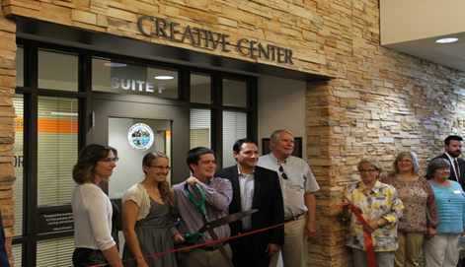

Heard around the tables:
DeKalb’s ski slopes are not attracting enough winter customers to Bob’s B-n-B.

Quote for the Day

“Be thankful for what you have; you’ll end up having more. If you concentrate on what you don’t have, you will never, ever have enough.”
-Oprah Winfrey

UPCOMING PROGRAMS: (Why not invite a guest? – that could also mean a prospective member!)
Nov 28 Joe Gastiger True or False in the era of “Fake News”
Dec 5 BOARD MEETING @ the Lincoln Inn
Dec 12 Misty Haji-Sheikh Water Resources, Part II
Dec 19 Madrigals Traditional Christmas Music
Dec 26 Year-end Reflections @ the Lincoln Inn

Today’s Attendance:
27 | Kish Kiwanians
0 | K-Family:
0 | Guests:
1 | Outside Speaker: Joleen
28 | Total

Serving the Children of the World

