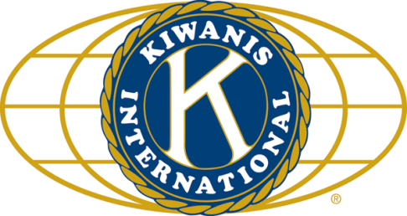

THE NEWS FROM the
VOLUME L, NUMBER 7

LUNCH: Breakfast burritos, pancakes (including homemade syrup!), fruit salad, pastries.
KISHWAUKEE KIWANIS CLUB of DeKalb, Illinois

Nov 28, 2018 Editor: Paul Stoddard http://www.kishkiwanis.org
. SONG: Jingle Bells, led by Roger S. Invocation: Al M.

ANNOUNCEMENTS, EVENTS

Officers for 2017-2018

President Roger Seymore
President Elect Sue Doubler
Vice President Jennie Cummings
Treasurer Bill Cummings
Asst. Treasurer Al Mueller
Secretary Ken Doubler
Asst. Secretary Jerry Wahlstrom
Immediate Past President
Bob Higgerson
Lt. Governor Erin Tamms
District Governor Alan Arbuckle

********************
Kishwaukee Kiwanis Meetings

2nd, 3rd, 4th, (and 5th) Wednesday at 11:45 a.m.
Faranda’s Banquet Center
302 Grove St.
DeKalb, IL

********************
K-Family Events/Meetings

Circle K Every Wednesday night at 7:00 p.m. in Stevenson Fishbowl. Hint: To stay young, attend one of their meetings!

AKtion Club – Second Wednesday of the month at 4:00 p.m. at Opportunity House (357 N. California St.) in Sycamore.

********************
Defining Statement

Kiwanis is a global organization of volunteers dedicated to changing the world, one child and one community at a time.

********************
Flag Salute

As our flag signifies purity, valor, and justice, may we as true Kiwanians exemplify these virtues as we serve the children of the world.

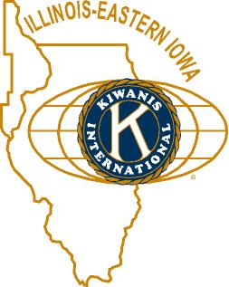

and OPPORTUNITITES

Next Interclub: DeKalb club is hosting. Elks Club. Monday 12/10 at 5:30pm.

Salvation Army Our Bell Ringing shifts will be on December 8 at Schnuck’s. It will be indoors!

Roger announced that Starbuck’s is having a contest. If you win you get a free drink every day for the rest of your life, a $50,000 value. That’s a LATTE money!

Steel Pan concert this Saturday on NIU’s campus. $5.

Beanzie Committee: A list of potential new Beanzie sponsors has been prepared. Bill M. will have the list next meeting. Check it out. If you know anyone with these companies, you may want to contact them and nudge them in the right direction.

Safe Passage is running a Christmas Purse Project. If you’ve got a new or gently used purse you’re not using, why not fill it with small gift items, and drop it off at VAC by December 17? You’ll be glad you did! Contact Colleen for more info.

Jerry S. gave a list of the top ten reasons not to invite guests to our meetings.

DeKalb County Not-For-Profit Project challenge from Doug Roberts. He will match $300,000 in contributions, and the DeKalb County Community Foundation still needs $150,000. Reviving the “Let’s make Tim pay” campaign, Tim Dunlop, Jerry Smith, and Paul Stoddard will be matching club donations up to $1000. With Doug’s match, for every $1 you give, DCCF gets $3 for the DCNFPP. Such a deal!
Pledges accepted until the end of this year, payable next year if you like. Info cards were available on the tables. Put Kish Kiwanis on the memo line of your check, so we make the double match!

Talent Show committee is kicking it up with regular meetings. First one was October 10, at 11:30 am, before the regular club meeting. We need help with publicity.

Feed My Starving Children. 21 members showed up. It was a record volume shift. Overall, over 1,000,000 meals were packed.

PoP Box
No PooP to PoP today.

PROGRAM

Joe Gastiger, yes our own Joe G., talked to us about “True or False in the era of ‘Fake News’.” Or did he? Perhaps what you’re reading right now is “fake news.” How would you know?
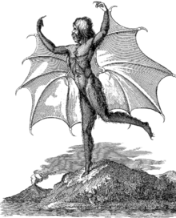
Joe reminded us that fake news has been around since the beginning of news. Richard Adams Locke, New York Sun editor in the 19th Century, published a series of detailed stories about the Moon’s inhabitants. The “facts” reported were attributed to a real-life astronomer, Sir John Herschel, who was safely incommunicado down in South Africa. The descriptions of the two races of lunar inhabitants (one of which is pictured at left) mimicked prejudiced ideas about people here on Earth. The articles were popular because they re-affirmed what people wanted to believe. Social media, like Facebook, is used to promote ideas under the guise of being “news.” Fake news is not news that happens to be wrong (a mistake, for example), but when the story is a deliberate fabrication. Cherry-picking information to make winning arguments is called “stove piping.” Be careful when reading such arguments – ask yourself if there could be information that they’re not telling you. Former VP Dick Cheney would call the New York Times with unattributed information, and then cite the paper as a source of that information. Today, fake news is tied to partisan identity. We are much more likely to believe stories not based on their “truthiness” but on whether they reinforce our ideas. And many of these stories are made up by people overseas as “click bait” – ways to get people to click on the story, and thus generate advertising revenue for their site. The more sensational the story, the more clicks it gets. Truth doesn’t factor into it at all. Joe would have gone on and on, but Dick and Roger got out the hook (it took both of them).
From today’s Washington Post: https://www.washingtonpost.com/politics/2018/11/28/fact-checking-president-trumps-interview-with-washington-post/?utm_term=.fb5d59144d6d&wpisrc=nl_most&wpmm=1

Heard around the tables:
People weren’t talking loud enough.

Quote for the Day

“You are entitled to your own opinion. But you are not entitled to your own facts.”
-Daniel Patrick Moynihan

UPCOMING PROGRAMS: (Why not invite a guest? – that could also mean a prospective member!)
Dec 5 BOARD MEETING @ the Lincoln Inn
Dec 12 Misty Haji-Sheikh Water Resources, Part II
Dec 19 Madrigals Traditional Christmas Music
Dec 26 Year-end Reflections @ the Lincoln Inn

Today’s Attendance:
36 | Kish Kiwanians
0 | K-Family:
0 | Guests:
0 | Outside Speaker:
36 | Total

Serving the Children of the World

