The News FROM the
VOLUME LIII, NUMBER 15

Aug 10, 2022 Editor-for-today: Mark Sawyer http://www.kishkiwanis.org

LUNCH: Pasta and sausages in veggies, slald Hybrid Meeting led by Prez Colleen
KISHWAUKEE KIWANIS CLUB of DeKalb, Illinois
. Invocation: Marty

ANNOUNCEMENTS, EVENTS

Officers for 2021-2022

President Colleen Bredeson
President Elect Mary McGinn
Vice President Bob Hoffman
Treasurer Sue Doubler
Asst. Treasurer Al Mueller
Secretary Ken Doubler
Asst. Secretary Jerry Wahlstrom
Immediate Past President
Jennie Cummings
Lt. Governor Lisa DeWitt
District Governor Angie Burford

********************
Kishwaukee Kiwanis Meetings

2nd, 3rd, 4th, (and 5th) Wednesdays at 11:45 a.m.
Faranda’s Banquet Center
302 Grove St.
DeKalb, IL

********************
K-Family Events/Meetings

Circle K Every other Fridayevening at 6:00 p.m. in DuSable 461 or via Teams Online.

AKtion Club – Looking to start up again in January at Opportunity House (357 N. California St.) in Sycamore.

********************
Defining Statement

Kiwanis is a global organization of volunteers dedicated to changing the world, one child and one community at a time.

********************
Flag Salute

As our flag signifies purity, valor, and justice, may we as true Kiwanians exemplify these virtues as we serve the children of the world.

and OPPORTUNITITES

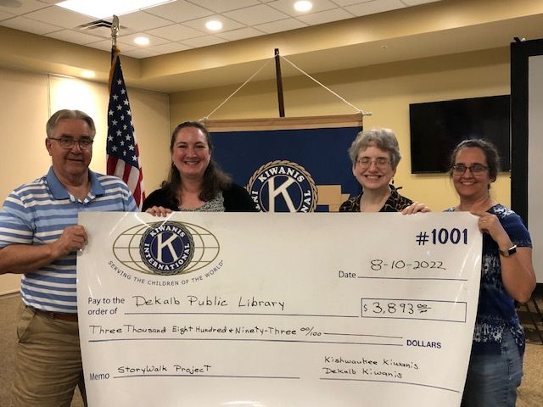

A check was presented to the DeKalb Public Library today from both Kish and DeKalb clubs to support the ‘Storywalk’ project. On hand to receive the check were Emily Faulkner and Teresa Winterbower. Presenting were Colleen and Mark Meier from DeKalb Club. The Storywalk project is being done in Eden’s Garden on Twombly Rd.

Coleen announced that the VAC Golf Outing is now available for sign-ups, if any members wanted to participate.

Volunteers are needed this coming Monday morning, 8am, to help unload food items from the truck at the Salvation Army.

Salvation Army picked our freezer on Tuesday, it has gone to a good home and is much appreciated.

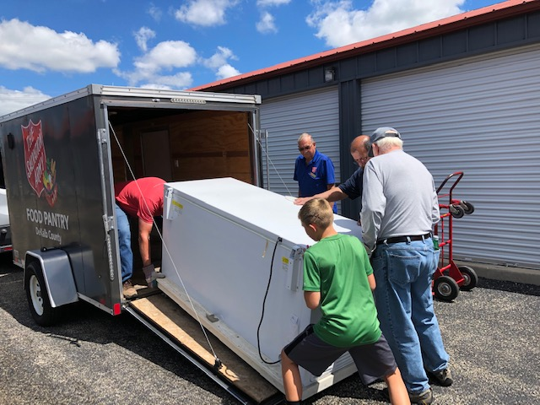

Keep in mind that Peanut Day is September 23rd and if you can help by selling a sponsor box it would be greatfully appreciated!

Sue sent around Committee Sing-up sheets today. Please get on board and get on some committees for the next Kiwanis year!

Today was also an Interclub, with attendees: DeKalb Club, Gary Vander Meer, Mark Meier, Shadow. Sycamore Club: Jean Erlenborn, John Toles, Larry Forsberg, Dave Leifheit, Beth Bollinger, Lisa DeWitt, Kathy Dombek, Lois Anderson.

Here’s the proof, Sue Doubler was installed as Lt. Gov for Div 14 at the District Convention.

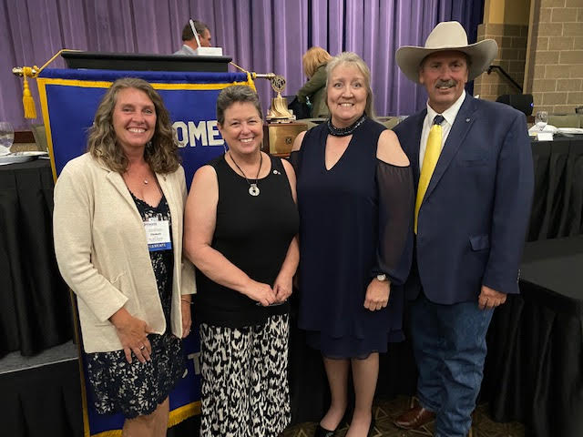

Quote for the Day

And so with the sunshine and the great bursts of leaves growing on the trees, just as things grow fast in movies, I had that familiar conviction that life was beginning over again with summer. F. Scott Fitzgerald, The Great Gatsby

PROGRAM
Michelle Donahoe from the DeKalb County History Center was our program today. She brought us up to date on happenings since the COVID lockdown through today. Focusing on the current exhibit, The History of DeKalb County in 100 Objects. An exhibit she notes ‘can connect us back to history in our county’. As the Center now represents all of DeKalb County, the exhibit is half in house at the Sycamore location, and half throughout the County at various other historic sites. At their website you can use interactive tools to locate on mapping where other objects reside. You can also learn about the entire collection. These ‘objects’ can be letters, books and items such as the Olympic Torch made in Sycamore or articles from various county publications. Michelle said that the search for what to put in the 100 objects was sort of like a treasure hunt, very fun and exciting. Please visit them on the web, or stop by at their Sycamore location.

UPCOMING PROGRAMS: (Why not invite a guest? – that could mean a prospective member!)

Aug 17, Marty Rousch Talking about his dad
Aug 24, John Bradley Billy the Kid – Real Story
Aug 31, Emily Faulkner DeKalb Library – Strategic Plan

Today’s Attendance:
21 | Kish Kiwanians ( )
12 | K-family: Interclub guests, see above
1 | Other Guests: Ralph Sherman & Shadow
1 | Outside Speaker: Michelle Donahoe
35 | Total

Have a closing thought for the day? Submit it to Bob Hoffman.

You are never too old to set a new goal or dream a new dream.
Serving the Children of the World

